ELEMENTS OF MECHANICAL ENGINEERING (BEMEM103/203)
MODULE-1
INTRODUCTION:
ROLE OF MECHANICAL ENGINEERING IN INDUSTRIES AND SOCIETY

Mechanical engineering plays a critical role in manufactured technologies, from cars to airplanes to refrigerators. It enables you to do many daily activities with ease, as it brings helpful technologies to our modern society.
Mechanical engineers work in various industries, building and designing nuclear plants, or automobiles, or railway equipment, or spacecraft. These mechanical engineers are sometimes called nuclear engineers, automotive engineers, railway engineers, and aerospace engineers'
Mechanical engineers also work as consulting practices, government and universities. They may
work in classrooms, factories offices, laboratories or testing facilities as teachers, managers,
designers or researchers. Some mechanical engineers work in sales and product quality control or
equipment maintenance. Many hold managerial positions in their companies. Whether working on an oil rig or in corporate headquarters, mechanical engineers are solving the technical problems of today and tomorrow.

Scope of Mechanical Engineering
Mechanical engineers have tremendous scope in different engineering industries like Automobile Engineering, Steel, Cement industry, Power sector, Manufacturing plants, Hydraulics, Drilling and Mining industry, Aeronautical, Petroleum, Biotechnology, etc. In the present day scenario, the scope is increasing in the biomedical and environmental fields.
Transportation:
The distance that used to take days for us to cover using biological modes of transport can now be achieved in mere hours and minutes. This has been possible only with the help of mechanically powered transportations that we came to know as automobiles. Everything starting from cars, ships, railways to airplanes made it possible by mechanical engineers.
Agricultural Mechanization:
Just like the transportation, the agricultural field too got the benefits of modified mechanized farming machinery which increased the production and reduced the time taken to do so manually. Without the implementation of the modern machinery like water pumps, tractors, harvesters, etc. developed by the mechanical engineers, our society as a whole would have been still hobbled and would have never attained its full potential.
Household Appliances and Waste Management:
Mechanical engineers have always played a crucial role in the development of various household appliances and mechanized items that make our lives easier and help us to focus on the more important aspects of life. Today, we all can very well enjoy a comfortable life with the help of appliances such as heaters, air conditioners, and refrigerators.
This would not have been possible without the mechanical engineers who spend a major portion of their time in trying to develop such machines.
Waste management has also played a pivotal role in our society by keeping it clean, hygienic and free of diseases. Waste disposal trucks, treatment facilities, and water purification systems are all significant contributions of mechanical engineers towards our society.
ROLE OF MECHANICAL ENGINEERS IN INDUSTRY
A few industries and the type of systems Mechanical Engineering plays vital role are listed below.
- Automotive
• Combustion
• Engines, transmissions
• Suspensions
- Aerospace
• Control systems
• Heat transfer in turbines
• Fluid mechanics (internal & external)
- Biomedical
• Biomechanics – prosthesis
• Flow and transport in vivo
- Computers
• Heat transfer
• Packaging of components & systems
- Construction
• Heating, ventilation, air conditioning (HVAC)
• Stress analysis
- Electrical power generation
• Steam power cycles - heat and work
• Mechanical design of turbines, generators,
- Petrochemicals
• Oil drilling - stress, fluid flow, structures
• Design of refineries - piping, pressure vessels
- Robotics
• Mechanical design of actuators, sensors
• Stress analysis
Emerging Trends and Technologies in Energy sector.
- Renewable
Renewable is one of the emerging trends in energy sector. This Renewable energy trend helps to safeguard the environment by emitting little to no harmful pollutants. The fundamental premise of renewable energy is to obtain it from a consistent source in the environment, such as the sun, wind, or geothermal sources. The source is then converted into useful power or fuel.
A variety of technologies that address various facets of generating power and heat from renewable sources is one of the latest technology trends in renewable energy. This involves lowering the cost of building renewable infrastructure and enhancing the efficiency of power generation.
- Internet of Energy (IOE)
ln the traditional method, during the time of construction, the electric power system uses the
central architecture and this poses a number of obstacles to the industry. And here loE comes into the frame. lt helps to recognize some of the challenges and accordingly propose the best efficiency and optimal design to build an energy system.
Technology trends in the energy industry refer to automate the power infrastructure in order to
manufacture and produce energy.
Benefits;
. Reduce insufficiency.
. Make the transmission of energy more productive.
. Reduce the expenses.
. Decrease in the wastage of energy.
3) Energy Storage
Energy storage is one of the effective energy industry emerging trends. Energy storage permits steady pricing by proactively maintaining demand from consumers.
In response to shifting energy demands and technological advancements, the energy storage business has evolved, adapted, and innovated during the last century. Energy storage systems offer a diverse set of technological solutions for improving our power supply to build more resilient energy infrastructure and save money for utilities and customers.
The many methods of energy storage can be classified into five categories based on their technology:
- Batteries
- Thermal
- Mechanical
- Pumped hydro
- Hydrogen
It has the potential to save consumers money while also improving dependability and resilience, integrating power sources, and reducing environmental impacts.
4) Blockchain
Blockchains or distributed ledgers are emerging technology trends in the energy industry that has drawn significant interest from energy supply firms, startups, financial institutions, governments, technology developers, and the academic community.
Blockchain technology proposes to combine all energy stakeholders under a single decentralized system. Electricity producers, metering operators, distribution network operators, and traders potentially avail from utilizing smart contracts. These agreements ensure that all energy-related transactions are routed through a safe and immutable network, reducing the risk of losses. Blockchain also has the ability to achieve some degree of equity between energy generators and consumers.
Emerging Trends and Technologies in Manufacturing sector.
AI, robots, 3D printing, and the like are all the latest manufacturing trends in manufacturing
technology - and have been for some time. 2021 is the year. manufacturing technology gets even smarter. Robots on the factory floor are growing at warp speed thanks to their declining cost and increasing capabilities.
Emerging Trends and Technologies in Automotive sector.
The automotive industry has been experiencing a great deal of change within the past several years. More software is being added to vehicles, along with a greater number of electric and autonomous vehicles are in production and on the road.
Here are the most common automotive trends of 2021.
. A Greater Amount of Al/Machine Learning and Connectivity
. An increase in Electric and Autonomous Vehicles
. Software Security Has Become a Top Concern
. Electrification
. Artificial Intelligence (AI)
. Human-Machine Interface
Emerging Trends and Technologies in Aerospace sector.
Aerospace collectively refers to the atmosphere and outer space; it's a diverse industry with a multitude of commercial, industrial, and military applications. Aerospace engineering consists of
aeronautics and astronautics and the research, design, production, operation, or maintenance of aircraft and spacecraft involves the work of numerous organizations'.
10 Aerospace Engineering Technology Trends.
1. Zero-Fuel Aircraft
2. Structural Health Monitoring (SHM)
3. Advanced Materials
4. Smart Automation and Block chain.
5. Additive Manufacturing (3D Printing).
5. Supersonic Flights.
7. More Resilient and Dynamic A&D Supply Chains.
8. Utilizing Internet of Things (IOT) to Anticipate Maintenance issues.
9. Artificial intelligence (Al).
10. Autonomous Flight Systems.
Emerging Trends and Technologies in Maritime sector.
Advances in shipbuilding, propulsion, smart shipping, advanced materials, big data and analytics, robotics, sensors and communications in conjunction with an increasingly skilled workforce are all having monumental shifts in how the maritime industry are approaching new challenges and opportunities.
The Indian Manufacturing sector currently contributes 16-17% to GDP and gives employment to around l2o/o (201a) of the country's workforce. Various studies have estimated that every job created in manufacturing has a multiplier effect in creating 2-3 jobs in the services sector.
Manufacturing, value added (% of GDP) in India was reported at 12.96 % in 2020, according to the World Bank collection of development indicators, compiled from officially recognized sources.
STEAM FORMATION AND APPLICATION:
STEAM
Introduction:
Steam is a vapor of water produced by applying thermal energy to water. Vapor does not obey the gas laws but when they are superheated they behave like a gas and obeys laws of gases. The use of water vapors for generation of power is the oldest method where steam is used in heat engines.
Pure substance
Pure substance is one which has homogenous molecular structure and is also invariable in chemical composition. Pure substance may exist in any of the phases; however, molecular structure remains same.
The steam is formed by heating water using various fuels. When water is heated beyond boiling point, it starts vaporizing and transforms from the liquid phase to gases phase to form steam. Since, Vapor does not obey the gas laws but when they are superheated they behave like a gas and obeys laws of gases and as such pressure, temperature and specific volumes are not correlated by simple gas equations.
The amount of heat addition to water for generation of steam depends on pressure at which water is heated.
Steam formation at constant pressure
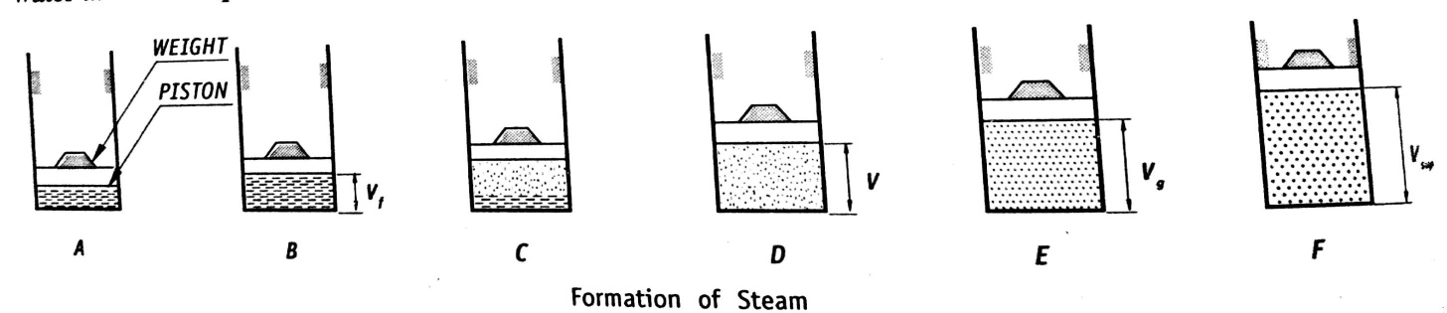

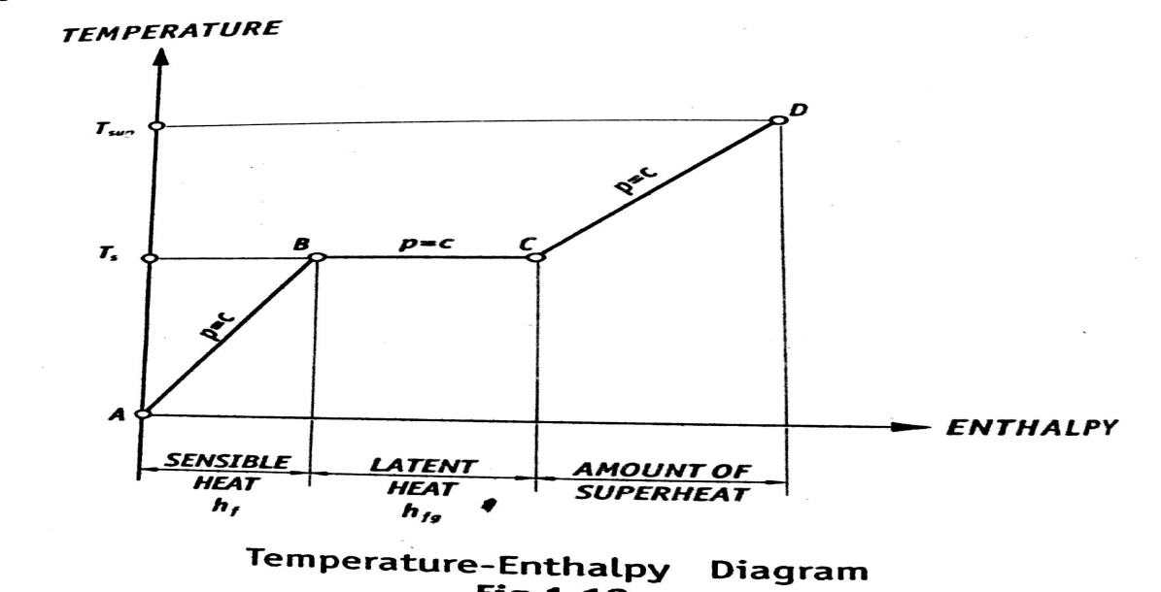
Let us consider 1 kg of water at 0°C is taken in a cylinder fitted with a freely moving piston and a chosen weight is placed over it to exert constant pressure on water during this experiment. This condition is presented by A on temperature- enthalpy diagram.
When water is heated at constant pressure, its temperature rises till boiling point is reached. At boiling point, slight increase in volume is observed. The temperature at which water starts boiling depends on pressure at which it is heated. This temperature at which the water starts boiling is called Saturation temperature. The saturation temperature is defined as the temperature at which the water begins to boil at a given pressure. This temperature is represented in above graph by B. the heating of water from 0°C to the saturation temperature is represented by line AB. The saturation temperature increases with increase in pressure at which water is heated. Heat supplied to water from 0°C to saturation temperature is called as sensible heat as heat added to water can be sensed or can be measured).
The sensible heat is defined as the amount of heat required to rise the temperature of 1 kg of water from 0°C to the saturation temperature (T_{s}) at a given constant pressure and is usually denoted by hf. It is also called as the heat of liquid or enthalpy of the liquid.
Further addition of heat to the water, initiates the vaporization of water without any rise in temperature. This heat addition causes phase transformation from liquid to gas. This evaporation continues at constant temperature (at saturation temperature) till whole of the water vaporizes and converts to steam. This point is represented by C on t- H diagram as shown above. This constant pressure and constant temperature heat addition is presented by horizontal line (B-C). As the heat added to water during evaporation cannot be sensed, it is called latent heat (hidden heat). Latent heat of vaporization can be defined as amount of heat required to evaporate 1 kg of water to 1 kg of dry steam at saturation temperature (at constant temp. Ts) at given pressure. It is also called as enthalpy of Evaporation.
Upon heating steam generated at constant pressure, temperature of the steam increases from saturation temperature to a desired temperature above it and is called superheated temperature. During this process, dry steam is heated and this process is called super heating and the steam is called superheated steam. This super heating is represented by line C- D on graph. The heat added to steam during super heating is called enthalpy of superheat.
Enthalpy of super heat can be defined as an amount of heat required to increase the temperature of dry steam from it saturation temperature to any desired higher temperature at a given constant pressure
The temperature above the vapour saturation and up to the superheated vapour temperature is known as the degree of superheat and denoted by T_{sup}.
Types of steam
Wet steam: Wet steam is a two phase mixture of entrained water molecules and steam in thermal equilibrium at saturation temperature corresponding to a given pressure. When water is heated beyond the saturation temperature at constant pressure, it starts evaporating. The steam evolved from the surface of the water entrains finely divided water molecules in it. These water molecules entrained in steam will be at same temperature as that of steam (saturation temperature) but have not absorbed the latent heat and converted to steam.
The quality of wet steam is depends on proportion of water molecules present in it. Thus the quality of wet steam is specified by dryness fraction.
The dryness fraction of steam is defined as the ratio of mass of the actual dry steam present in known quantity of wet steam to the total mass of the wet steam.
Let mg = mass of dry steam present in sample of wet steam
Mf = mass of water molecules present in the sample of wet steam
Dryness fraction = x=(Mass of dry steam present in wet steam)/(Total mass of wet steam)
If dryness fraction is less than 1, it is wet steam.
Dry steam or saturated steam: It is the steam at saturated temperature at given pressure and having no water molecules in it. Since the dry saturated steam does not contain any water molecules in it, it dryness fraction will be unity.
Superheated steam: When dry steam is heated further at a constant pressure, its temperature rises beyond it saturation temperature. The steam in this state is called superheated steam.
The superheated steam may be defined as the steam which is heated beyond its dry saturated state of a temperature higher (than its saturated temperature) at a given pressure.
Enthalpy:
It is sum of internal energy and the product of pressure and volume. At constant pressure steam generation process, the amount of heat supplied to water to convert it to steam is equal to change in enthalpy.
Enthalpy of wet steam: It is the total heat supplied at a constant pressure to convert 1 kg of water at 0°C to 1 kg of steam at the specified dryness fraction. It is denoted by h and will be equal to sensible heat and the product of dryness fraction and the latent heat of evaporation.
h = h_{f} +x * h_{fg}
whereh_{f} = sensible heat, h_{fg =} latent heat of vaporization, x = dryness fraction.
Enthalpy of Dry saturated steam
It is the total heat supplied at a constant pressure to convert 1 kg of water at0°C to 1 kg of steam at the saturation temperature. It is usually denoted by h_{g} .
h_{g} = h_{f} + h_{fg}
where, h_{f} = sensible heat, h_{fg =} latent heat of vaporization

Enthalpy of superheated steam
It is the total heat supplied at a constant pressure to convert 1 kg of water at 0°C to 1 kg of superheated steam at stated superheated temperature.It is usually denoted by h_{sup.} It is equal to enthalpy of saturated steam plus amount of super heat.
h_{sup} = h_{g} + C_{ps}( T_{sup} – T_{s})
where, C_{ps} = specific heat of superheated steam, T_{sup}= superheating temperature ad T_{S} = saturation temperature
Specific volume
It is the volume occupied b unit mass of a substance.
Specific volume of saturated steam: It is the volume occupied by 1 kg of water at the saturation temperature at a given pressure. It is usually denoted by v_{f}
Specific volume dry saturated steam: It is the volume occupied by 1 kg of dry saturatedat a given pressure. It is usually denoted by v_{g}
Specific volume of superheated steam: It is the volume occupied by 1 kg superheated steam at at a given superheated temperature. It is usually denoted by v_{sup}.
v_{sup =} v_{g} * ( T_{sup}/T_{s})
Specific volume of wet steam: It is equal to sum of volume occupied by the dried up portion of the steam in 1 kg of wet steam and volume occupied by the entrained water molecules in same mass of wet steam. If x is the dryness fraction of the steam, and the mass of the water molecules will be equal to (1-x) kg.
V = xv_{g} + (1-x)*v_{f}
External work of Evaporation: It is the fraction of latent heat which does work.
Internal Latent heat: It is the energy required to change the phase i.e. from water to steam. It can be obtained by subtracting the external work of evaporation from the latent heat
Internal energy of the steam: It is the difference between enthalpy of the steam and work
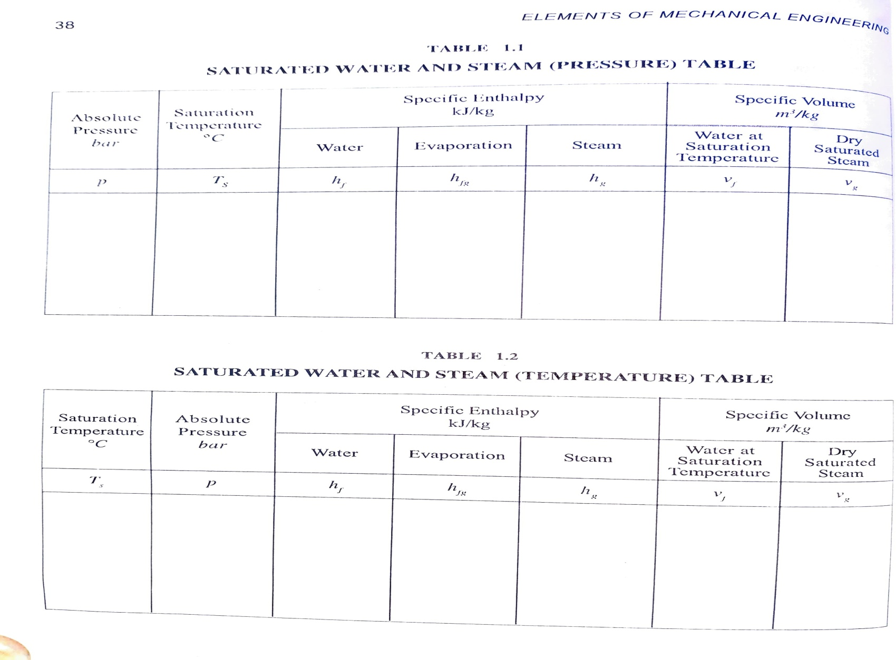
Numericals on Steam:

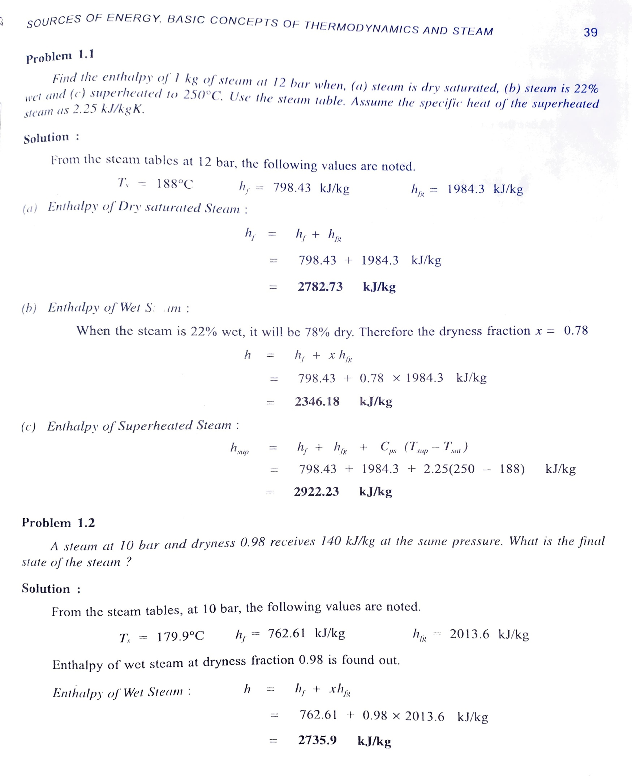

Fossil fuels:
Fossil fuels are made from decomposing plants and animals. These fuels are found in the Earth’s crust and contain carbon and hydrogen, which can be burned for energy. Coal, oil, and natural gas are examples of fossil fuels. Coal is a material usually found in sedimentary rock deposits

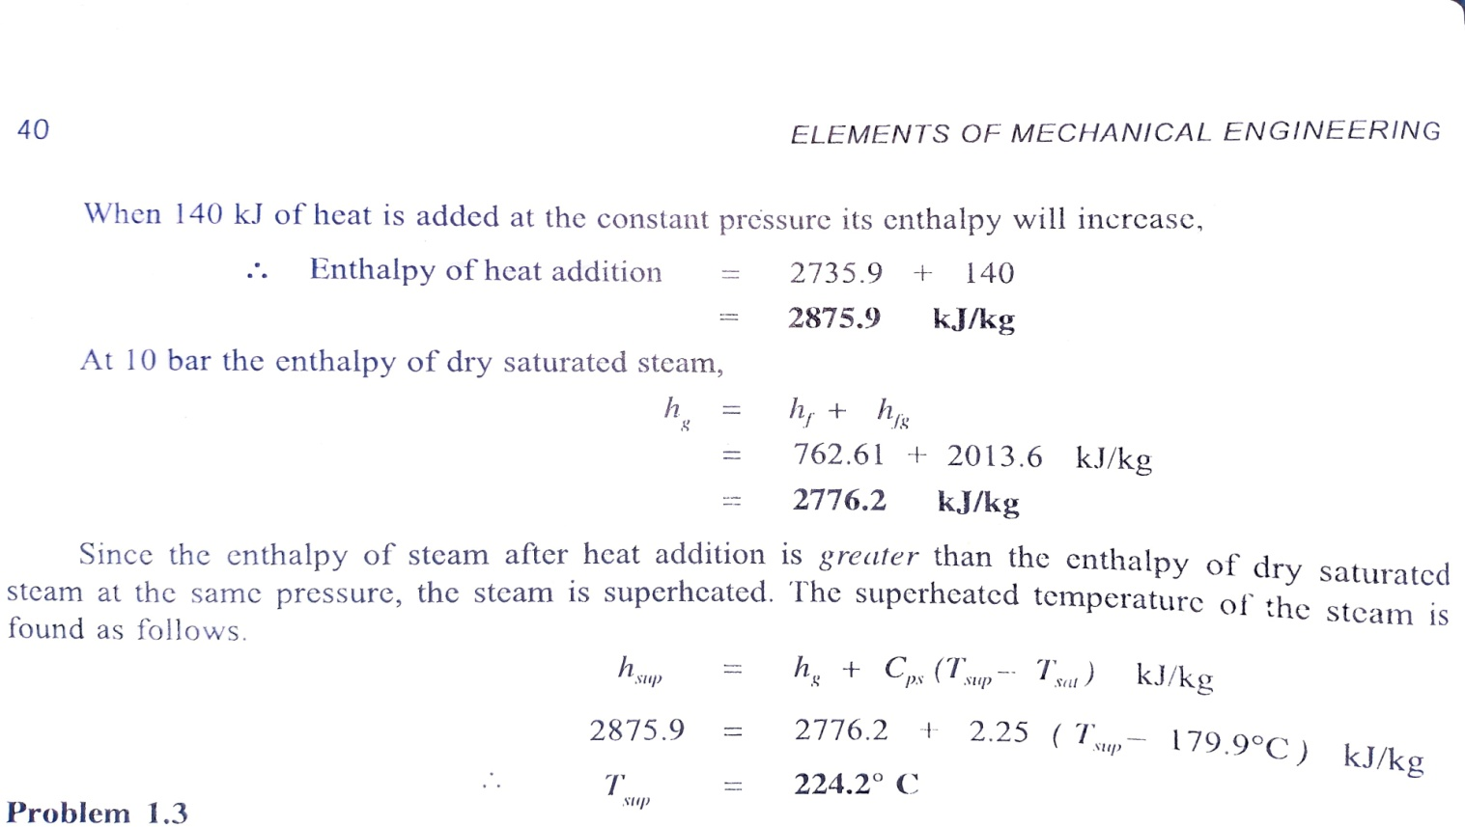

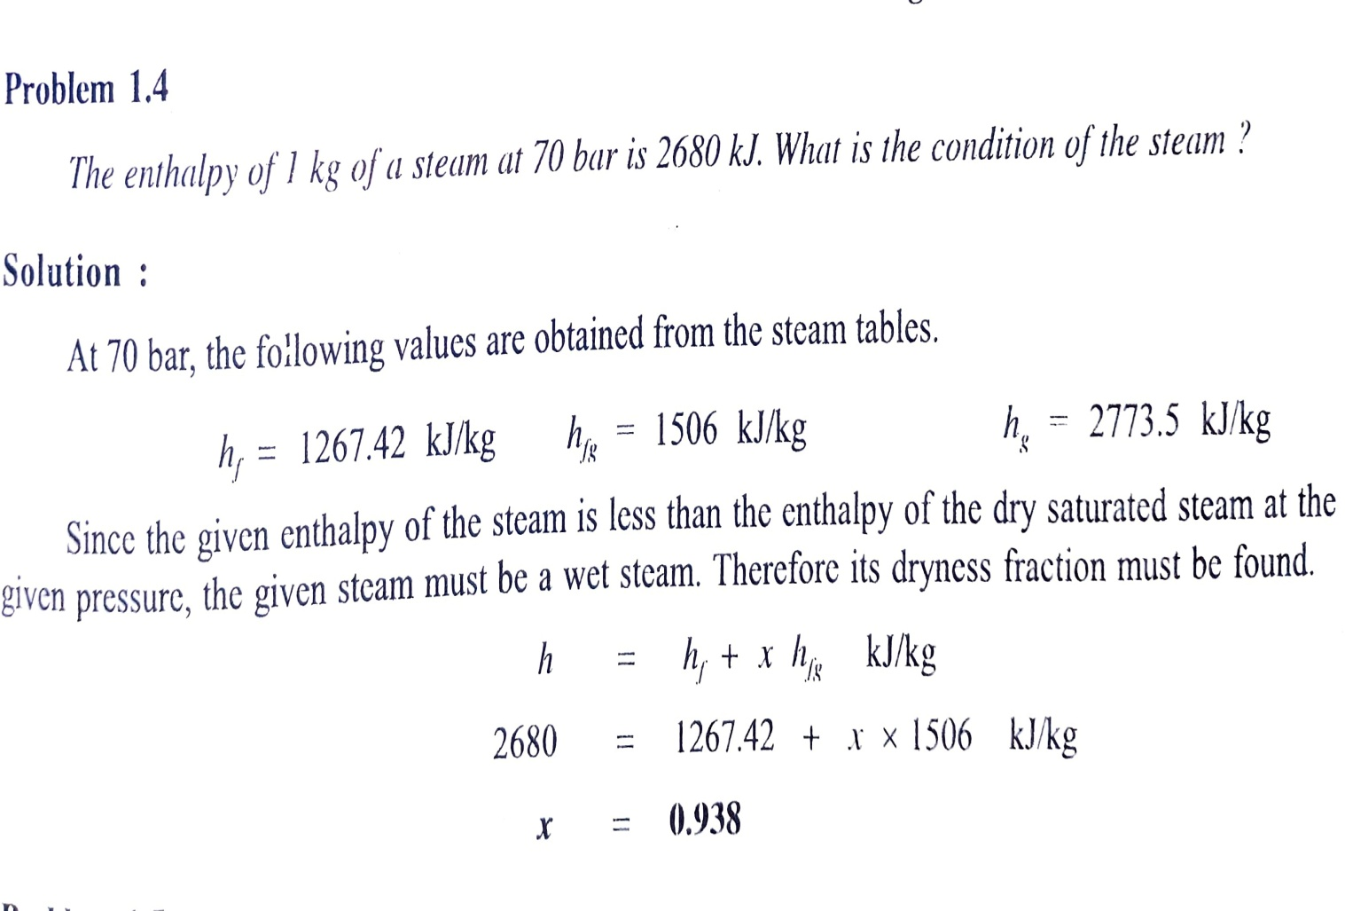

ENERGY SOURCES AND POWER PLANTS:
Renewable sources of energy | Non- Renewable sources of energy
These are in-exhaustible | These are exhaustible
Freely available and environment friendly | Not freely available & hazardous to environment
Initial cost is high but maintenance cost is low | Initial cost is low but maintenance cost is high
Energy concentration varies from region to region | Energy concentration almost same in all region
Example: solar, hydel, wind, tidal etc. | Example: Fossil fuels, nuclear fuels.

FOSSIL FUELS:
where rock and dead plant and animal matter are piled up in layers. More than 50 percent of a piece of coal’s weight must be from fossilized plants. Oil is originally found as a solid material between layers of sedimentary rock, like shale. This material is heated in order to produce the thick oil that can be used to make gasoline. Natural gas is usually found in pockets above oil deposits. It can also be found in sedimentary rock layers that don’t contain oil. Natural gas is primarily made up of methane.

Types, Formation and Uses of Fossil Fuels
Fossil fuels are of the following types:
- Coal
- Petroleum
- Natural gas

Coal
- It is a hard, black coloured substance made up of carbon, hydrogen, nitrogen, oxygen and sulphur.
- The major types of coal are- anthracite, bituminous and lignite.
- Anthracite has a higher carbon concentration and is the hardest type of coal.
- Lignite has a high concentration of oxygen and hydrogen but a low concentration of carbon.
- Bituminous is a moderate form of coal.
- Coal is processed industrially to obtain derivatives like coke, coal tar and coal gas.
Uses of Coal
- Coal was used to produce steam in the railway engines initially.
- It is used to cook food.
- It is used to generate electricity in thermal plants.
- It is used in industries as fuel.

Petroleum
- It is a clear, oily liquid, usually green or black in colour.
- It has a very strange smell and is a mixture of petroleum gas, diesel, paraffin wax, petrol, lubricating oil, etc.
- It is also termed as “Black Gold” because of its wide range of uses in many industries.
Uses of Petroleum
- It is used to power internal combustion engines in the form of petrol.
- It is used in roofing, road pavements and as a water repellent.
- It is used in manufacturing detergents, plastics, fibres, polyethene, etc.

Natural gas
- It is a clean and non-toxic fossil fuel.
- It is colourless and odourless and can be easily transferred through pipelines.
- It is stored as compressed natural gas (CNG) under high pressure.
- It is a less polluting and less expensive fossil fuel.
- Methane is the most important natural gas.
Uses of Natural gas
- Compressed Natural Gas is used for generating power.
- It is used as fuels in automobiles.
- It can be used at homes for cooking.
- It is used as a starting material in chemicals and fertilizers.

Advantages and Disadvantages of Fossil Fuels
Advantages:
- Fossil fuels can generate a large amount of electricity at a single location.
- They can be found very easily.
- They are cost-effective.
- Transportation of oil and gas can be done easily through pipelines.
- They have become safer over time.
- Despite being a finite resource, it is available in plenty.
Disadvantages
- Fossil fuels emit carbon dioxide when burnt which is a major greenhouse gas and the primary source of pollution. This has contributed to global warming.
- They are a non-renewable resource, i.e., once used they cannot be replaced.
- Combustion of fossil fuels makes the environment more acidic. This has led to unpredictable and negative changes in the environment.
- Harvesting of fossil fuels also causes fatal diseases among the people. For ex. the coal miners often suffer from Black Lung Disease. The natural gas drillers are constantly exposed to chemicals and silica which is dangerous for their health.

POWER PLANTS:
HYDEL POWER PLANT:
A typical hydro-power station is shown below in figure.
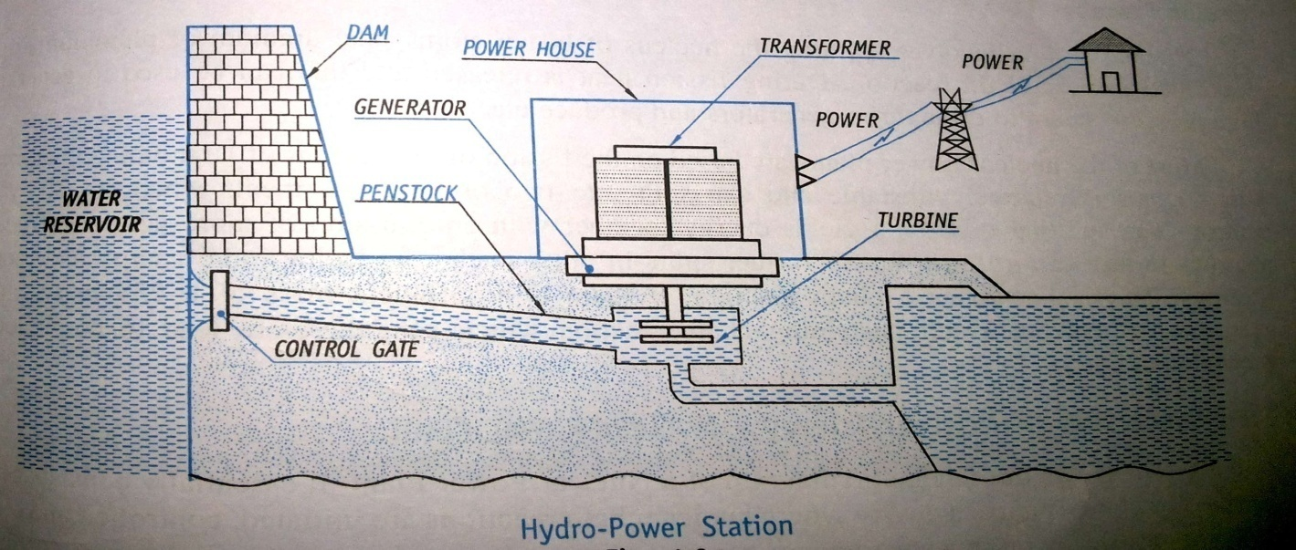
Most commonly, the rain water flowing as river stored to higher levels by building dam across the river. The water in river consists of two types of energies:
- Kinetic energy: The energy of water due to its motion
- Potential energy: The energy of water due to its high level.
Depending on the type of hydraulic power plants kinetic and/or potential energy of water is used to generate electricity.
The large quantities of water from river are flown by pipelines also called as penstock, towards the large turbines and allowed to fall on the large turbine blades to rotate turbine. The shaft of the turbine rotates the electric generator where electricity is generated. This electricity is then passed to the transformers for use.

NUCLEAR POWER PLANT:
There are some atoms (blocks of matter) are stable and stay as they are forever. But some atoms are unstable and are called radioactive isotopes they are bound to split into bites (one or more smaller atoms), giving off other particles and energy, this process is called nuclear fission. This process can also be made to happen on demand (this is how we get energy out of atoms in nuclear power plant). Some isotopes will go on splitting themselves automatically and produces energy as long as you want, is called chain reaction.
Suppose you take a really heavy atom (a stable kind of uranium-235) each of its atoms has a nucleus with 92 protons and 143 neutrons. Fire a neutron at uranium-235 will turn into uranium-236 which is unstable and it splits into two smaller atoms (barium and krypton), releasing lot of energy and three spare neutrons at the same time. These spare neutrons strikes other uranium-235 atoms making them to split and release energy and spare neutrons in this way this becomes a chain reaction (controlled) and release huge amount of energy in the form of heat.
The below figure shows the schematic diagram of nuclear power plant, it consists of
- Nuclear reactor:
- A steam generator
- A turbine
- A cooling water condenser:
- A cooling tower
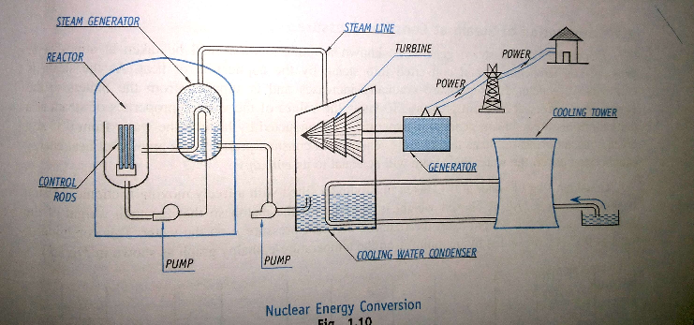

Nuclear reactor, (device where nuclear chain reaction is initiated and controlled) and steam generator are housed in a containment structure. Enormous amount of heat is generated in the nuclear reactor due to nuclear reaction (fission), which is used to generate steam. This steam is allowed to fall on the large turbine blades to rotate turbine. The shaft of the turbine rotates the electric generator where electricity is generated. This electricity is then passed to the transformers for use. The steam is cooled by using cooling towers and cooling water condenser.

Construction & Working of Thermal Power Plant:

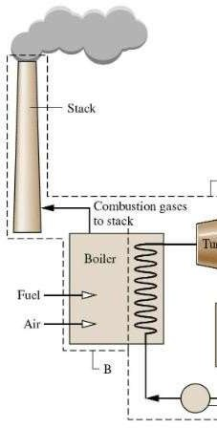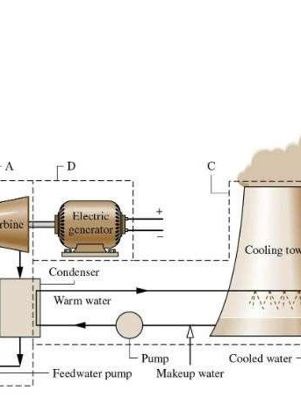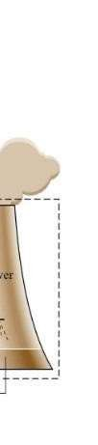

Figure: Layout of Thermal Power Plant
Working of Thermal Power Plant:
- In the steam power plant, the pulverized coal is fed into the boiler and it is burnt in the furnace. The water present in the boiler drum changes to high pressure steam.
- From the boiler the high-pressure steam passed to the superheater where it is again heated up to its dryness.
- This superheated steam strikes the turbine blades with high speed and the turbine starts rotating at high speed.
- A generator is attached to the rotor of the turbine and as the turbine rotates it also rotates
with the speed of the turbine. The generator converts the mechanical energy of the

It is the power plant which is used to generate electricity by the use of steam turbine. The major components of these power plants are boiler, steam turbine, condenser, and water feed pump.

turbine into electrical energy.
  - After striking on the turbine the steam leaves the turbine and enters into the condenser. The steam gets condensed with the help of cold water from the cooling tower. The condensed water with the feed water enters into the economizer.

In the economizer the feed water gets heated up before entering into the boiler. This heating of water increases the efficiency of the boiler.
  - The exhaust gases from the furnace pass through the superheater, economizer and air pre-heater. The heat of this exhaust gases is utilized in the heating of steam in the superheater, feed water in the economizer and air in the air pre-heater.
  - After burning of the coal into the furnace, it is transported to ash handling plant and finally to the ash storage.

Advantages:
    - Less initial cost as compared to other generating stations.
    - It requires less land as compared to hydro power plant.
    - The fuel (i.e., coal) is cheaper.
    - The cost of generation is lesser than that of diesel power plants.

Disadvantages:
    - It pollutes the atmosphere due to the production of large amount of smoke. This is one of the causes of global warming.
    - The overall efficiency of a thermal power station is low (less than 30%).

SOLAR POWER PLANT:
- Electrical Energy (Helio Electric Process)
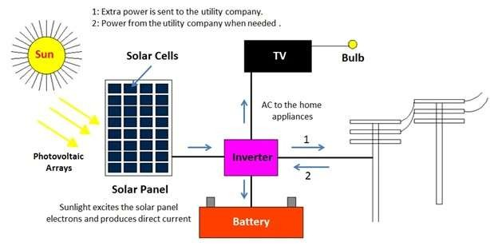
It is generated by photovoltaic effect caused when the sun is beamed on the semiconductors, when a p-a junction of a semi conductor is exposed to sunlight, its p-region becomes positively charged and the n-region becomes negatively charged. If an external load is applied, this charge difference will drive a current through it till the sunlight is effective; this principle is used in to generate electrical energy.

- Thermal Energy (Helio Thermal Process)
In this process the radiant solar energy is collected on the surface called collectors and directly converted into thermal energy.
- Flat plate collectors
- Focusing collectors
The amount of radiant energy on a surface (collector) is called “Solar insolation” and it is composed of
- Direct component called beam component
- Diffused component and
- Short wavelength component, which is reflected from the other terrestrial surfaces
Liquid Flat plate collectors
The construction of liquid flat plat collector is as shown in figure, it consists of
- a glass or cover
- a blackened sheet of metal (plate) also called as absorber
- fluid flow pipes attached to blackened sheet of metal
- insulated casing
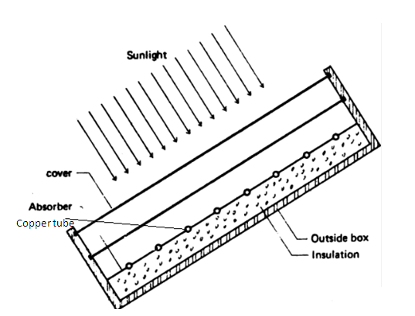
It basically consists of flat surface with high absorptivity for solar radiations, called the absorbing surface. Typically a metal plate, usually of copper, steel or aluminum material with tubing of copper in thermal contact with the plates, are the most commonly used materials. The absorber plat is usually made from the metal sheet 1 to 2 mm in thickness. While the tubes, which are also of metal , range in diameter from 1 to 1.5 cm. they are soldered , brazed or clamped to the bottom of the absorber plate with the pitch ranging from 5 to 15 cm. the heat is transferred from the absorber plate to a point of use by circulation of fluid across the solar heated surface. Thermal insulation of 5 to 10 cm thickness is usually placed behind the absorber plate to prevent the heat losses from the rear of the surface. Insulation materials are generally mineral wool or glass wool or fiber glass.
The front covers are generally glass that is transparent to incoming solar radiations and opaque to the infrared re-radiations from the absorber. The glass cover act as a convection shield to reduce the losses from the absorber plate beneath. Glass is generally used for the transparent covers but certain plastic films may be satisfactory. The thickness of 3 to 4 mm is commonly used. The usual practice is to have 1 or 2 covers with a specific ranging from 1.5 to 3 cm. sometimes, instead of glass, plastic sheets are used as covers, but they have some drawbacks. Most of the plastics are not as opaque as glass to the thermal infrared radiation and so permit greater loss of heat from the absorber. They also suffer a decrease in transparency and sometimes breakup in the course of time due to heating and the action of solar ultraviolet radiations.
As the Sun rays passes through the glass and strikes the blackened sheet of metal (plate), the plate gets heated up by absorbing the solar rays. Because blackened sheet of metal has the property of absorbing the sunlight (direct, diffused and terrestrially reflected) falling on it and convert it into heat. So absorbed heat is transferred to liquid passing through the pipes attached to the blackened sheet of metal.
The insulated casing is to minimize the heat loss to the atmosphere. The glass acts as diathermanous medium permitting the short wavelength solar radiation to be transmitted through it, while blocking the long wavelength solar radiation from the surface of the blackened sheet.

Solar pond
Solar pond is a pool of salt water used to collect and store solar energy.
Working Principle:
We know that when water or air is heated they become lighter and rise upward. In the solar pond this tendency is restricted by using salty water, which will be too heavy to rise upon heating. The typical working of solar pond is shown in figure below.
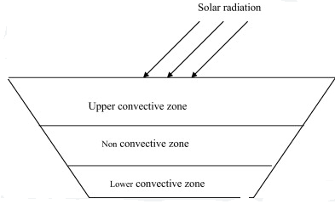

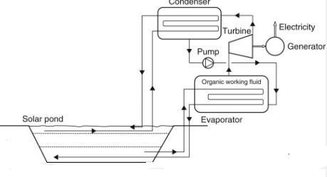

There are three zones namely
- Surface zone [Upper Corrective Zone (UCZ)] contains less salt content, so it is at atmospheric temperature.
- Storage zone [Lower Corrective Zone (LCZ)] contains large amount salt content, so it is very hot. This is the zone which collects and stores the solar energy in the form of heat.
- Gradient zone [Non- Corrective Zone (NCZ)] contains medium amount of salt content, so in this layer heat neither rise nor fall, this acts as transparent insulator i.e. this allows the sun light to reach LCZ and trap the heat there.
This trapped heat can be taken off to an evaporator (acts as heat exchanger) and this heat in the form of steam is fed to a turbine which is coupled to generator to generate power. Cold water from UCZ is fed to a condenser where the droplets formed are pumped to the heat exchanger. The cold water is again brought back to the UCZ and the loop continues. A figure of solar pond power plant is shown below

Solar photovoltaic principle

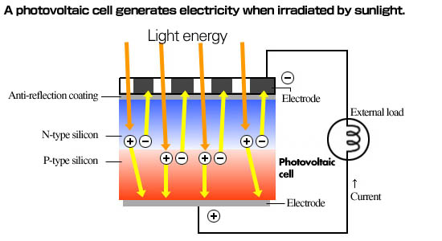
Semiconductor is a device made either from p-type or n-type base material, a cell which comprises with these two types of semiconductors is called photovoltaic cell. The joint between these two semiconductors is called the "P-N junction."
In p-n junction, free electrons (negative particles) from n-side tend to diffuse into p-side and readily recombine because of very large hole (positive particles) concentration. This movement leaves a net positive charge in the n-side of the junction.
Similarly, holes (positive particles) from p-side tend to diffuse into n-side and readily recombine with numerous free electrons (negative particles). This movement leaves a net negative charge on the p-side of the junction.
This charge distribution near the junctions gives rise to an electric field and a potential difference across the junction.
When a photovoltaic cell is exposed to sun light some of the photons are absorbed in the junction and will generate particles with positive or negative charge, which move from one side to another side, if an external load, such as an electric bulb or an electric motor, is connected, electricity flows in the cell.
WIND POWER PLANT
Wind energy is the kinetic energy of large masses of moving air over the Earth surface (which is due to the unequal heating of the atmosphere by the sun).
OR
Wind energy is the energy contained in the force of the winds blowing across the Earth’s surface.
This energy can be converted into mechanical energy and later as electrical energy. Wind speed increases with height; hence, they are greater in hilly and coastal areas than on normal land surfaces.
Power in the wind: is a measure of air blowing velocity (V, m/s) and kinetic energy of wind (E).
Then wind power P = EV, W/m²,
Where, Kinetic energy E= 1*ρV² J/m³
Conversion of Wind Energy:
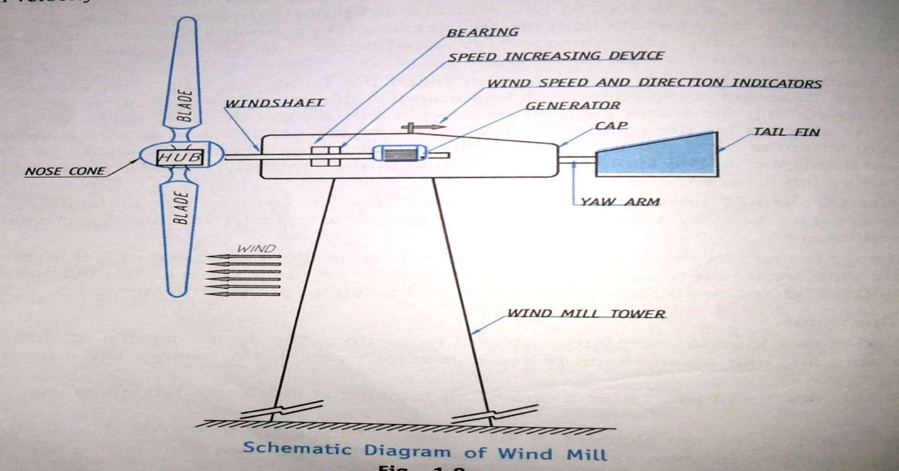
The wind energy may be converted into mechanical energy by deflecting the air through an angle. This principle is used in wind mills. A typical schematic diagram of windmill is shown below.

It consists of a rotor fitted with large blades. As air flow over the blades, the rotor rotates, thus producing energy. These are used to grinding, milling, pumping water etc. Serious efforts are being made to obtain electrical energy from it in effective way.

TIDAL POWER PLANT:

Tidal Energy/Power
Tidal energy is a form of renewable energy which is created by converting energy from tides into electricity using various methods. Tides are more predictable than the wind and therefore the sun. Although tidal energy is renewable energy, it has traditionally suffered from relatively high cost and limited availability of web sites with sufficiently high tidal ranges or flow velocities, thus constricting its total availability. However, many recent technological developments and enhancements, both in design and turbine technology indicate that the entire availability of tidal power could also be much above previously assumed which economic and environmental costs could also be brought down to competitive levels.
The Rance Tidal power plant in France is the world’s first large-scale tidal energy station. It became operational in 1966. It was the most important tidal power plant in terms of output until Sihwa Lake Tidal power plant opened in South Korea in August 2011.

The Principle behind Tidal Energy
Tidal energy is generated from the Earth’s oceanic tides. These tidal waves are the forces which form due to gravitational attraction exerted by celestial bodies. These forces create corresponding motions or currents within the world’s oceans.
Due to the strong attraction to the oceans, a bulge within the water level is made, causing a short-lived increase in water level. Now due to Earth’s rotation, this huge volume of ocean water meets the shallow water adjacent to the shoreline and creates a tide. This natural phenomenon is repetitive and takes place in an unfailing manner, due to the consistent rotation of the moon’s orbit around the earth.
A tidal generator is required to convert the energy of tidal flows into electricity. The potential of a site for tidal electricity generation is directly proportional to greater tidal variation and better tidal flow velocities. These together can dramatically increase the tidal energy generation. As we know that Earth’s tides take place due to the gravitational force of Earth with the Moon and Sun, so the tidal energy is practically inexhaustible and classified as a renewable energy resource. Movement of tides causes a loss of energy within the Earth-Moon system.
The components of Tidal power plant
- Dam or barrage
- Sluice ways from the basins to the sea
- Power House
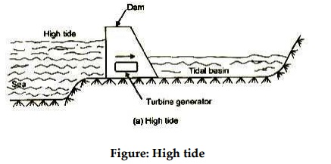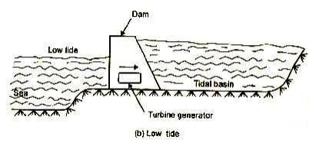
Barrage:
The function of dam is to form a barrier between the sea and the basin or between one basin to the other in case of multiple basins. Tidal barrage have to resist waves whose shocks can be sever and where pressure changes sides continuously. The barrage needs to provide channels for the turbines in reinforced concrete.
Gates and locks
The sluice ways are used either to fill the basin during the high tide for empty the basin during the low tide, as per operational requirement. Gate structure can be floating as modular units. Flap gases are operated by water pressure that are positioned so as to allow water in to the holding basin and require no mechanical means of operation.
The flap gates allow only in the direction of the sea to basin. Hence, the basin level rises well above to sea level as ebb flow area is far less than flood flow area.
Power House:
The turbines, electric generators and other auxiliary equipment are the main components of a power house. The design cycle may also provide for pumping between the basin and the sea in either direction. If reversible pump turbines are provided, the pumping operation can take place over a any time by the same machine.

