ELEMENTS OF MECHANICAL ENGINEERING (BEMEM103/203)

MODULE-2

Machine Tool Operations:

Tool: Tool is a device which is used to fix, repair or assemble something or tool is a device use to carry out various manufacturing operations.
Hand Tools: The tools which are powered by hands is called hand tools. Ex: Screw driver, hacksaw blade, Knife, files etc etc.
Cutting tools:- Tools which are used to separate or remove material from the work piece are known as cutting tools. Ex hack saw, chisel etc.
Machine tools: - Machine tools are power driven cutting tools or machines with which the excess stock of material from the work piece can be removed.

Lathe:-
- Lathe is one of the most widely used machine tools in metal cutting work.
- Lathe is generally used for machining cylindrical jobs.
- Lathe machine operation includes, the job which is to be machined rotated and a cutting tool is fed to cause the cutting action.

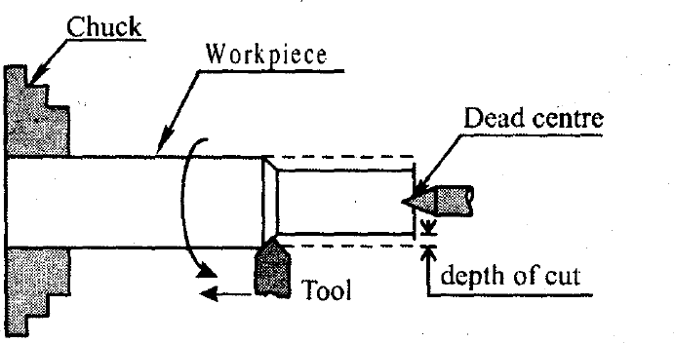
Working principle of Lathe:

The work piece is hold firmly in the work holding device called the chuck and is supported by the dead center as shown in the above figure (if the length of the job is more). The chuck is rotated at a particular speed by some mechanisms; the cutting tool is moved against the rotating work piece to facilitate the removal of material.

Schematic Diagram of Lathe Machine.

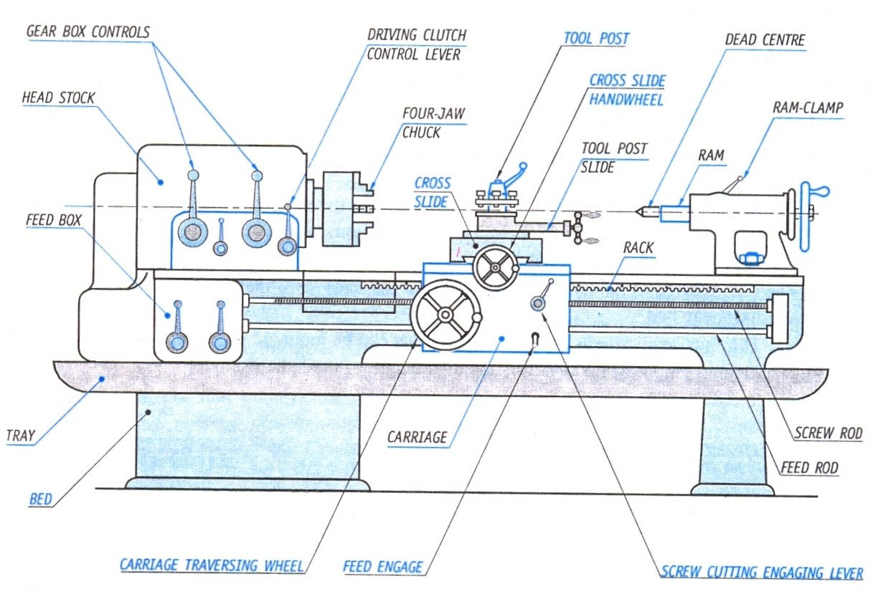

- Bed: The lathe bed provides a heavy rigid frame on which all the main components like headstock, tail stock and carriage are mounted. It comprises inner and outer guide rails that are precision machined. Lathe bed is made out of cast iron alloy.
- Headstock: It is mounted in a fixed position at the left end on the bed. It carries a hollow spindle; this can rotate at different speeds. The spindle carries a work-holding device which in turn rotates the job to be machined. The spindle speed is controlled by a stepped cone pulley and back gear arrangement both of which are housed inside the headstock.
- Tailstock: It is mounted at the left end on the bed and can slide towards the headstock. It can be fixed at any position on the bed to suit the length of the work to hold a lathe center, drill bit or other such tool. The tailstock is used for drilling, reaming, tapping, threading and centering parts.
- Carriage: It moves on the guide ways of the lathe bed. A cutting tool is fixed in the tool post, the movement of which is guided by the carriage. The carriage is equipped with levers, clutches and gears that control its movement either by hand or by power feed. It carries the following units.
  - Saddle: It is the main part or the base of the carriage which slides along the bed ways. It supports cross-slide, compound rest and tool post. Generally, it uses a hand wheel to move along the bed but it can also be power operated through the apron mechanism.
  - Cross slide: It is mounted on the saddle and slides in a direction perpendicular to the axis of the spindle
  - Compound rest: It is mounted on the top of the cross-slide. It can swivel to any desired angle in a horizontal plane. It is operated by a hand wheel through the compound rest.
  - Tool post: It is fixed on top of the compound rest and mounts the tool holder, in which the cutting tools are clamped.
  - Apron: is attached to the front of the carriage and bears the mechanism which controls the movement of the carriage and the cross slide.

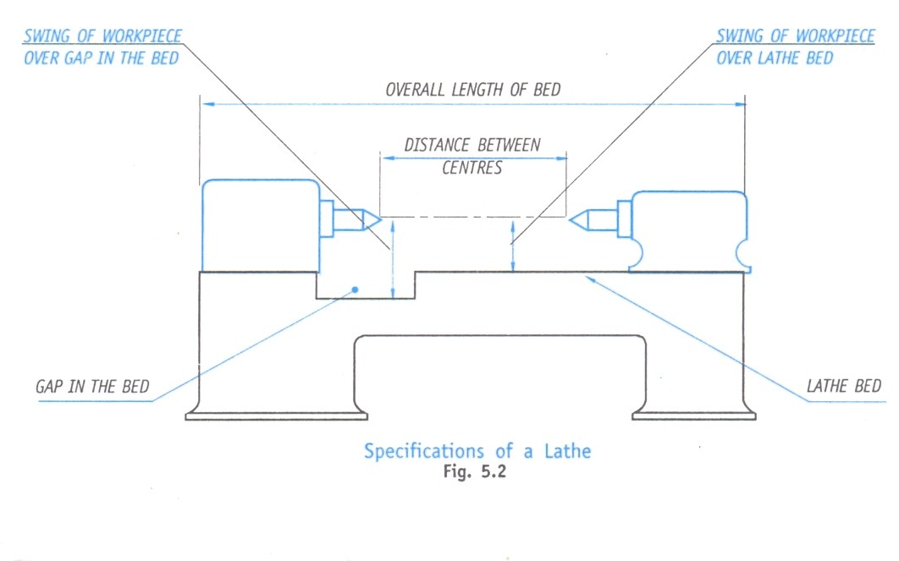
Specification of Lathe:
Lathe Operations
Lathe is the most versatile general-purpose machine tool. It is capable to perform a large variety of operations.
Following are a few operations that can be performed on a lathe:
- Turning: Removal of excess material from the workpiece according to the required size and shape by using single point cutting tool is called turning process. In other words, reduction in the diameter of the work piece is called turning process.
Depending upon the job requirement, the turning operation may be of various types, such as Plain turning.

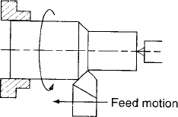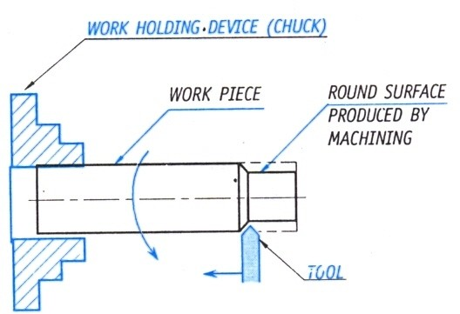

- Facing: It is a process of producing flat surfaces at the end of the work piece by using single point cutting tool is called facing or reducing the length of the work piece is called facing.
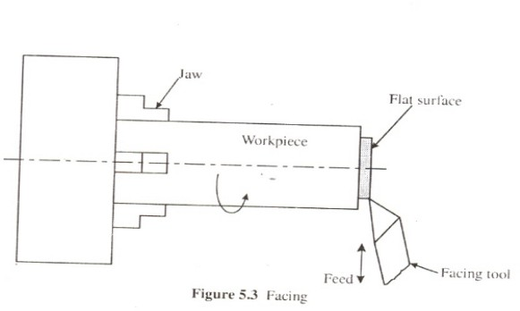
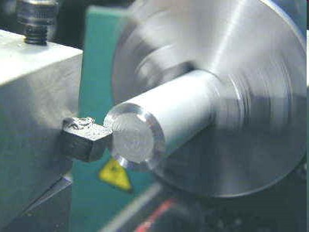

- Knurling: It is a special operation to produce diamond shaped pattern or serrated surface pattern on the work piece by using a special tool called knurling tool called knurling process. It is done for the purpose of creating a better gripping surface. Knurling is performed with special metal wheels called a knurling tool.

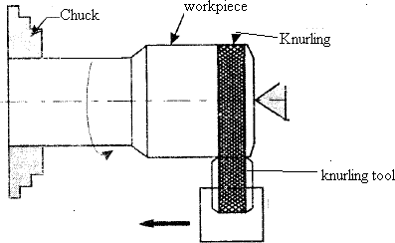

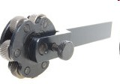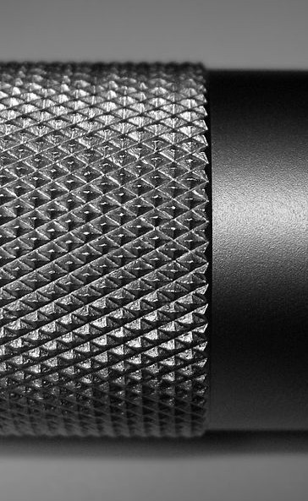

- Thread Cutting: It is a process of cutting helical grooves of a standard thread form. It may be of two types, namely, external thread cutting and internal thread cutting. Thread cutting operation performed on lathe to produce threads by using a tool whose shape will be same as that of thread
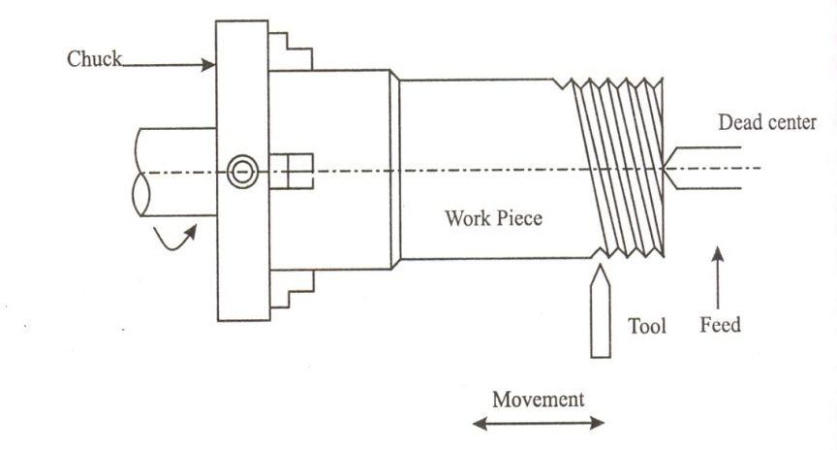
- Taper turning by swiveling the Compound Rest:

Taper Turning

Taper turning is the process of generating a conical surface, like an uniform increase or decrease in the diameter of the workpiece along its length. It is done on a lathe by feeding the cutting tool at an angle to the axis of rotation the workpiece.
There are four basic methods of turning tapers on a lathe:

by compound rest swiveling method;
  - by tailstock set-over/tailstock offset method;

Taper Turning by Swiveling the Compound Rest

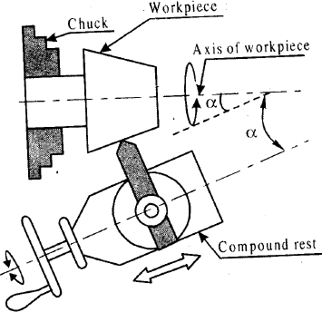

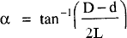

Where, D= bigger diameter of the taper (mm) d= smaller diameter of the taper (mm) L= Length of the taper (mm)

- The work piece is rotated on lathe axis .The cutting tool mounted on the compound rest is attached to a circular base which can be swiveled and locked at any desired taper angle as shown in figure .
- Compound rest may be swiveled at either side of the lathe. When the compound rest set at the desired taper angle is moved against the workpiece the cutting tool generates the required tapered surface on the workpiece.
- As the compound tool rest has only limited movement, this method can generate only short tapers.

Milling Machine Tool

Milling is a metal cutting operation in which multi point cutting tool is used to produce flat surfaces, slots, pockets, keyways, grooves etc. In milling machine cutting tools is rotating and work piece is fed against rotating milling cutter.
Types of Milling
Horizontal milling machine:
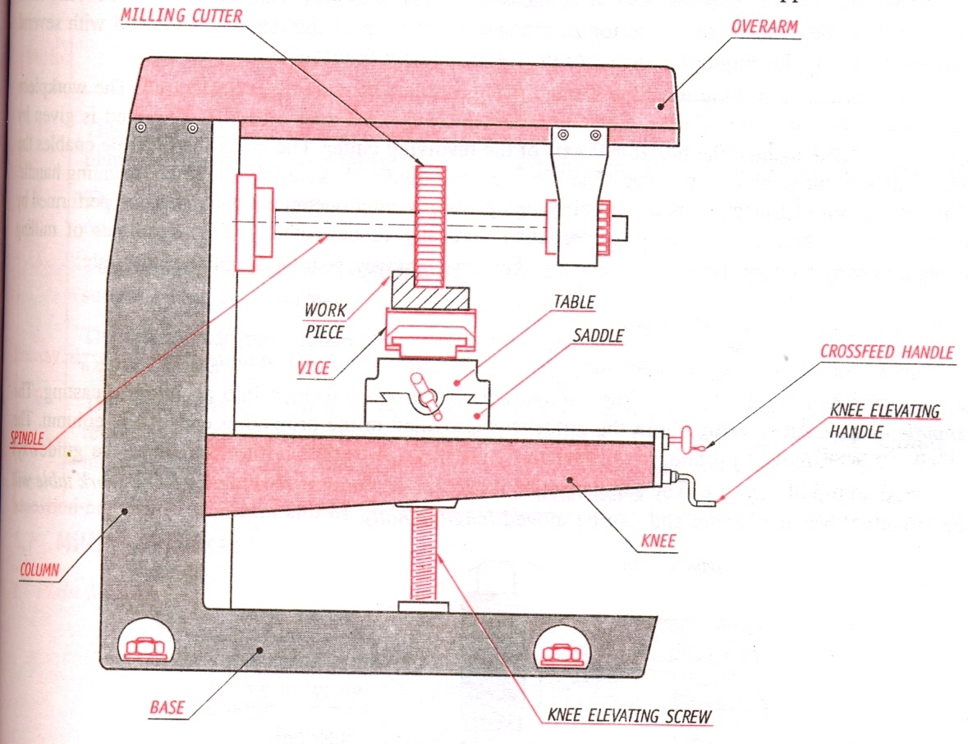
- Base – it is a hollow cast iron structure which forms the foundation of machine on which other parts are mounted.
- Column – houses main drive, transmission system, spindle. It is provided with vertical guide square or dovetail to accommodate knee.
- Knee – mounted on vertical slide of column moved up or down by an elevating screw.
- Saddle – slides on knee by operating cross feed handle. This is provided with guide ways on top to support the table
- Table – mounted on top of saddle with a dovetail fit. Table slides perpendicular to the axis of saddle movement.
- Arbor – shaft which carries the cutter with its other end supported by yoke.
- Over arm – mounted on top of column. Supports the free end of arbor through yoke.
- Work piece is mounted directly on table using machine vice.
- Cutter of required shape and size are mounted over the arbor which is driven by spindle.

Vertical milling machine
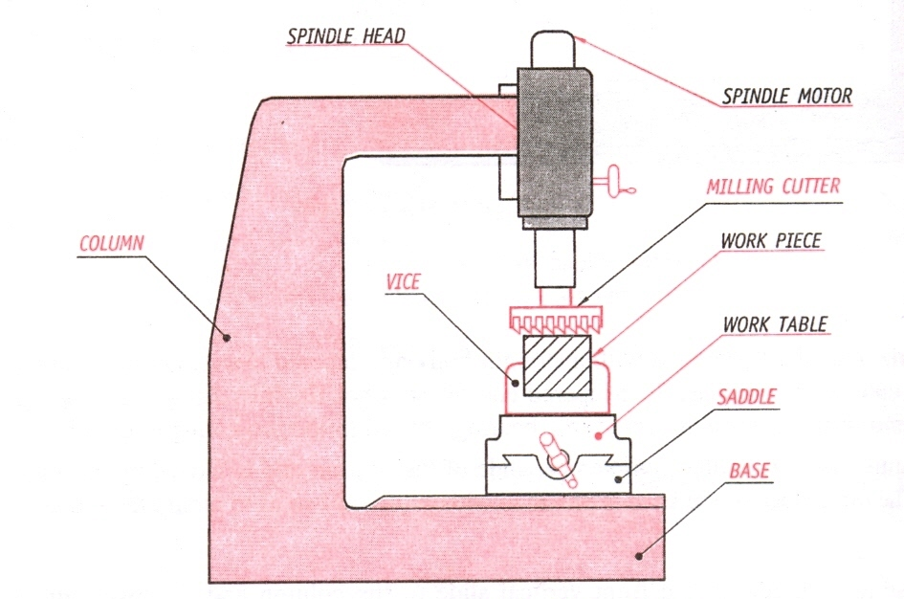

- Base and column – base is the foundation for the machine and column is the vertical part houses motor, transmission system.
- Spindle head – mounted on front face of the column at the top. It has a vertical spindle run by motor to which milling tool is fitted to end.
  - Work piece is mounted on table and cutter is mounted on vertical spindle.
  - Feed is given by movement of knee, saddle and table and also vertical movement of tool.
Milling methods
Up milling

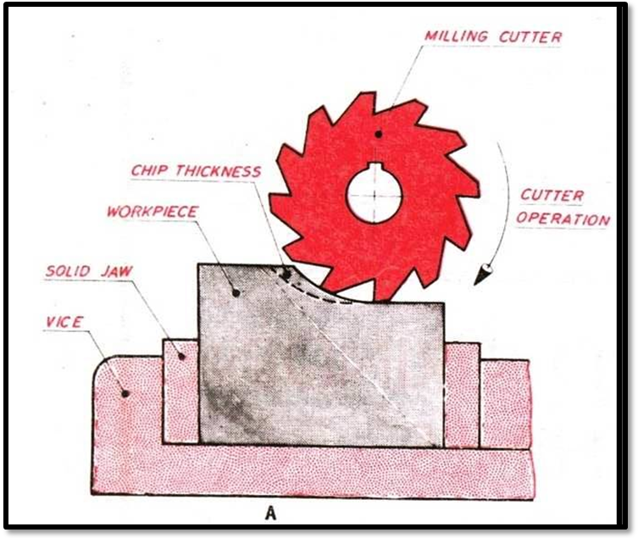
- Work piece is fed against the direction of rotating milling cutter.

Down milling

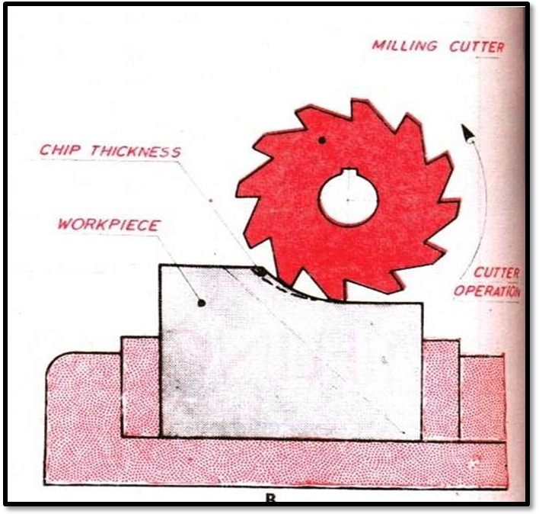

The workpiece is fed against the same direction of rotating milling cutter.
Milling process /Milling Operations
- Plain milling
- End Milling
- Slot milling
1. Plain milling
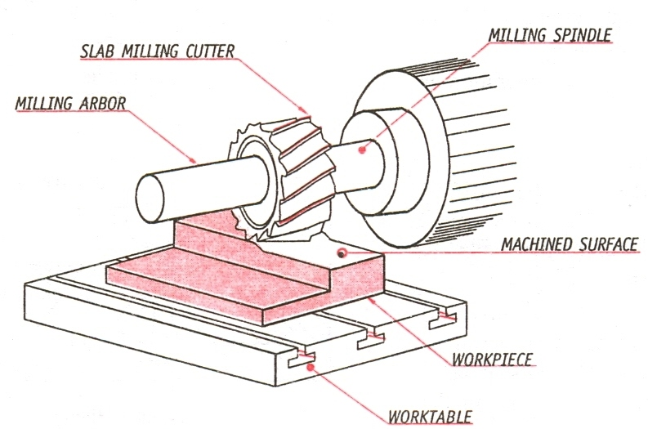
- Process used to produce flat surfaces on the work piece by using horizontally arranged multipoint milling cutter.
- Milling cutter axis is parallel to the surface that is being milled.

- End milling
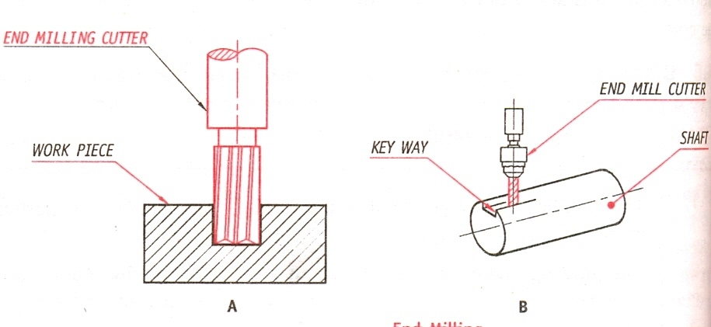
It is used to produce slots, pockets and keyways by using multipoint milling cutter which is arranged vertically. Axis of milling cutter is perpendicular to the surface of the work piece.

3. Slot milling

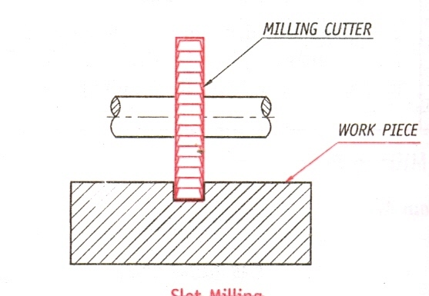

Axis of spindle is horizontal or parallel to surface of work piece. It is used produce rectangular slots, T-slots, dovetail slots by using milling cutter called slot drill.

Drilling Machine
Drilling: is an operation of producing holes in a solid metal / non metal by means of a revolving tool called drill or twist drill.
The machines employed for drilling holes are called drilling machines. The drilling machine is the one of the essential machine tool used in fabrication, production shop and tool rooms, for machining/producing holes.
The machine consists of a spindle which provides rotary motion to the drilling tool (twist). The spindle may also produce motion to table on which the work rests.
Working Principle of Drilling Machine:
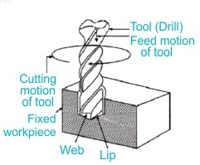
When power is supplied to the motor, the spindle rotates, causing the attached stepped pulley to also rotate as shown in figure.
On the opposite end, a stepped pulley is attached, which can be inverted to increase or decrease the rotational speed. A V-belt is installed between the stepped pulleys for maximum power transmission.
Now, the drill bit that was placed in the fixed workpiece is connected to the spindle. As it rotates through the rotation of pulleys, the drill bit rotates. The spindle is moved down to advance the drilling process with the help of a handwheel. After the hole is drilled, the handwheel is rotated to lift the spindle. The final result creates a hole in the fixed workpiece.
TYPES OF DRILLING MACHINES
l) Portable drilling machine
2) Sensitive or bench drilling machine
3) Up-right drilling machine
4) Radial drilling machine
5) Gang drilling machine
6) Multiple-spindle drilling machine
7) Deep-hole drilling machine

Drilling operations

- Drilling

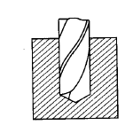

Drilling is the most important and common drilling machine operation. In the drilling, we usually, produce a cylindrical hole inside the workpiece and remove the material inside it. Here, the material is removed by the rotating edge of the cutting tool and that rotating edge is called a drill.
It is a process of creating or originating a hole in a solid workpiece using a tool called Twist drill.
- Reaming:
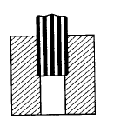

Reaming is the operation of finishing an already drilled hole using a reamer. A reamer which matches the diameter of the already existing hole is fitted in to the machine spindle and reaming operation is carried over which is similar to drilling operation except higher spindle speed in reaming. The material removed is very less and the drilled hole surfaces are finished with high accuracy. The accuracy of a reamed hole is around ±0.005 mm.
- Boring:

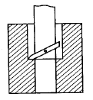

Boring is the operation of enlarging an already drilled hole using a boring tool. The boring tool is fixed to the boring bar which in turn fits into the machine spindle. The speed of rotation of a boring tool is lesser than the speed of rotation of a corresponding reamer. Holes with accuracy of± 0.00 125 mm can be obtained by this operation.
- Tapping operation:
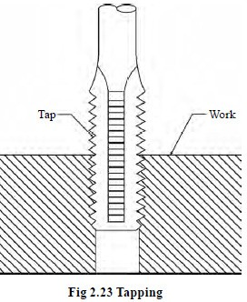

- Counter sinking operation:

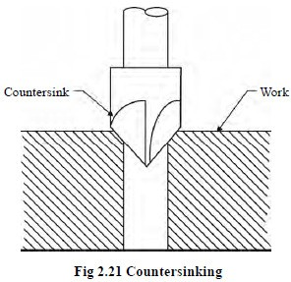

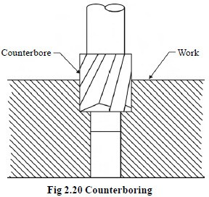
- Counter boring:

Introduction to Advanced Manufacturing Systems:

Computer Numerical Control

Definition of CNC Machine
Let me first introduce you about what is CNC machine, so CNC stands for Computer Numerical Control. When computers are used to control a Numerical Control (NC) machine tool than the machine is called CNC machine. In other words, the use of computers to control machine tools like lathe, mills, slotter, shaper etc is called CNC machine.
The cutting operations performed by the CNC is called CNC machining. The Various machining services in which CNC machine is used are known as CNC machining services. In CNC machine shops, programs are designed or prepared first, and then it is fed to the CNC machine. According to the program, the CNC controls the motion and speed of the machine tools.

Block Diagram of CNC Machine

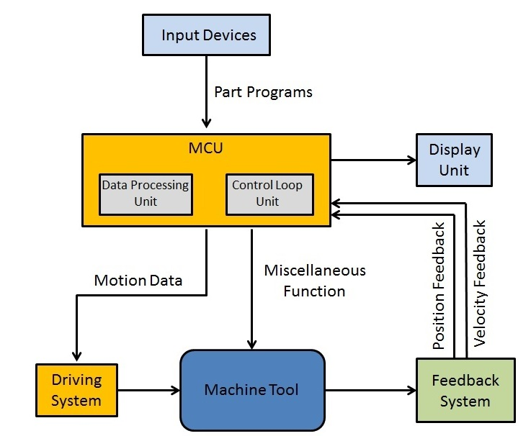

Main Components of CNC Machine:
The main parts of the CNC machine are
- Input Devices: These are the devices which are used to input the part program in the CNC machine. There are three commonly used input devices and these are punch tape reader, magnetic tape reader and computer via RS-232-C communication.
- Machine Control Unit (MCU): It is the heart of the CNC machine. It performs all the controlling action of the CNC machine, the various functions performed by the MCU are
- It reads the coded instructions fed into it.
- It decodes the coded instruction.
- It implements interpolation (linear, circular and helical) to generate axis motion commands.
- It feeds the axis motion commands to the amplifier circuits for driving the axis mechanisms.
- It receives the feedback signals of position and speed for each drive axis.
- It implements the auxiliary control functions such as coolant or spindle on/off and tool change.
- Machine Tool: A CNC machine tool always has a slide table and a spindle to control of the position and speed. The machine table is controlled in X and Y axis direction and the spindle is controlled in the Z axis direction.
4. Driving System: The driving system of a CNC machine consists of amplifier circuits, drive motors and ball lead screw. The MCU feeds the signals (i.e. of position and speed) of each axis to the amplifier circuits. The control signals are than augmented (increased) to actuate the drive motors. And the actuated drive motors rotate the ball lead screw to position the machine table.
5. Feedback System: This system consists of transducers that act as sensors. It is also called a measuring system. It contains position and speed transducers that continuously monitor the position and speed of the cutting tool located at any instant. The MCU receives the signals from these transducers and it uses the difference between the reference signals and feedback signals to generate the control signals for correcting the position and speed errors.
6. Display Unit: A monitor is used to display the programs, commands and other useful data of CNC machine.

Advantages
- It can produce jobs with the highest accuracy and precision than any other manual machine.
- It can be run for 24 hours a day.
- The parts produced by it have the same accuracy. There is no variation in the parts manufactured.
- A highly skilled operator is not required to operate it. A semi-skilled operator can also operate accurately and more precisely.
- Operators can easily make changes and improvements and reduce the delay time.
- It has the capability to produce complex designs with high accuracy in minimum possible time.
- The modern design software, allows the designer to simulate the manufacturer of his/her idea. And this removes the need for making a prototype or model and saves time and money.
- Fewer workers are required to operate a CNC and save labor costs.

Disadvantages
Despite of having so many advantages, It has some disadvantages too. And these are:
- The cost of the CNC machine is very high as compared with a manually operated machine.
- The parts of the CNC machines are expensive.
- The maintenance cost in the case of CNC is quite high.
- It does not eliminate the need for costly tools.

Applications of CNC
Almost every manufacturing industry uses CNC machines. With an increase in the competitive environment and demands, the demand for CNC usage has increased to a greater extent. The machine tools that come with the CNC are lathe, mills, shaper, welding, etc. The industries that are using CNC machines are the automotive industry, metal removing industries, industries of fabricating metals, electrical discharge machining industries, wood industries, etc.

3D PRINTING OR ADDITIVE MANUFACTURING
3D printing, also known as additive manufacturing, is a method of creating a three dimensional object layer-by-layer using a computer created design.
3D printing is an additive process whereby layers of material are built up to create a 3D part. This is the opposite of subtractive manufacturing processes, where a final design is cut from a larger block of material. As a result, 3D printing creates less material wastage.
There are a variety of 3D printing materials, including thermoplastics such as acrylonitrile butadiene styrene (ABS), metals (including powders), resins and ceramics.
The earliest 3D printing manufacturing equipment was developed by Hideo Kodama of the Nagoya Municipal Industrial Research Institute, when he invented two additive methods for fabricating 3D models.

3D Printing Technologies
There are three broad types of 3D printing technology; sintering, melting, and stereolithography.
- Sintering is a technology where the material is heated, but not to the point of melting, to create high resolution items. Metal powder is used for direct metal laser sintering while thermoplastic powders are used for selective laser sintering.
- Melting methods of 3D printing include powder bed fusion, electron beam melting and direct energy deposition, these use lasers, electric arcs or electron beams to print objects by melting the materials together at high temperatures.
- Stereolithography utilises photopolymerization to create parts. This technology uses the correct light source to interact with the material in a selective manner to cure and solidify a cross section of the object in thin layers.
3D printing, also known as additive manufacturing, processes have been categorized into seven groups by ISO/ASTM 52900 additive manufacturing - general principles - terminology. All forms of 3D printing fall into one of the following types:
- Binder Jetting
- Direct Energy Deposition
- Material Extrusion
- Material Jetting
- Powder Bed Fusion
- Sheet Lamination
- VAT Polymerization

Advantages and Disadvantages
The advantages of 3D printing include:
- Bespoke, cost-effective creation of complex geometries:
This technology allows for the easy creation of bespoke geometric parts where added complexity comes at no extra cost. In some instances, 3D printing is cheaper than subtractive production methods as no extra material is used.
- Affordable start-up costs:
Since no moulds are required, the costs associated with this manufacturing process are relatively low. The cost of a part is directly related to the amount of material used; the time taken to build the part and any post processing that may be required.
- Completely customisable:
Because the process is based upon computer aided designs (CAD), any product alterations are easy to make without impacting the manufacturing cost.
- Ideal for rapid prototyping:
Because the technology allows for small batches and in-house production, this process is ideal for prototyping, which means that products can be created faster than with more traditional manufacturing techniques, and without the reliance on external supply chains.
- Allows for the creation of parts with specific properties:
Although plastics and metals are the most common materials used in 3D printing, there is also scope for creating parts from specially tailored materials with desired properties. So, for example, parts can be created with high heat resistance, water repellency or higher strengths for specific applications.
The disadvantages of 3D printing include:
- Can have a lower strength than with traditional manufacture:
While some parts, such as those made from metal, have excellent mechanical properties, many other 3D printed parts are more brittle than those created by traditional manufacturing techniques. This is because the parts are built up layer-by-layer, which reduces the strength by between 10 and 50%.
- Increased cost at high volume:
Large production runs are more expensive with 3D printing as economies of scale do not impact this process as they do with other traditional methods. Estimates suggest that when making a direct comparison for identical parts, 3D printing is less cost effective than CNC machining or injection moulding in excess of 100 units, provided the parts can be manufactured by conventional means.
- Limitations in accuracy:
The accuracy of a printed part depends on the type of machine and/or process used. Some desktop printers have lower tolerances than other printers, meaning that the final parts may slightly differ from the designs. While this can be fixed with post-processing, it must be considered that 3D printed parts may not always be exact.
- Post-processing requirements:
Most 3D printed parts require some form of post-processing. This may be sanding or smoothing to create a required finish, the removal of support struts which allow the materials to be built up into the designated shape, heat treatment to achieve specific material properties or final machining.

3D Printing Industries
Due to the versatility of the process, 3D printing has applications across a range of industries, for example:

Aerospace
3D printing is used across the aerospace (and astrospace) industry due to the ability to create light, yet geometrically complex parts, such as blisks. Rather than building a part from several components, 3D printing allows for an item to be created as one whole component, reducing lead times and material wastage.

Automotive
The automotive industry has embraced 3D printing due to the inherent weight and cost reductions. It also allows for rapid prototyping of new or bespoke parts for test or small-scale manufacture. So, for example, if a particular part is no longer available, it can be produced as part of a small, bespoke run, including the manufacture of spare parts. Alternatively, items or fixtures can be printed overnight and are ready for testing ahead of a larger manufacturing run.

Medical
The medical sector has found uses for 3D printing in the creation of made-to-measure implants and devices. For example, hearing aids can be created quickly from a digital file that is matched to a scan of the patient's body. 3D printing can also dramatically reduce costs and production times.

Rail
The rail industry has found a number of applications for 3D printing, including the creation of customised parts, such as arm rests for drivers and housing covers for train couplings. Bespoke parts are just one application for the rail industry, which has also used the process to repair worn rails.

Robotics
The speed of manufacture, design freedom, and ease of design customization make 3D printing perfectly suited to the robotics industry. This includes work to create bespoke exoskeletons and agile robots with improved agility and efficiency.

