ELEMENTS OF MECHANICAL ENGINEERING (BEMEM103/203)
MODULE-3
I.C. Engines
An internal combustion engine more popularly known as I.C.Engine, is a heat engine which converts heat energy in to useful mechanical work.

Classification of Engines

- External combustion engine: An engine in which combustion of fuel takes place outside the engine cylinder is called external combustion engine. These engines are generally called EC engines. Ex: Steam engines, steam turbines, closed cycle gas turbine etc.
- Internal combustion engine: An engine in which combustion of fuel takes place inside the engine cylinder is called internal combustion engine. These engines are generally called IC engines. Ex: Petrol engine, diesel engine, gas engine etc.
Further classification of I.C. engines:

- According to the type of fuel used
- Petrol engines: fuel used is petrol.
- Diesel engines: fuel used is diesel.
- Gas engines: gaseous fuels like natural gas, biogas, are used.
- Bi-fuel engines: These engines use a mixture of two fuels.
- According to the number of strokes per cycle
- 4-stroke engine: the working cycle is completed in four different strokes.
- 2-stroke engine: the working cycle is completed in two different strokes.
- According to the method of ignition
- Spark ignition engine (S.I.Engine): fuel is ignited by an electric spark generated by a spark plug.
- Compression ignition engine (C.I. Engine): fuel gets ignited as it comes in contact with the hot compressed air.
- According to the cycle of combustion
- Otto cycle engine: combustion of fuel takes place at constant volume
- Diesel cycle engine: combustion of fuel takes place at constant pressure
- Duel combustion engine: combustion of fuel first takes place at constant volume and then at constant pressure.
- According to the number of cylinders
- Single cylinder engine: This type of engines consists of only one cylinder
- Multi cylinder engine: This type of engines consists of 2, 3, 4, 6 or 8 cylinders.
- According to the arrangement of cylinders
- Vertical engine: the cylinder is arranged in a vertical position
- Horizontal engine: the cylinder is arranged in horizontal position.
- Inline engine: the cylinders are arranged in line
- Radial engine: the cylinders are arranged along the circumference of a circle
- V-engine: In this type of engines, combination of two inline engines equally set an angle.
- According to the method of cooling
- Air cooled engine: the heated cylinder walls are cooled by continuous flow of air
- Water cooled engine: water is used for cooling the heated cylinder walls.
Parts of an I.C. Engine
Below figure shows the main parts of an I.e. engine and described below.
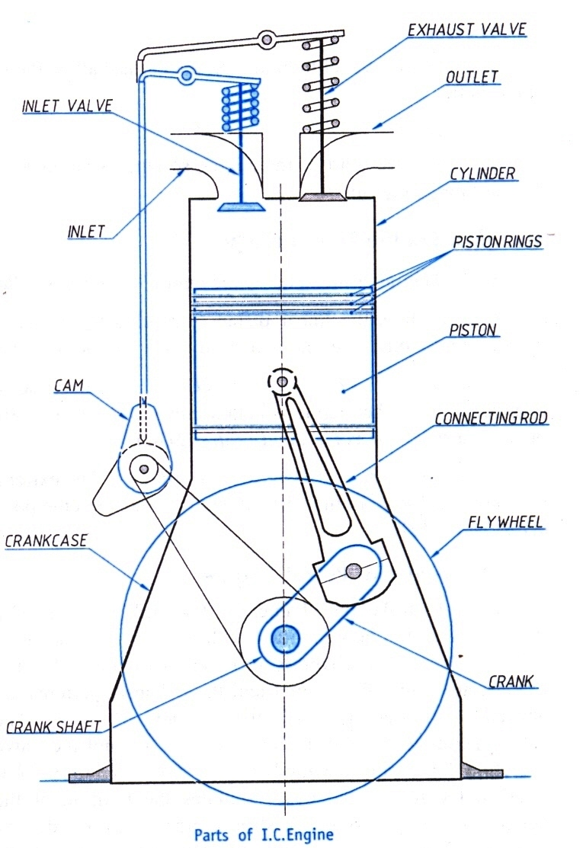

- Cylinder: It is the cylindrical vessel in which the fuel is burnt to develop the power. It is considered as heart of the engine. The primary functions of cylinder is
- To contain the working fluid under pressure and
- To guide the piston while reciprocating inside the cylinder.
- Cylinder head: it is a detachable component at the top end of the cylinder to close is closed by a removable cylinder head. It consists of two valves 'inlet valve' and 'exhaust valve'.
- Piston Rings: The rings which are placed in the grooves cut towards top of the piston are called Piston Rings. There are two set of rings inserted into the groves. They are compression rings and oil rings.
- Compression rings: The compression rings press hard with the cylinder walls forming a tight seal between the piston and the cylinder. This prevents escaping of the high pressure gases into the crankcase.
- Oil rings: The function of oil rings is to extract the lubricating oil from the cylinder walls and send it back to oil sump.
- Connecting rod: The connecting rod is a link that connects the piston and the crankshaft. Its function is to convert the reciprocating motion of the piston into rotary motion of the crankshaft.
- Crank: The crank is a lever with one of its end connected to the connecting rod by a pin joint with other end connected rigidly to the crankshaft.
- Crank case: It encloses the crankshaft and serves as a sump for the lubricating oil.
- Valves: The valves are control devices that allow the air/fuel to enter into the cylinder and also to discharge the burnt gases to atmosphere. There are two valves.
- Inlet valve: is the one through which fresh charge (air and fuel or air) enters into the cylinder.
- Exhaust valve: through which the burnt gases are discharged out of the cylinder.
- Cams: It is an element designed to control the movement of both the inlet and exhaust valves.
- Flywheel: It is a heavy mass of rotating wheel mounted on the crankshaft and is used as an energy storing device. The flywheel stores energy received during the power stroke and supplies the same during other strokes.

I.C. Engine Terminology
Figure, shows the details regarding the terms used in I.C. engines.
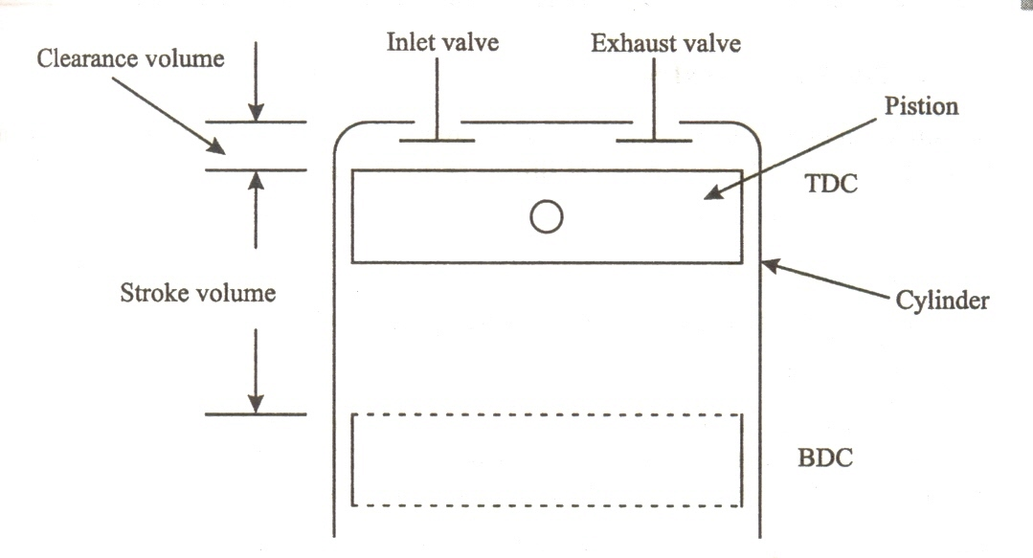

- Bore: The inside diameter of the cylinder is called 'bore'.
- Top dead center (TDC): The extreme position of the piston near to the cylinder head is called 'top dead center' or 'TDC'.
- Bottom dead center (BDC): The extreme position of the piston nearer to the crankshaft is called 'bottom dead center' or 'BDC'.
- Stroke: It is the linear distance travelled by the piston from the TDC to BDC or BDC to TDC.
- Clearance volume (V_{c}): It is the volume of cylinder above the top of the piston, when the piston is at the TDC.
- Swept volume or Stroke volume (V_{s}): It is the volume swept by the piston as it moves from BOC to TDC or TOC to BDC.
- Compression ratio: (R_{C}): The ratio of the total cylinder volume to the clearance volume is called Compression ratio.
Total cylinder volume = Stroke volume (V s) + Clearance volume (V e)
R = Vs+V_{C}
V_{c}
- Piston Speed: The average speed of the piston is called ‘piston speed’.
Piston speed = 2.L.N where L = Stroke length in m
N = Speed of engine in RPM.

FOUR-STROKE ENGINES
In 4-stroke engines, piston performs four different strokes to complete all the operations of the working cycle. The four different strokes performed are,
- Suction stroke
- Compression stroke
- Power stroke (Expansion stroke or Working stroke)
- Exhaust stroke
Each stroke is completed when the crankshaft rotates by 180°. Hence in 4-stroke engines, four different strokes are completed through 720° of the crankshaft rotation or 2 revolutions of the crankshaft.
Four stroke engines are classified as.
- Four Stroke Petrol Engine and
- Four Stroke Diesel Engine
- Four Stroke Petrol Engine
The working principle of a 4-Stroke Petrol engine is based on theoretical Otto cycle. Hence it is also known as Otto cycle engine.
A 4 - Stroke petrol engine performs four different strokes to complete one cycle. The working of each stroke is shown in the figure below and its details are discussed.
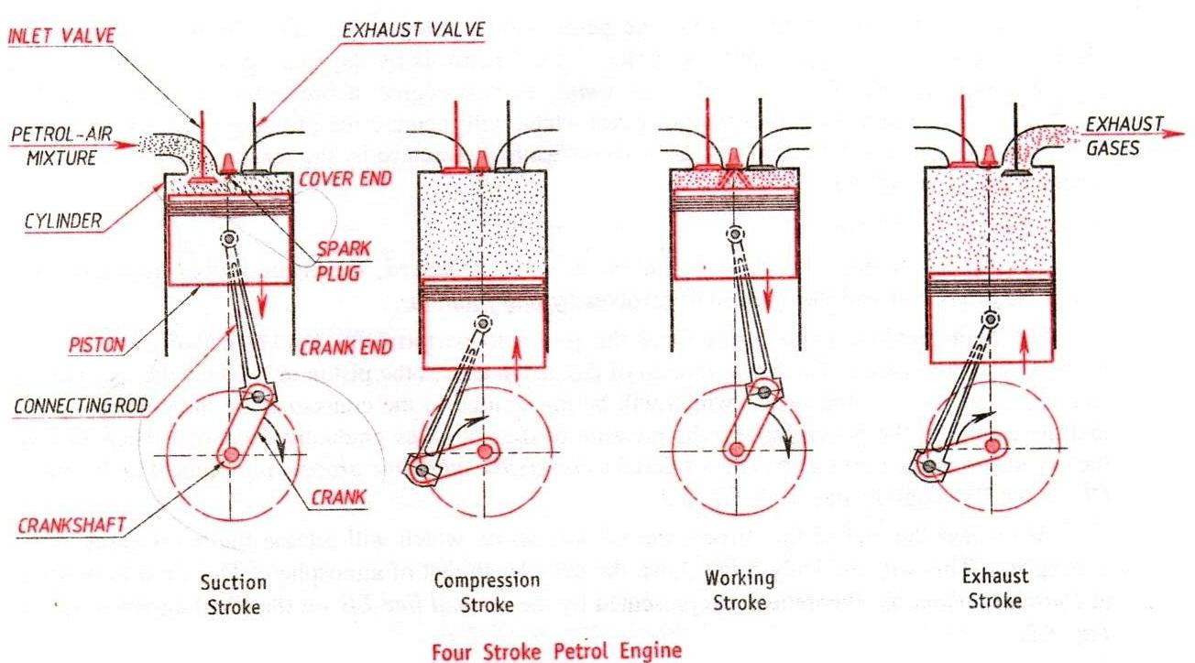
Fig. 3 Working of a 4-Stroke Petrol Engine

(a) Suction stroke:
At the beginning of the stroke, piston is at TDC and during the stroke, the piston moves from TDC to BDC. During this stroke the inlet valve opens and the exhaust valve will be closed. As the piston moves downwards, suction is created in the cylinder as a result, fresh air-petrol mixture (charge) is drawn into the cylinder through the inlet valve. As the piston reaches BDC, the suction stroke completes and inlet valve closes. The suction stroke is represented by the line AB on P- V diagram as shown in the figure below.
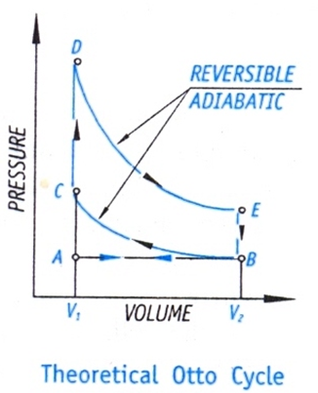
Fig.4 Theoretical Otto Cycle (P-V Diagram)

(b) Compression stroke:
During the stroke the piston moves from BDC to TDC and both inlet and exhaust valves are closed. As the piston moves upwards, the air-petrol mixture in the cylinder is compressed adiabatically. The pressure and temperature of the charge increases and this is shown by the curve BC on the P- V diagram. When the piston reaches the TDC, the spark plug ignites the charge. The combustion of the fuel takes place at the constant volume, due to which the pressure rises and is shown by a line CD on the P- V diagram. The compression ratio in petrol engines ranges from 7:1 to 11:1.

(c) Power stroke/Expansion stroke/working stroke
During this stroke piston moves from TDC to BDC and both inlet and exhaust valves remain closed. The combustion of fuel liberates gases and these gases start expanding. Due to expansion, the hot gases exert a large force on the piston and as a result the piston is pushed from TDC to BDC. The power impulse is transmitted down through the piston to the crank shaft through the connecting rod. This causes crankshaft to rotate at high speeds. Thus work is obtained in this stroke. Hence, this stroke is also called working stroke. Also gas expands and does work on the piston so this stroke is also called an expansion stroke.
The expansion of gases is adiabatic in nature and this is shown by the curve DE on P- V diagram. As the piston reaches the BDC, the exhaust valve opens. A part of the burnt gases escape through the exhaust valve out of the cylinder due to their own expansion and the drop in pressure at constant pressure is shown by the line EB on P- V diagram.

(d) Exhaust stroke:
During this stroke the piston moves from BDC to TDC. The inlet valve is closed and exhaust valve is opened. As the piston moves upward, it forces the burnt gases out of the cylinder to the atmosphere through the exhaust valve. This is shown by the line SA on P- V diagram. When the piston reaches the TDC, the exhaust valve closes and this completes the cycle.
In the next cycle the piston which is at TDC moves to BDC thereby allowing fresh charge to enter the cylinder and the process continues.

- Four Stroke Diesel Engine
The working principle of a 4-stroke diesel engine is based on theoretical diesel cycle. Hence it is also called diesel cycle engine.
A 4 - Stroke diesel engine performs four different strokes to complete one cycle. The working of each stroke is shown in the figure below and its details are discussed.

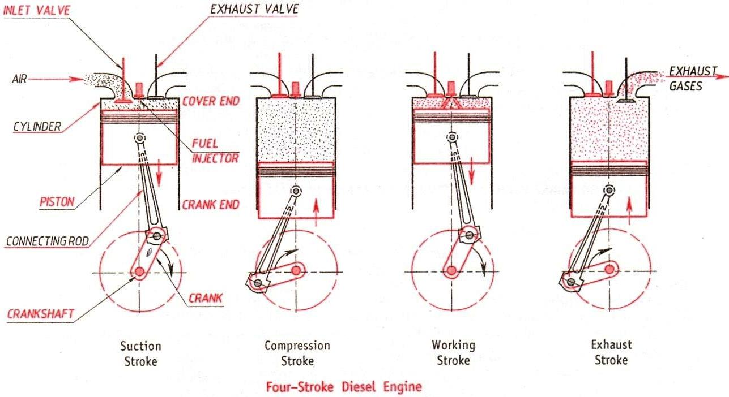

Fig.5 Working of 4-Stroke Diesel Engine

(a) Suction stroke:
During this stroke, piston moves from TDC to BDC and the inlet valve remains opens and the exhaust valve will be closed. The downward movement of the piston creates suction in the cylinder and as a result, fresh air is drawn into the cylinder through the inlet valve. When the piston reaches the BDC, the suction stroke completes and this is represented by the line AB on P-V diagram as shown in the figure below.
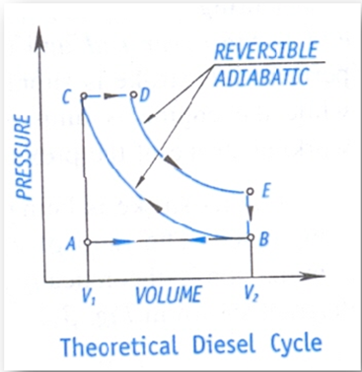
Fig 6. Theoretical Diesel Cycle (P V diagram)

(b) Compression stroke
During this stroke piston moves from BDC to TDC and both inlet and the exhaust valves are closed. As the piston moves upwards, air in the cylinder is compressed to a high pressure and temperature. The compression process is adiabatic in nature and is shown by the curve BC on P-V diagram. At the end of the stroke, the fuel (diesel) is sprayed into the cylinder by fuel injector. As the fuel comes in contact with the hot compressed air, it gets ignited and undergoes combustion at constant pressure. This process is shown by the line CD on PV diagram. At the point D fuel supply is cutoff. The compression ratio ranges from 16:1 to 20:1.
(c) Power stroke / Expansion stroke/ Working stroke
During this stroke, piston moves from TDC to BDC and both inlet and the exhaust valve remain closed. As combustion of fuel takes place, the burnt gases expand and exert a large force on the piston. Due to this, piston is pushed from TDC the BDC. The power impulse is transmitted down through the piston to the crank shaft through the connecting rod. This causes the crankshaft to rotate at high speeds. Thus work is obtained in this stroke.
The expansion of gases is adiabatic in nature and this is shown by the curve DE on P- V diagram. When the piston reaches the BDC, the exhaust valve opens. A part of burnt gases escapes through the exhaust valve out of the cylinder due to self expansion. The drop in pressure at constant volume is shown by the line EB on P- V diagram.
(d) Exhaust stroke
During this stroke, piston moves from BDC to TDC. The inlet valve is closed and the exhaust valve is opened. As the piston moves upward, it forces the remaining burnt gases out of the cylinder through the exhaust valve. This is shown by the line SA on P- V diagram. When the piston reaches the TDC the exhaust valve closes. This completes the cycle.
In the next cycle the piston which is at the TDC moves to BDC thereby allowing fresh air to enter into the cylinder and the process continues.

 | Position of the
Stroke | piston |  | Inlet valve | Exhaust valve | Crank rotation
 | Initial | Final
Suction | TDC | BDC | Open | Close | 0⁰ - 180⁰
Compression | BDC | TDC | Close | Close | 180⁰ - 360⁰
Power | TDC | BDC | Close | Close | 360⁰ - 540⁰
Exhaust | BDC | TDC | Close | Open | 540⁰ -720⁰
SI. | Petrol Engine (SI Engine) | Diesel Engine (CI Engine)
1. | Draws a mixture of petrol and air during suction stroke | Draws only air during suction stroke.
2. | The carburetor is employed to mix air and petrol in the required proportion and to supply to engine during | The injector is employed to inject the fuel at the end of compression stroke.
3. | Compression ratio ranges from 7: 1 to12: 1 | Compression ratio ranges from 18:1 to22:1
4. | The charge (petrol and air mixture) is ignited with the help of spark plug. This type of ignition is called spark ignition | The ignition of the diesel is accomplished by the compressed air This type of ignition is called compression ignition.
5. | The combustion of fuel takes place approximately at constant volume. | The combustion of fuel takes place approximately at constant pressure
 |  | .
6. | Works on theoretical Otto Cycle. | Works on theoretical Diesel Cycle.
7. | Power developed is less. | Power developed is more.
8. | Thermal efficiency is low. It is up to about 26% | Thermal efficiency is high. It is up to about 40%.
9. | These are high speed engines | These are low speed engines.
10. | The maintenance cost is less. | The maintenance cost is more.
11. | The running cost is high because of the higher cost of petrol. | The running cost is low because of lower cost of diesel
12. | Lighter and cheaper because of low compression ratio | Heavier and costlier because of high compression ratio.

Numericals on I C Engines:
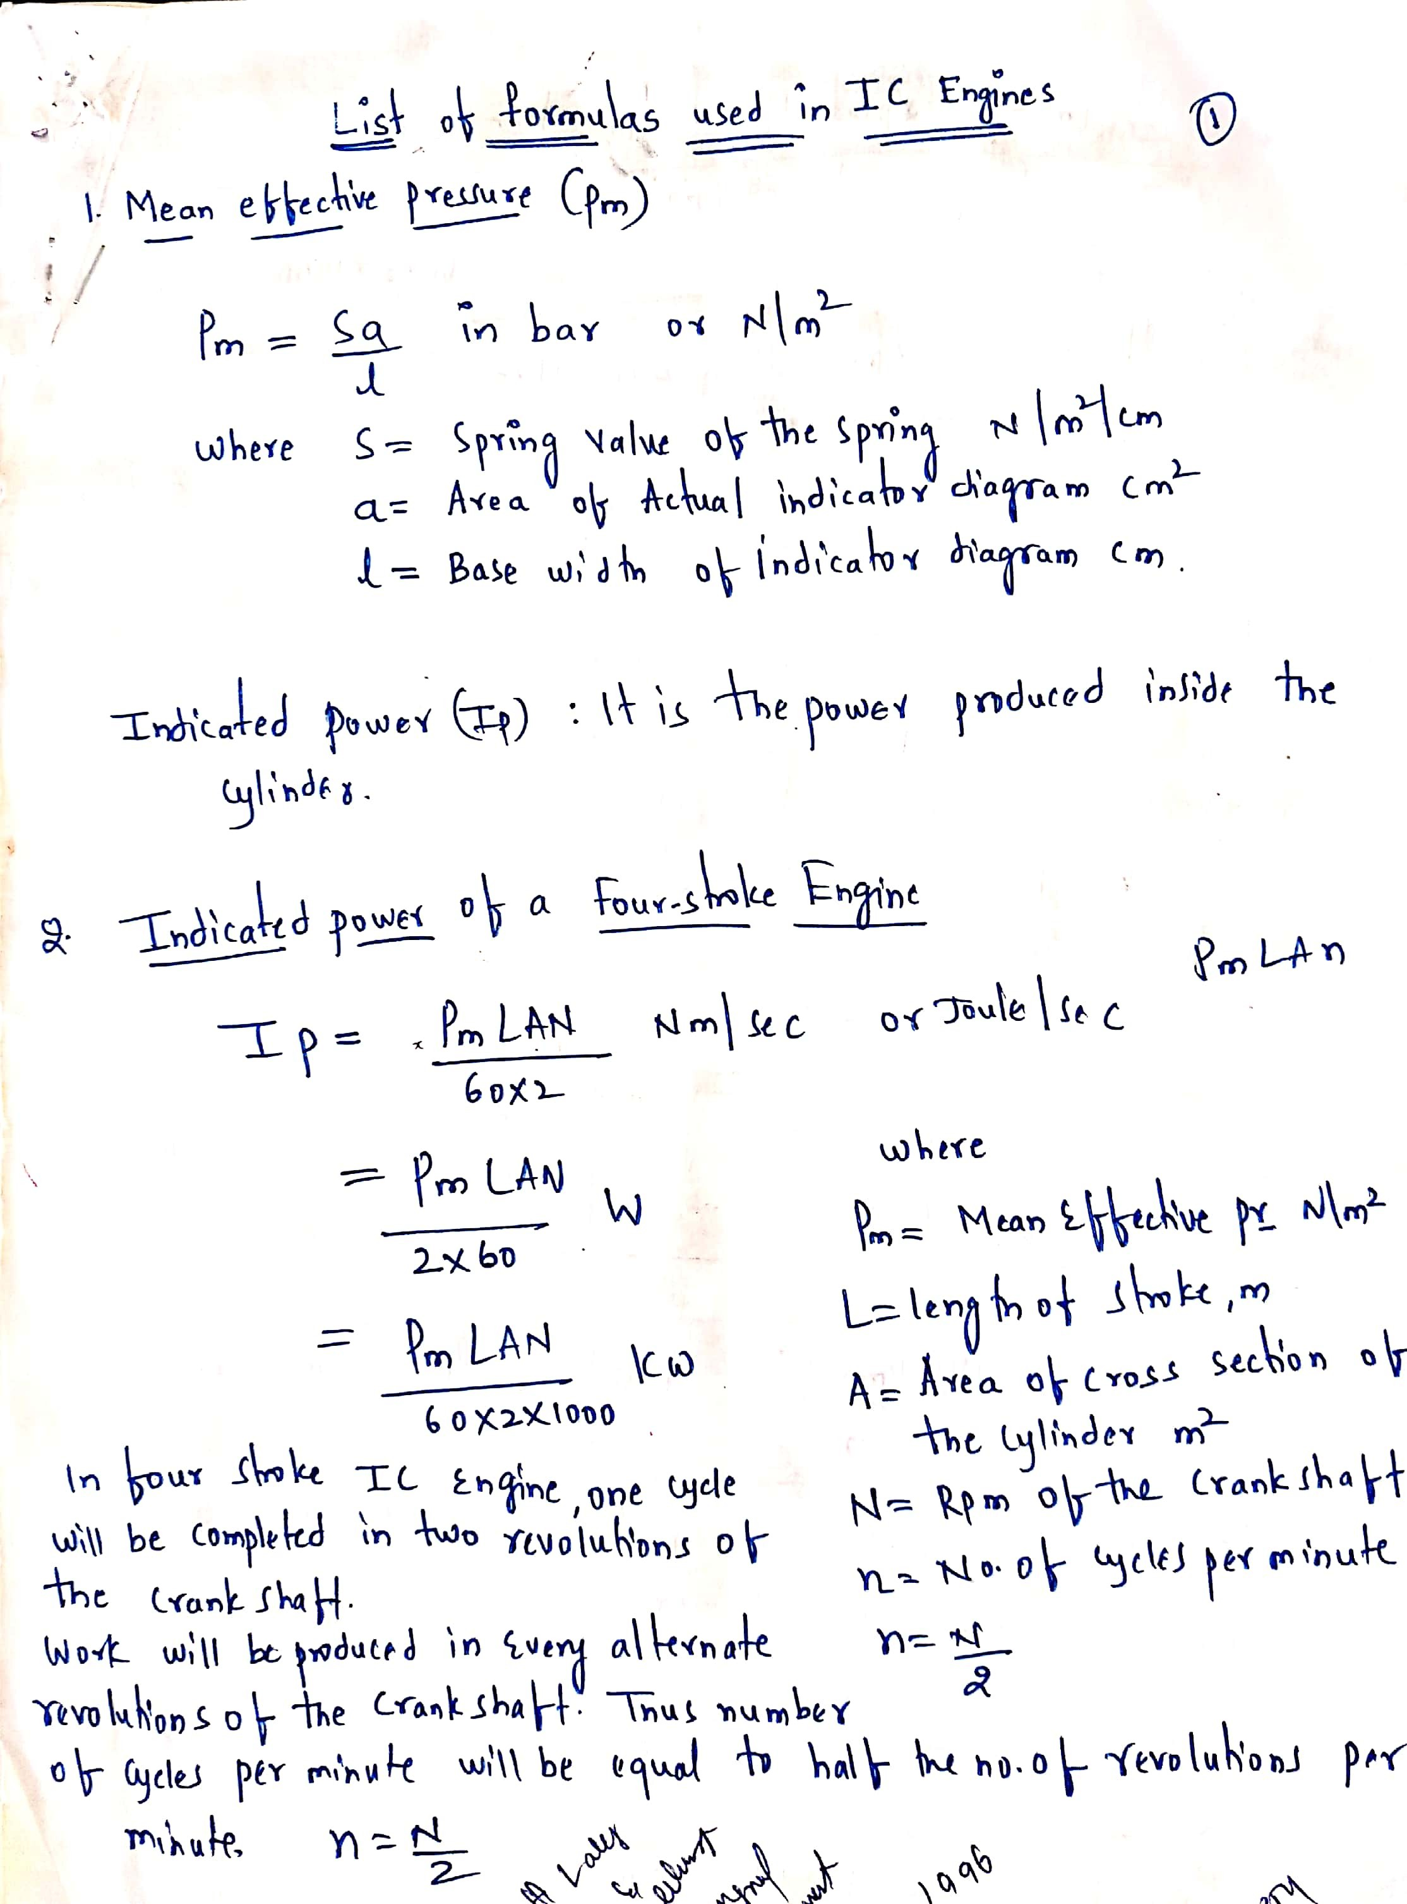

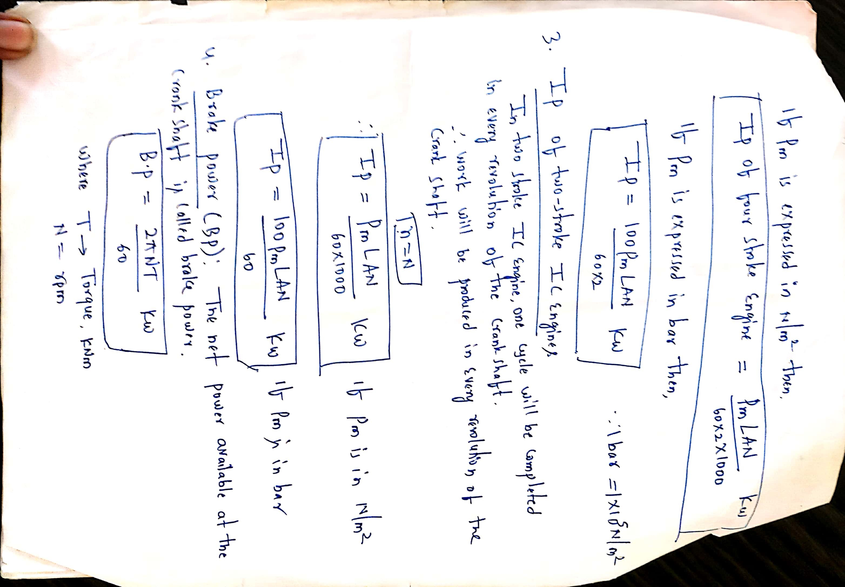

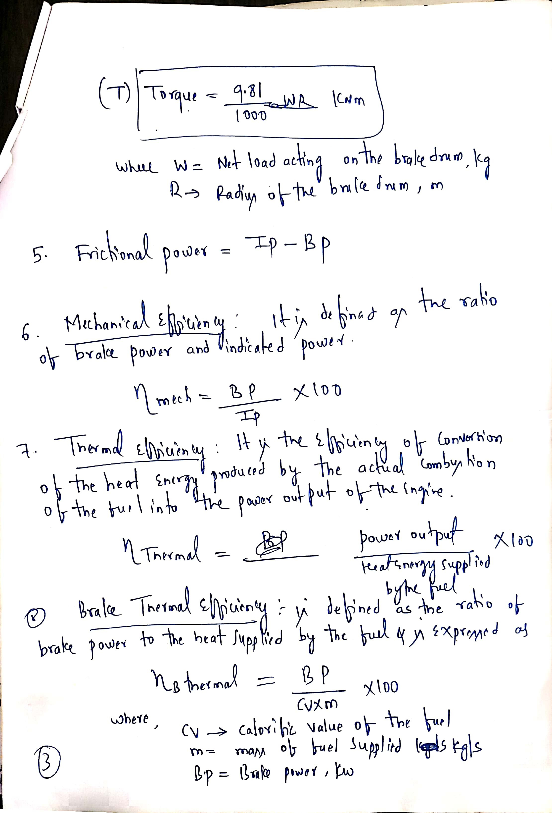

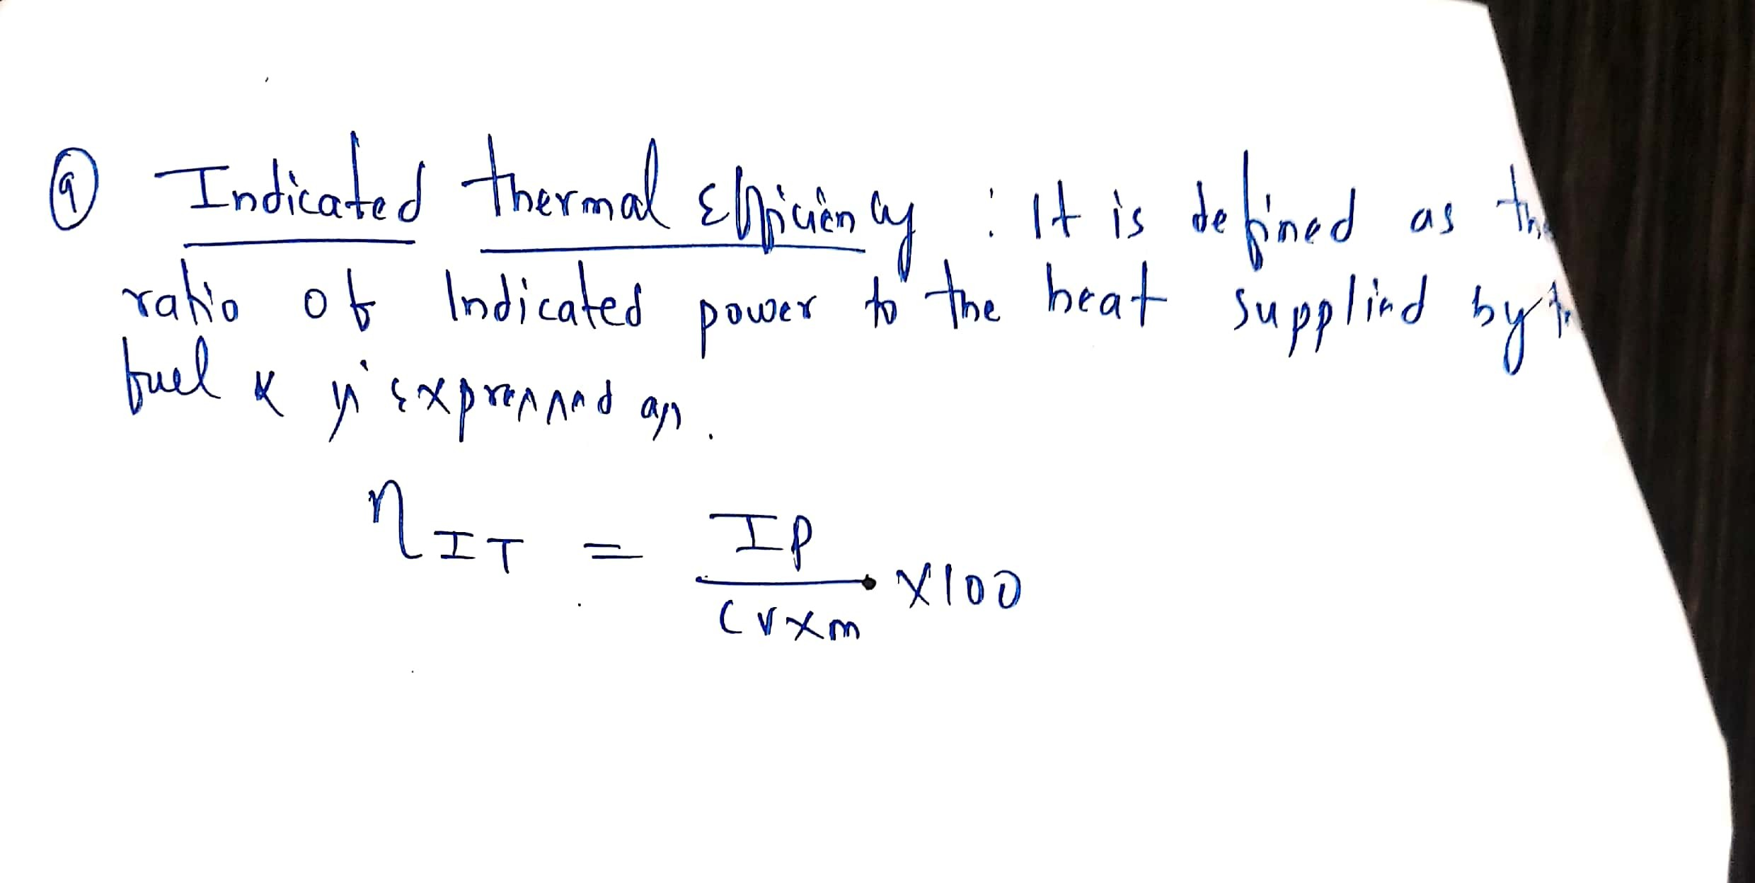

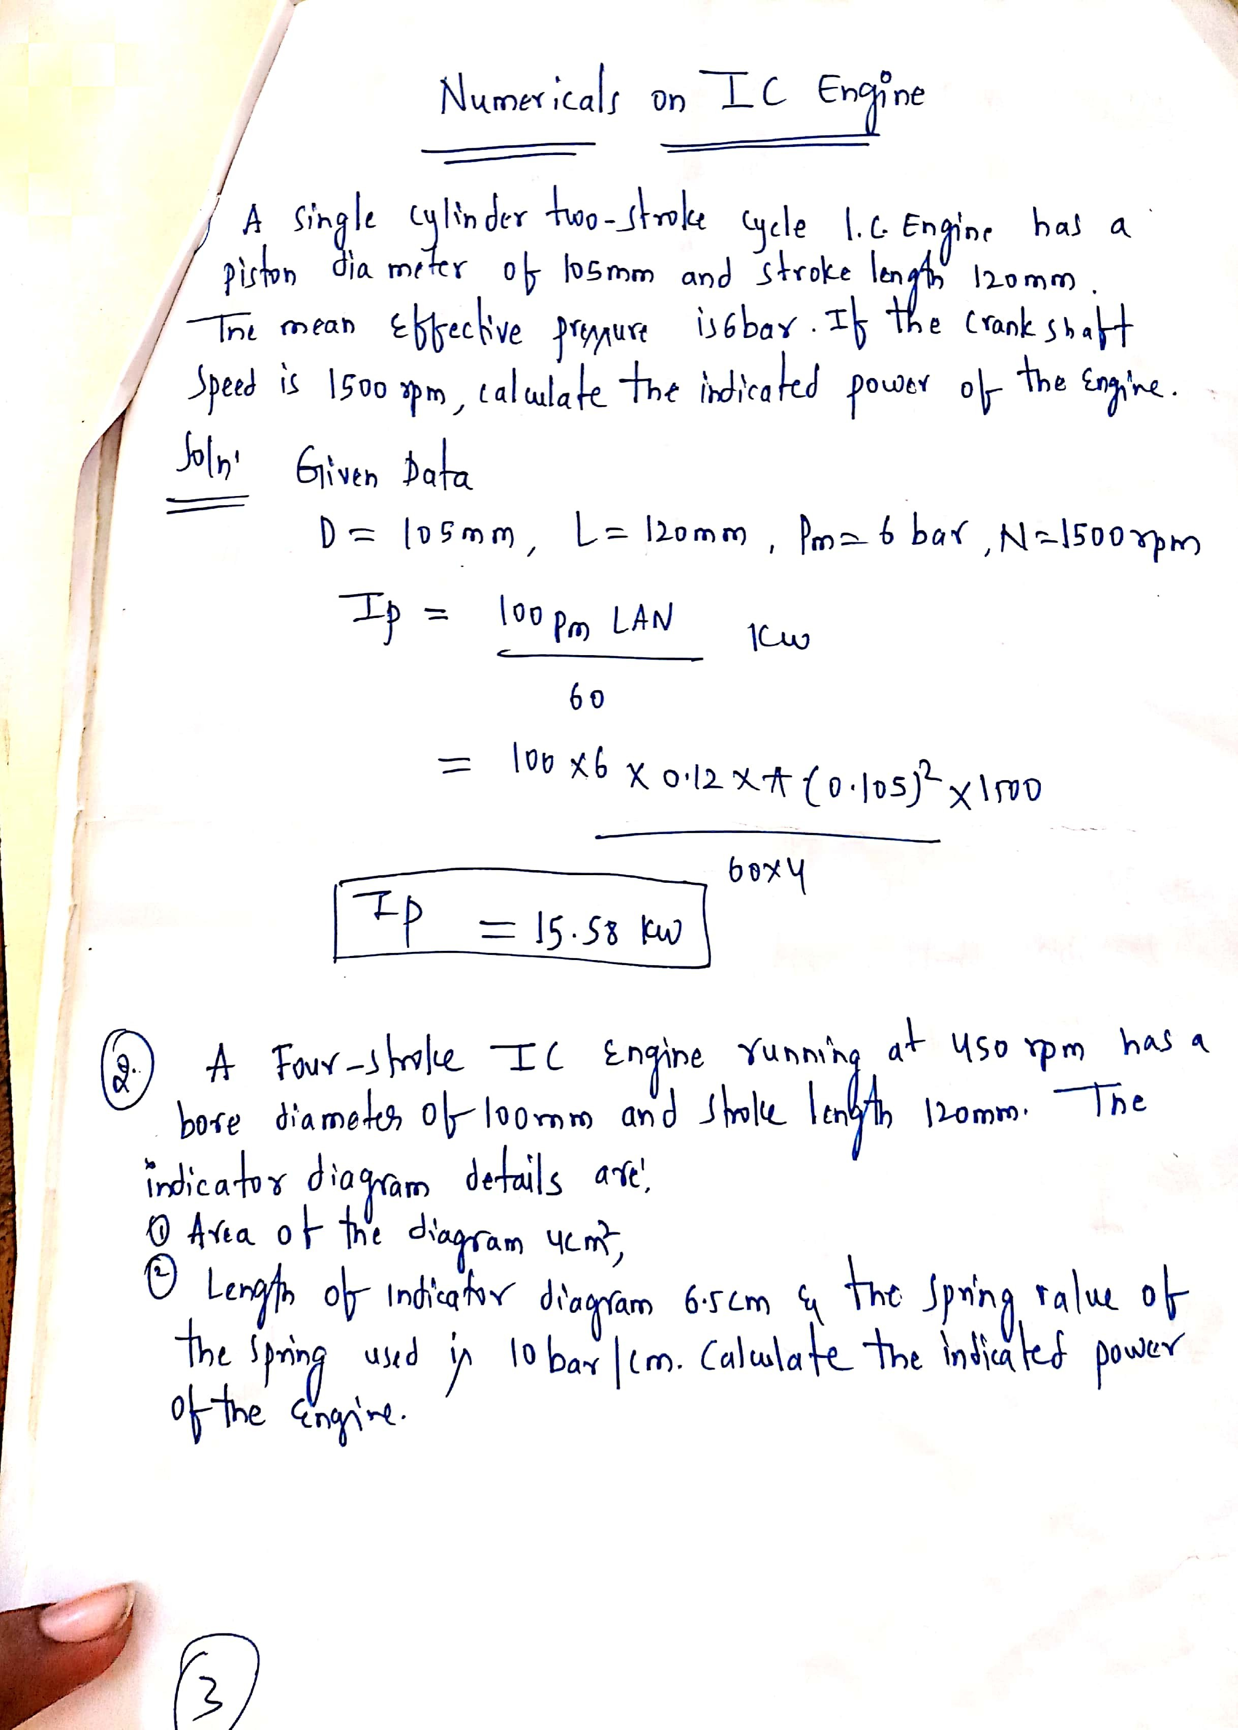

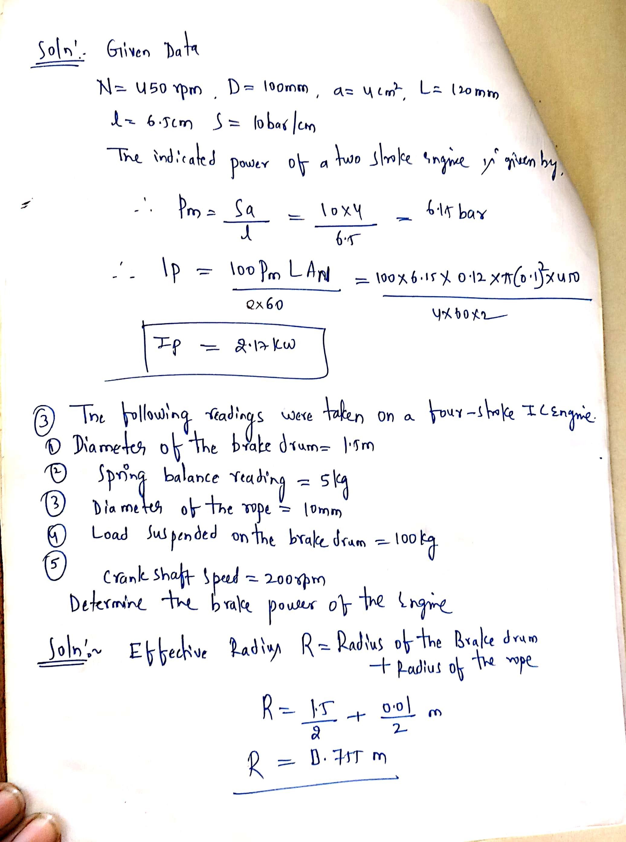

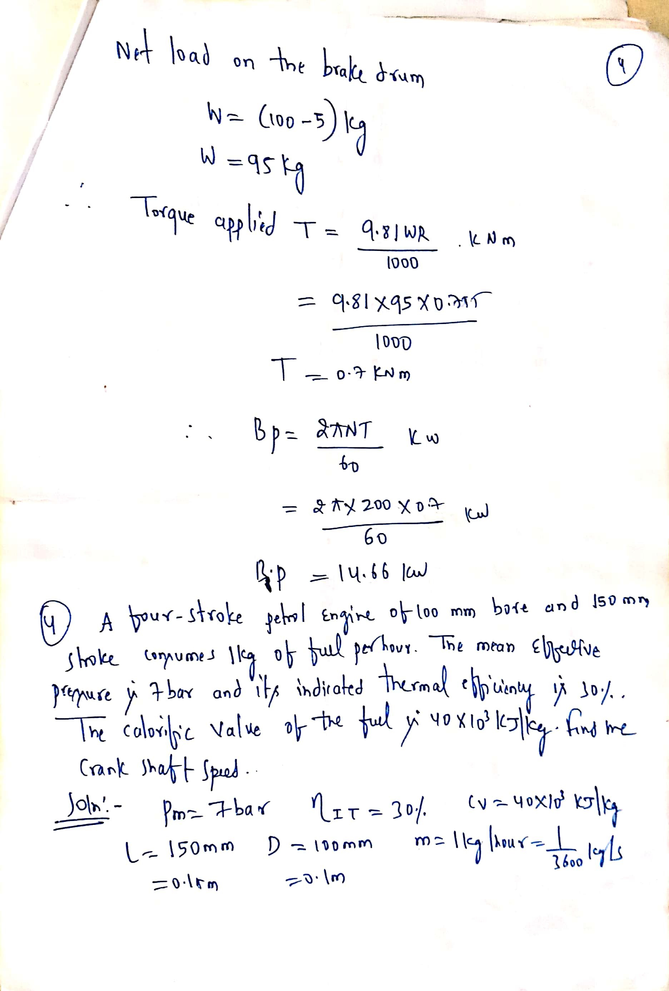

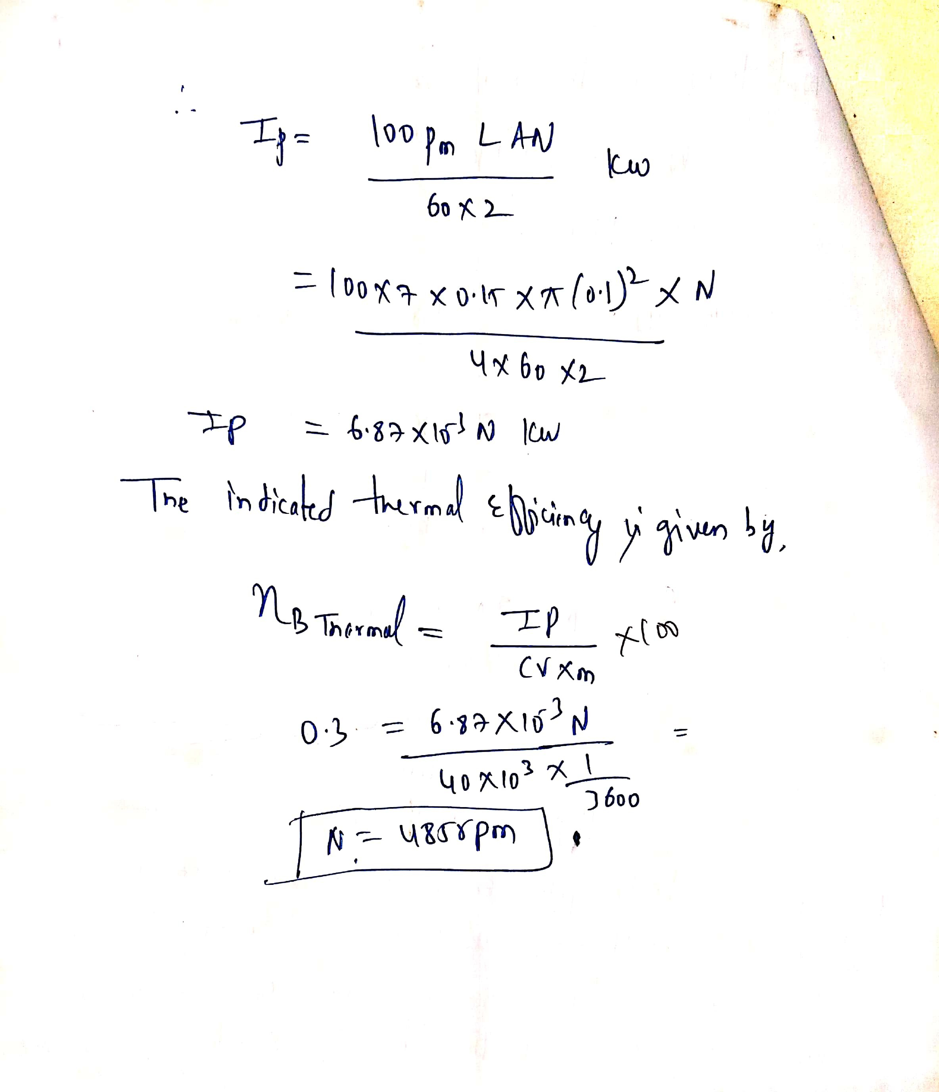

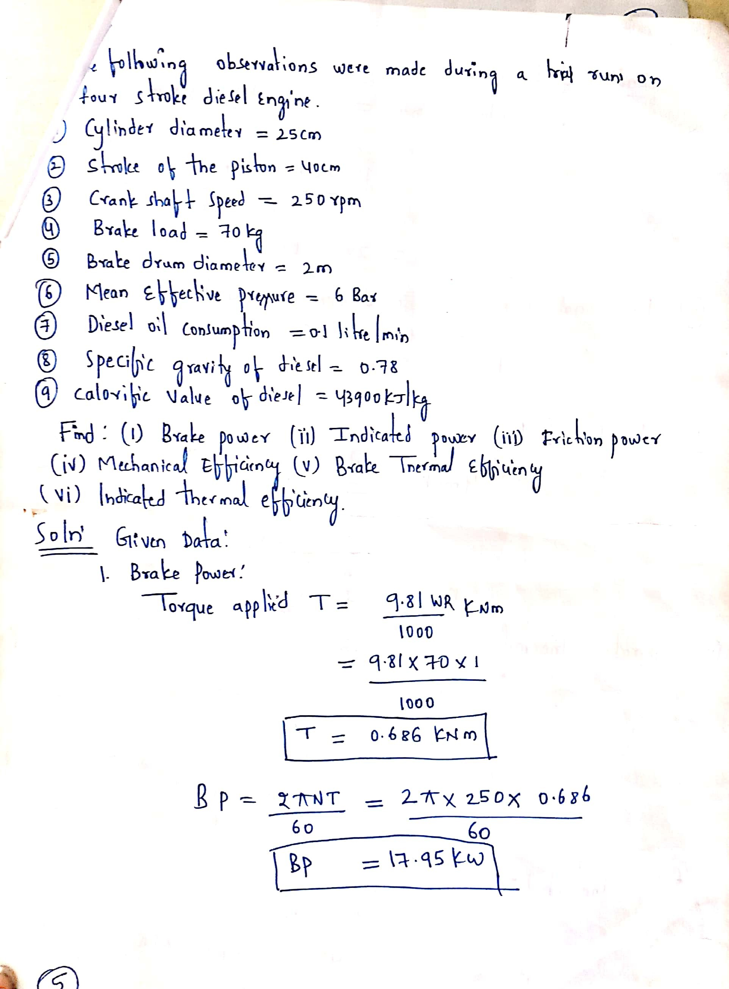

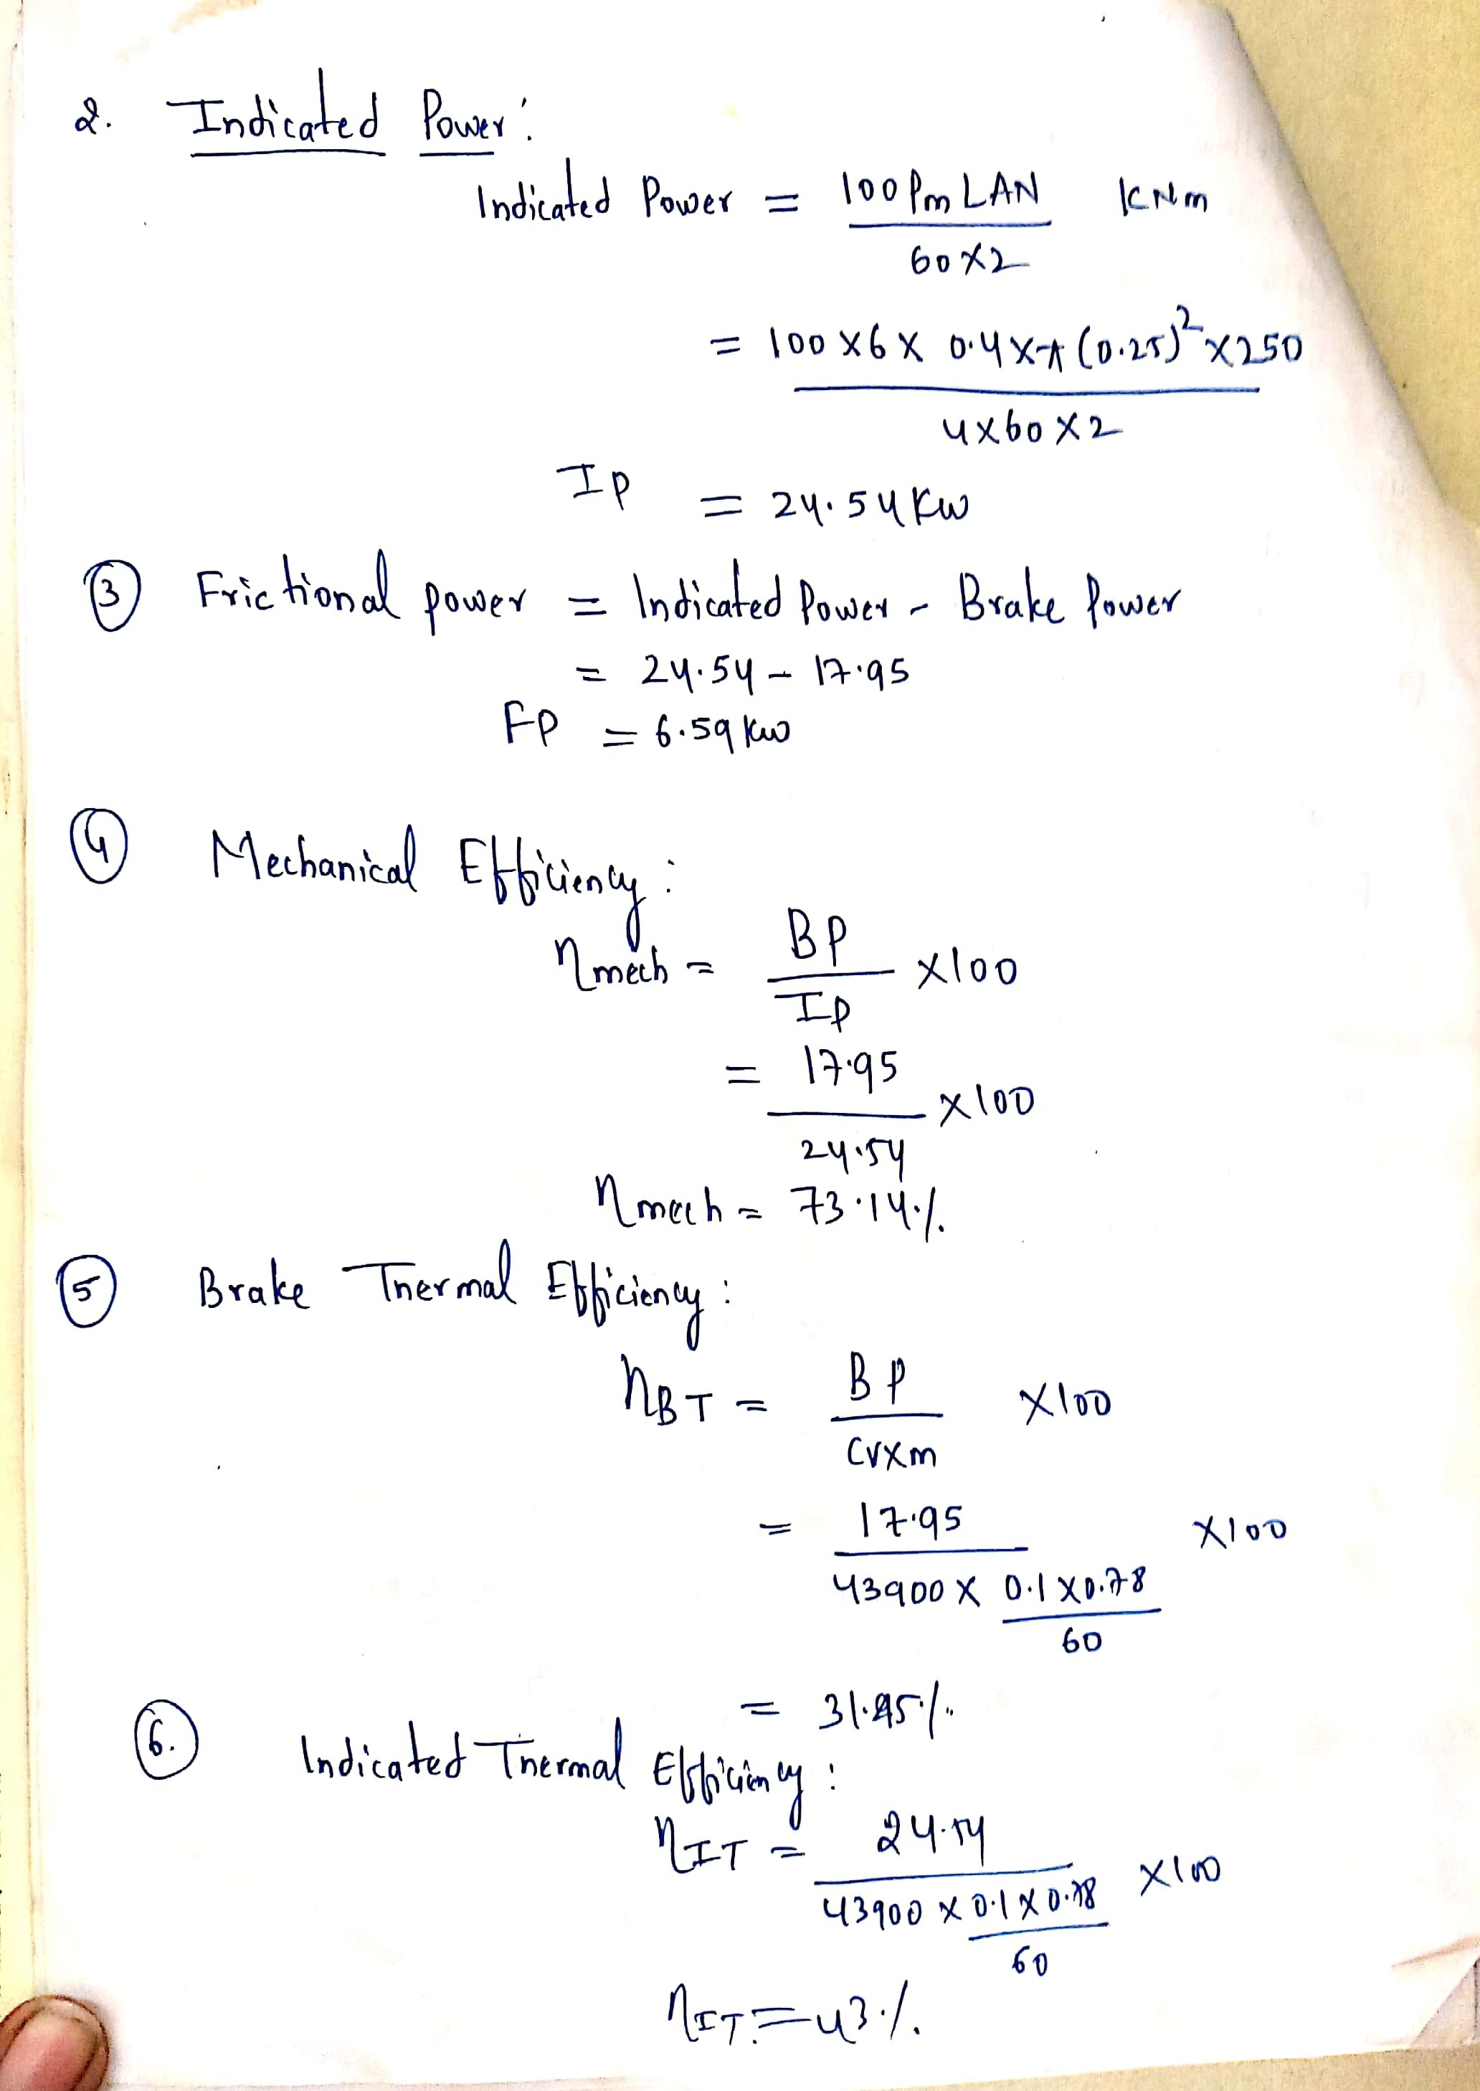

Refrigeration and Air Conditioning
Refrigeration:
Refrigeration is defined as a method or process of reducing the temperature of a system below that of the surroundings and maintaining it at the lower temperature by continuously extracting the heat from it.
Principle of refrigeration:

The principle of refrigeration is based on second law of thermodynamics. It states that heat does not flow from a low temperature body to a high temperature body without the help of an external work. In refrigeration process, the heat is continuously removed from a system at lower temperature and transfers it to the surroundings at a higher temperature. This operation according to second law of thermodynamics can only be performed by the aid of the external work. Therefore in a refrigeration system, power is to be supplied to remove heat continuously from the refrigerator to keep it cool at a temperature less than the surroundings.
Refrigeration concept
The principle of refrigeration is based on the following concepts.
- Heat flows from a system at higher temperature to another at lower temperature
- Fluids by absorbing the heat, change from liquid phase to vapour phase and subsequentlycondense by giving off the heat
- The boiling and freezing temperatures of a fluid depend on its pressure. When a certain fluid at a very low pressure and temperature is compressed, even though its pressure increases, it may still be in the condensed state itself if its temperature is not increased to the saturation temperature corresponding to the increased pressure
- Heat can flow from a system at low temperature to a system at higher temperature by the aidof external work done as per second law of thermodynamics

Refrigerant:A medium called refrigerant continuously extracts the heat from the space within
the refrigerator which is to be kept cool at a temperature less than the atmosphere.
Refrigerator: is a machine by means of which cold can be produced
Most commonly used refrigerants and their uses
- Ammonia: It is the most widely used refrigerant in vapour absorption system. It hasnormal boiling point of -33.3C. It is highly toxic, inflammable, irritating and corrosive.Hence not suitable for domestic applications. It is used in large industries for coldstorage, ice plants, packaging plants, etc
- Carbon Dioxide: It is non-toxic and non-flammable. Its normal boiling point is -77.6C.It is heavier than air and hence requires higher operating pressures. Due its low specific volume, the plant size is compact and hence used in marine applications.
- Sulphur dioxide: It is colour-less, suffocating and possesses irritating odour. Boilingpoint is -10C. Used in domestic refrigerators in olden days
- Freon - 12: It is non-flammable, non-explosive, non.-corrosive and odour-less. Boilingpoint -29.8C. Used in small capacity plants such as domestic refrigerators, watercoolers, air conditioners, etc
- Freon- 22: It has a boiling point of -40.8C. It is employed for large air conditioners,food freezing, food drying, etc
Uses of Refrigeration:
- Ice making
- Preservation of food products and medicines
- Air conditioning
- Transportation of food stuffs, flowers etc
- Cooling of concrete for dams
- Treatment of air for blast furnace
- Special industrial processes such as chemicals, medicals, surgical aids, etc
- Processing of food products, beverages, textiles, printing work, etc
Important terms
- Refrigeration effect: The rate at which the heat is absorbed in a cycle from the interior space to be cooled is called refrigeration effect. or
It is defined as the quantity of heat removed to the time taken. It is also called as the capacity of a refrigerator.
- Ton of refrigeration: The capacity of the refrigeration system is expressed in ton ofrefrigeration which is the unit of refrigeration.
A ton of refrigeration is defined as thequantity of heat absorbed in order to form one ton of ice in 24 hours when the initialtemperature of water is zero degree centigrade.
The standard in S.I unit is
- ton of refrigeration = 210 kJ/min = 3.5 kW
- Ice making capacity: It is the ability of the refrigeration system to make ice. In other words, it is the capacity of refrigeration system to remove heat from water to make ice. It is usually specified by kg/hr.
- Co-efficient of Performance (COP): The Co-efficient of Performance is defined as theratio of heat absorbed in a system to the work supplied.
If Q= heat absorbed or removed, kW
W= work done, kW
COP= Q/W
- Relative COP: It is the ratio of actual COP to the theoretical COP of a refrigerator.Actual COP is measured during a test and theoretical COP is obtained by applying thelaws of thermodynamics.
Relative COP = Actual COP / Theoretical COP
Parts of a refrigeration system
Following are the parts of a refrigeration system
- Evaporator: The evaporator is the heart of the refrigeration system, where the liquidrefrigerant is evaporated by the absorption of the heat from the refrigerator cabinet inwhich the substances to be cooled are kept. It consists of copper tubing surrounding thefreezing and cooling compartments.
- Compressor or Pump: For circulating the refrigerant in the system, a compressor or apump is used. They increase the pressure and therefore the temperature of the refrigerant.Generally these devices are driven by electric motor.
- Condenser: A condenser is an appliance in which the heat from the refrigerant is rejected at a higher temperature to another medium, usually atmospheric air. In a condenser, the refrigerant vapour, gives off its latent heat to the air and consequently condenses into liquid form so that it can be re-circulated in the refrigeration cycle. It consists of coil of tubes made of copper.
- Expansion or Throttle valve: An expansion valve serves as a device to reduce the pressure and temperature of the liquid refrigerant before it passes to the evaporator. This also usedto control the flow of refrigerant to the evaporator.

Types of Refrigeration system
The mechanical refrigerator systems are classified as
- Air Refrigerator
- Vapour Compression Refrigerator
- Vapour Absorption Refrigerator
Vapour Compression Refrigeration System (VCRS)
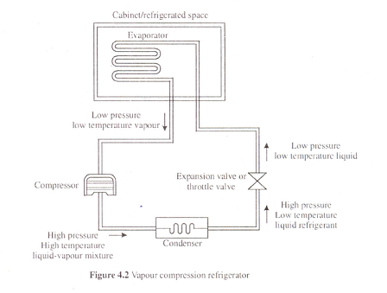

The vapour compression refrigeration system is most commonly used in domestic refrigerators. In VCRS the liquid (heat carrying substance) refrigerant alternatively undergoes a change of phase from vapour to liquid and vice versa during a cycle. During evaporation it absorbs the latent heat from the refrigerated space and subsequently gives off heat while condensing. The system consists of evaporator, compressor, condenser and an expansion valve.

The liquid refrigerant which is at low pressure and low temperature in the evaporator absorbs the heat from the medium (cabinet/refrigerated space) which is to be cooled and undergoes a change of phase form liquid to vapour. The vapour at low temperature and pressure is drawn into the compressor. In the compressor the refrigerant is compressed and converted into a high pressure and hightemperature. The compressed vapour then enters the condenser. In the condenser the vapour refrigerant is cooled and condensed to high pressure liquid refrigerant by giving its latent heat to the circulating cooling medium (air or water). The high-pressure liquid refrigerant leaves the condenser and passes through the expansion valve where it is expanded to low pressure and temperature. The temperature of the refrigerant falls to a value less than that of the refrigerated space. The low pressure-low temperature refrigerant again enters the evaporator where it absorbs the heat from the medium (cools the medium) and evaporates. The low pressure-low temperature vapour is drawn into the compressor and the cycle repeats.
Thus, heat is continuously extracted from the medium, thereby keeping the contents at the required lower temperature.
The desirable properties of a good refrigerant are as under.
- Boiling point: An ideal refrigerant must have a low boiling point at atmospheric pressure.
- Freezing point: The refrigerant must have a very low freezing point because the refrigerant should not freeze at low evaporator temperatures.
- Latent heat of evaporation: It should be very high so that a minimum amount of refrigerant will accomplish the desired result.
- Specific volume: should be very low and it reduces the size of the compressor.
- Specific heat of liquid and vapour: A good refrigerant must have a low specific heat in liquid state and high specific heat in vapour state. The low specific heat of the refrigerant helps in sub-cooling of the liquid and high specific heat of vapor helps in decreasing the superheating of the vapour.
- Viscosity: must be very low as it improves the heat transfer rate and reduces the pumping pressure.
- Non-toxic: should be non-toxic because any leakage increases the suffocation and poisons the atmosphere.
- Non-corrosive: to prevent corrosion of the metallic parts
- Chemical stability: should not decompose under operating conditions
- Odourless: otherwise food preserved will loosen their taste.
- Leakage tests: any leakage must be easily detected by simple tests
- Action with lubricating oil: should not react with lubricating oil
Air conditioning
Introduction: An Air conditioning system draws the air from an indoor space to be cooled and cools it by refrigeration principles and discharges it back to the same indoor space that needs to be cooled. Such continuous cyclic and recirculation of the cooled air keeps the indoor space at the required lower temperature for the desired purpose.
Definition:Air conditioning is defined as the process of simultaneous control and maintaining of temperature, humidity, cleanliness and air-motion of the confined space.

Working Principle of Air Conditioning
An air conditioner operates on the principle of refrigeration by cooling the air drawn from the conditioned space and returning the cool, fresh air to the conditioned space.
A simple room air conditioner is shown in Figure using block diagram.
The system consists of a compressor, a condenser, an evaporator, a capillary tube, condenser and evaporator fans driven by the same motor. The evaporator fan and the evaporator coils of the unit always lie inside the building or space which is to be conditioned. Condenser and the condenser fan of the unit projects outside the building or space to enable heat transfer with the atmosphere.
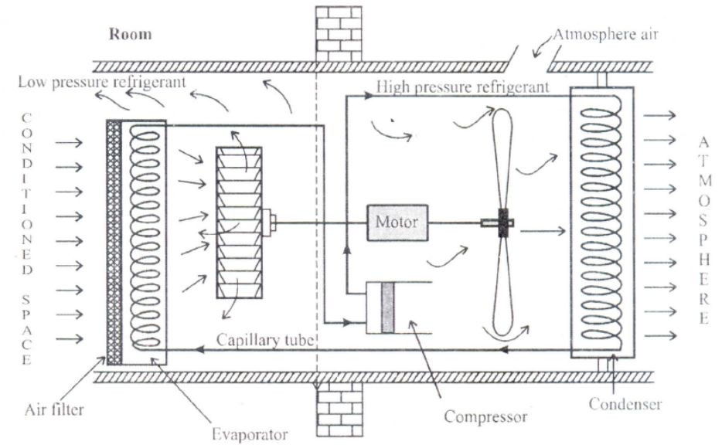

The cold refrigerant is exists in the evaporator coils. The evaporator fan continuously draws hot air passing through the air filter from the conditioned or to be conditioned space and circulates it over the evaporator coils. The hot air passing through the air filter comes in contact with cold evaporator coils and exchanges its heat with refrigerant present in the evaporator coils, refrigerant evaporates and air gets cooled and circulates in the conditioned space. The evaporated refrigerant enters into the compressor, where it gets compressed to high pressure and high temperature. This high pressure and high temperature refrigerant leaving the compressor enters the condenser coils for condensation of vapour refrigerant. The condenser fan draws air from outside the building and circulates it the condenser coils, with which the latent heat of the refrigerant vapour is given off to the surrounding atmosphere. This process convert vapour refrigerant into high temperature liquid refrigerant. This high temperature liquid refrigerant enters the capillary tube and expands in it, where the pressure and temperature of refrigerant reduces. Then the cold refrigerant enters the evaporator coils. The cycle repeats again and again till the required temperature inside the room is achieved and this can be adjusted by thermostatic control device.

Applications of Air conditioning
Air conditioning provides comfort for human beings and also a controlled environment for industrial activities. Hence, applications of air conditioning can be broadly divided into comfort applications and process applications.

Comfort applications:Aim to provide an indoor environment that remains relatively constant in a range (preferred by humans) despite changes in external weather conditions or in internal heat loads. Applications include
- In Residential buildings - single house and apartments.
- Institutional buildings - offices, hospitals, large complex buildings etc.
- Commercial buildings - shopping centers, malls etc.
- Transportation - in aircrafts, automobiles. Ships etc.
Process application:Aim to provide a suitable environment for a process being carried out, regardless of internal heat loads and external weather conditions. Applications include
- Hospitals
- Clean rooms - for production of integrated circuits, pharmaceuticals
- Textile factories
- Nuclear facilities
- Food cooking and processing areas
- Data processing centers etc.
Important terms with respect to Air conditioning
- Pyshrometry: It is the study of the properties of the moist air. The properties of air and
water vapour mixture are called pyschometric properties.
- Dry Air : The atmospheric air without the presence of water vapour is called dry air
- Moist air : It is the mixture of dry air and water vapour
- Humidity: It is the quantity of water vapour present in the air.
- Absolute humidity isdefined as the weight of water vapour contained in a given volume of air.
- Specific humidity is defined as the ratio of weight of water vapour to the total weight of air.
- Relative Humidity: It the ratio of mass of water vapour present in a given volume of
air at a given temperature to the mass of water vapour present in the same volume and
temperature of the air when it is fully saturated.
- Effective Temperature (ET):It is defined as the temperature of saturated air at which a person would experience the same feeling of comfort as experienced in the actual unsaturated environment.
It is found that effective temperature of 21.7oC, dry bulb temperature of 25 + 1oC, relative humidity of 50 + 5 % at room air velocity of 0.4 m/s is found to be the most comfortable for human beings during summer.

