ELEMENTS OF MECHANICAL ENGINEERING (BEMEM103/203)
MODULE-4
Mechanical Power Transmission

Gear Drives

Gears - Gears are also used for power transmission. This is accomplished by the successive engagement of teeth. The two gears transmit motion by the direct contact like chain drive. Gears also provide positive drive (no slip) & constant velocity ratio.
Gear Drives - These are drives used to transmit motion & power from one shaft to another through help of gears whose distance are relatively small. Shaft axis may be parallel, non parallel or intersecting.
Advantages of gear drives
- It is positive drive
- Operation is smooth & reliable
- Power transmission is high
- Power can be transmitted to any direction

Disadvantages of gear drives
- Large distances are not permitted
- Production cost is high
- Lubrication & maintenance
- Efficiency is less

Classification of gears
- Spur Gears – for parallel axes shafts
- Helical Gears – for parallel, non parallel & non intersecting axes shaft
- Spiral Gears – for non parallel & non intersecting axes shaft
- Bevel Gears – for intersecting axes shaft
- Elliptical Gears – for parallel axes shaft to obtain variable motion for the driven shaft.
- Worm Gears – for non parallel & non co planar axes shafts
- Rack & pinion – for converting rotary motion to linear motion.

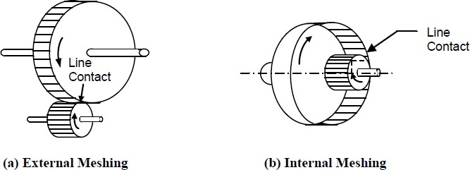
Spur gears - When the axes of driving & driven shafts are parallel & co planar, teeth of gears are parallel to axes then the gears are called spur gears. Teeth of spur gears are cut on the circumference of the cylindrical axes. These are used for high power transmissions but the drawback is noise produced is high.
Helical gears - In helical gears, the teeth make an angle with the axes of the gears which is called helix angle. The two meshing gears have same helix angle but its layout is in opposite sense. Power transmission is possible in parallel, non parallel & non intersecting shafts

When compared to spur gears their operation is smooth & less noisy at higher speeds. They are used in automobile power transmission.
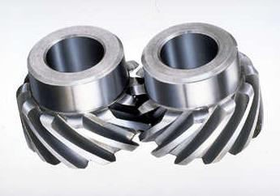
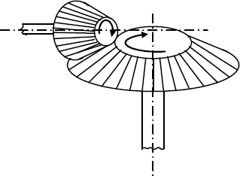
Bevel gears - These gears have straight teeth which are radial to the point of intersection of the shaft axes. Their teeth vary in cross section throughout their length. Generally, they are used to connect shafts at right angles. When two bevel gears have their axes at right angles & are of same size then they are known as miter gears.
Worm gears - These are used to transmit power for shafts which are at right angles & non coplanar. Worm gears are used when large gear reductions are needed. Worm gears are used for high power transmission when a high velocity ratio like 60:1 is needed. Many worm gears have an interesting property that no other gear set has: the worm can easily turn the gear, but the gear cannot turn the worm. This is because the angle on the worm is so shallow that when the gear tries to spin it, the friction between the gear and the worm holds the worm in place.
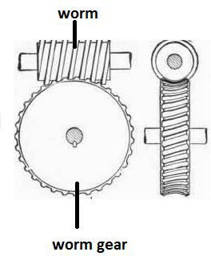
Rack & Pinion - This arrangement is used when rotary motion is to be converted into linear motion. The principle of working is similar to that of spur gears. This arrangement has application in machines such as lathe, drilling machine, planning machines, etc.

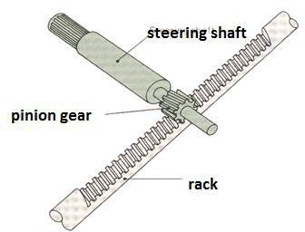

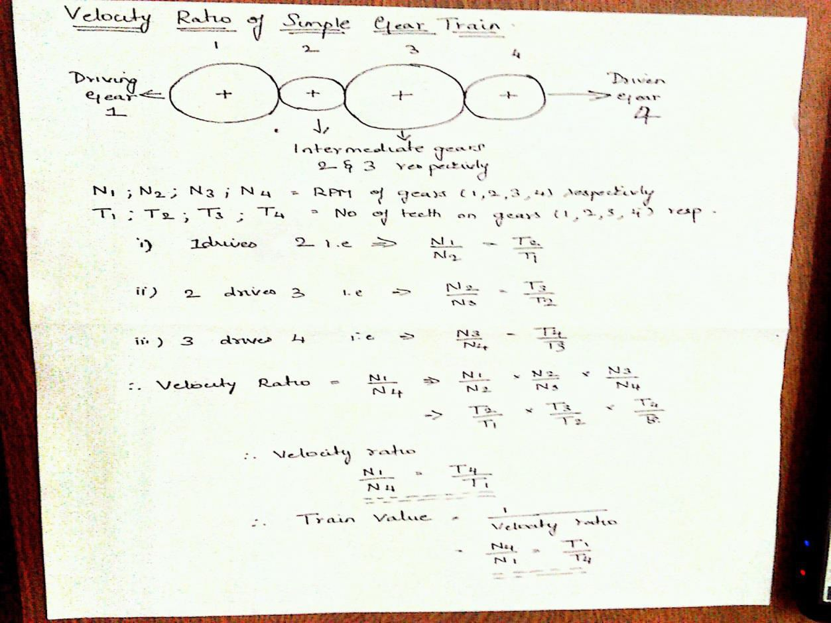

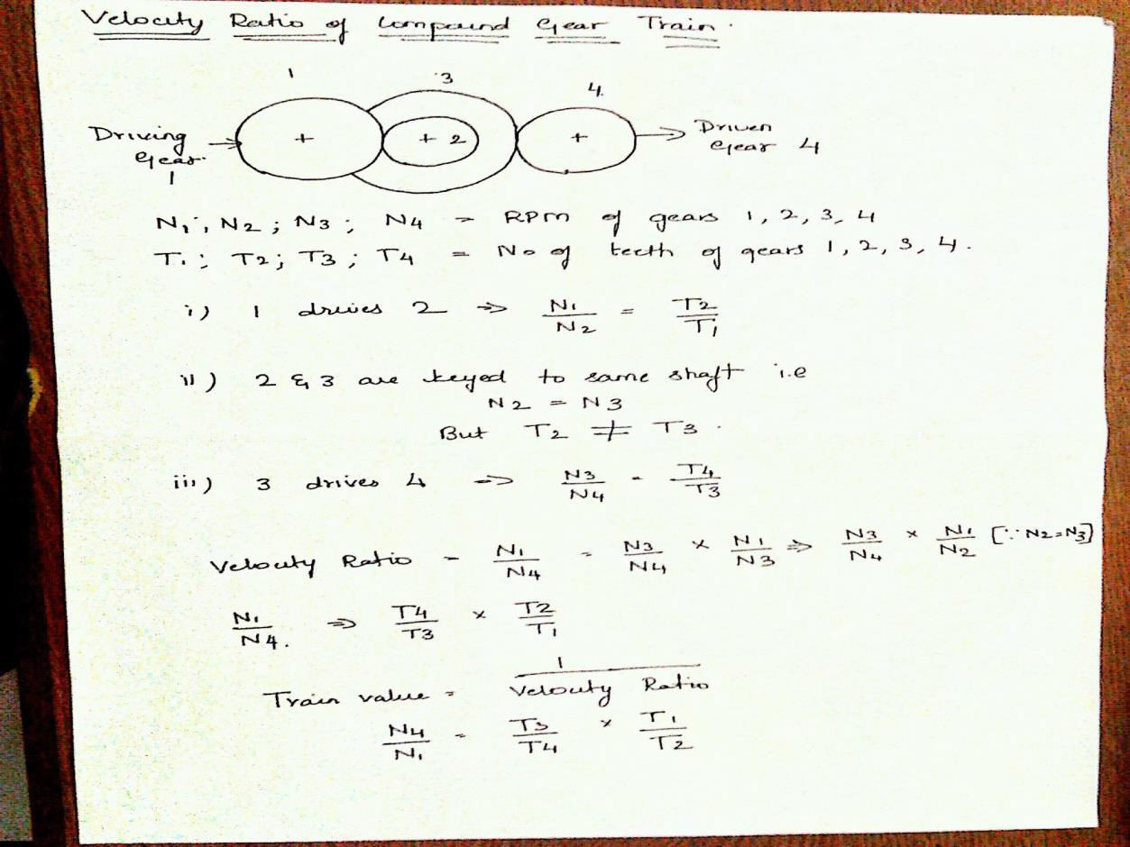

Power transmissions
The power is transmitted from one shaft to the other by means of belts, chains and gears. The belts and ropes are flexible members which are used where distance between the two shafts is large. The chains also have flexibility but they are preferred for intermediate distances. The gears are used when the shafts are very close with each other. This type of drive is also called positive drive because there is no slip. If the distance is slightly larger, chain drive can be used for making it a positive drive. Belts and ropes transmit power due to the friction between the belt or rope and the pulley. There is a possibility of slip and creep and that is why, this drive is not a positive drive. A gear train is a combination of gears which are used for transmitting motion from one shaft to another.
Types of drives
- Belt Drives
- Rope Drives
- Chain Drives
- Gear Drives

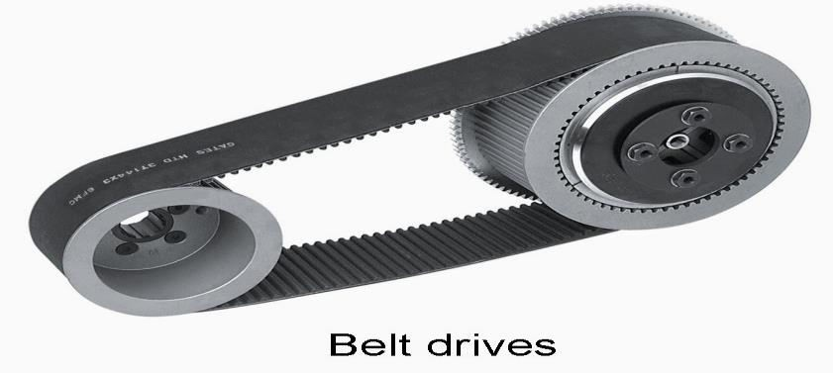
Belt Drives – this drive is used when power transmission is needed between two parallel shafts. Belt drives consists of two pulleys over which an endless belt is passed encircling both of them. Power is transmitted from driving pulley to driven pulley due to friction b/w the belt & pulley. The end with higher tension is known as tight side & end having lesser tension is known as slack side. The difference between the tensions is known as effective pulling power.

Belt Materials – Leather, Canvas, Rubber, Balata Types of belt drives
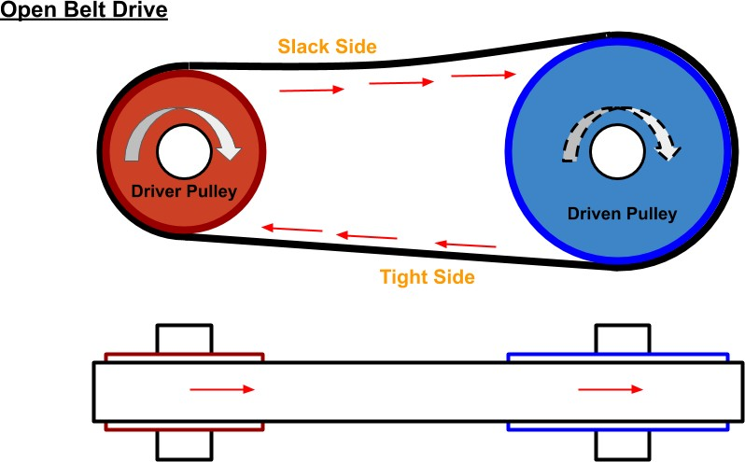
Open Belt drive - Open belt drive is used when sense of rotation of both the pulleys is same. It is desirable to keep the tight side of the belt on the lower side and slack side at the top to increase the angle of contact on the pulleys.

Close Belt drive - In case of cross belt drive, the pulleys rotate in the opposite direction. The angle of contact of belt on both the pulleys is equal. This drive is shown in sketch below. As shown in the figure, the belt has to bend in two different planes. As a result of this, belt wears very fast and therefore, this type of drive is not preferred for power transmission.
This can be used for transmission of speed at low power.
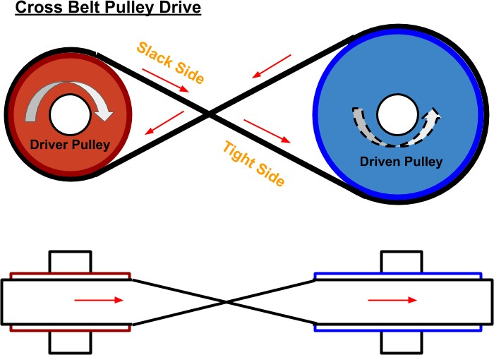

Cross belt drive

Belt Types
- Flat Belts
- V- Belts
- Rope/Circular Belts
The flat belt is rectangular in cross-section as shown below. The pulley for this belt is slightly crowned to prevent slip of the belt to one side. It utilises the friction between the flat surface of the belt and pulley.
The V-belt is trapezoidal in section as shown below. It utilizes the force of friction between the inclined sides of the belt and pulley. They are preferred when distance is comparative shorter. Several V-belts can also be used together if power transmitted is more.
The circular belt or rope is circular in section as shown below. Several ropes also can be used together to transmit more power.
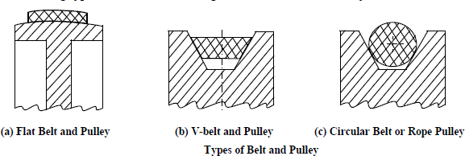

Advantages & Disadvantages of Flat belt drive Advantages -
- Simplicity & smooth operation
- Easy maintenance & low cost

- Flexibility & shock absorption at heavy loads
- Durability is more compared to V belts
Disadvantages -
- Always tends to slip
- Cannot be used for smaller distances
- Belt joints reduce the life of belts
- High power transmission is not possible
Advantages & Disadvantages of Cross belt drive Advantages-
- Transmits high power
- Suitable for short distances
- Standard dimensions are available
- Highly durable Disadvantages
- Not suitable for high speed operations & large centre distances
- High initial cost
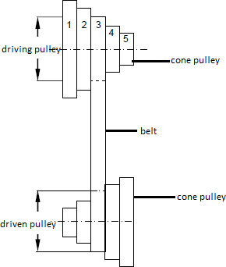
- Pulley construction is more complex Stepped/Cone Pulley

These pulleys are used when there is requirement of changing speed of the driven pulley such as lathe & drilling machines. It is an integral casting having three or more pulleys adjacent to each other of different diameters. One set of stepped cone pulley is mounted in reverse to the driven shaft. Then belt is mounted on the pulleys. By shifting the belt to other pulley pair speeds of the driven shaft could be varied.

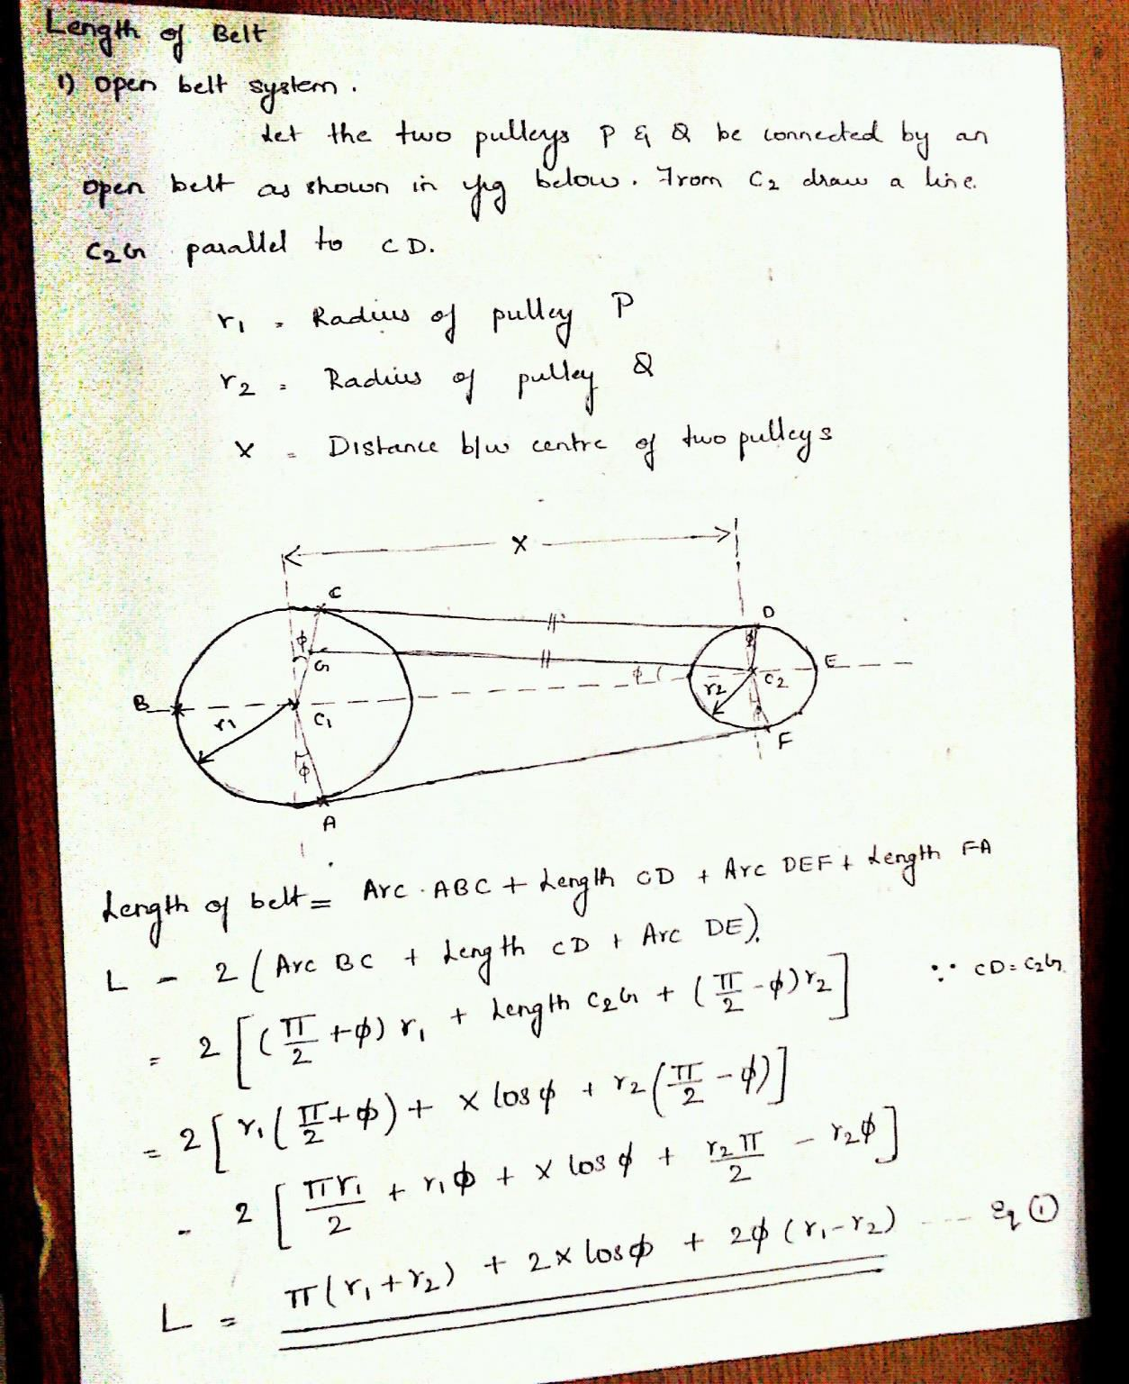

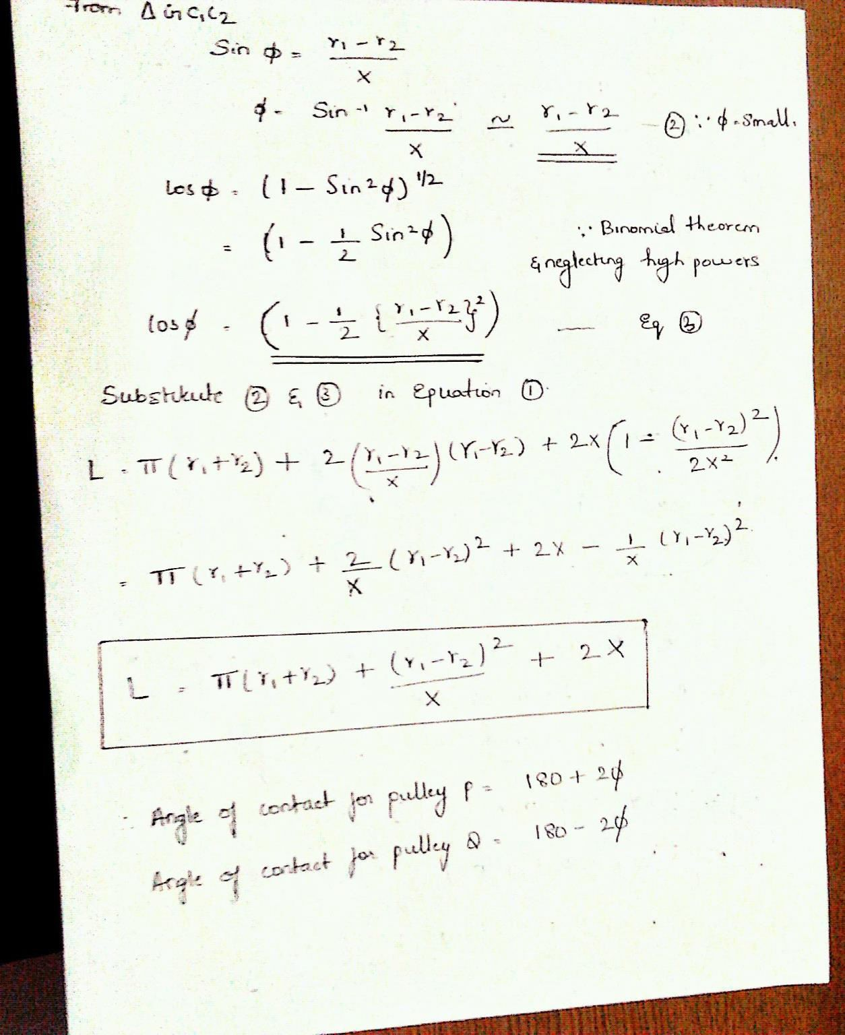

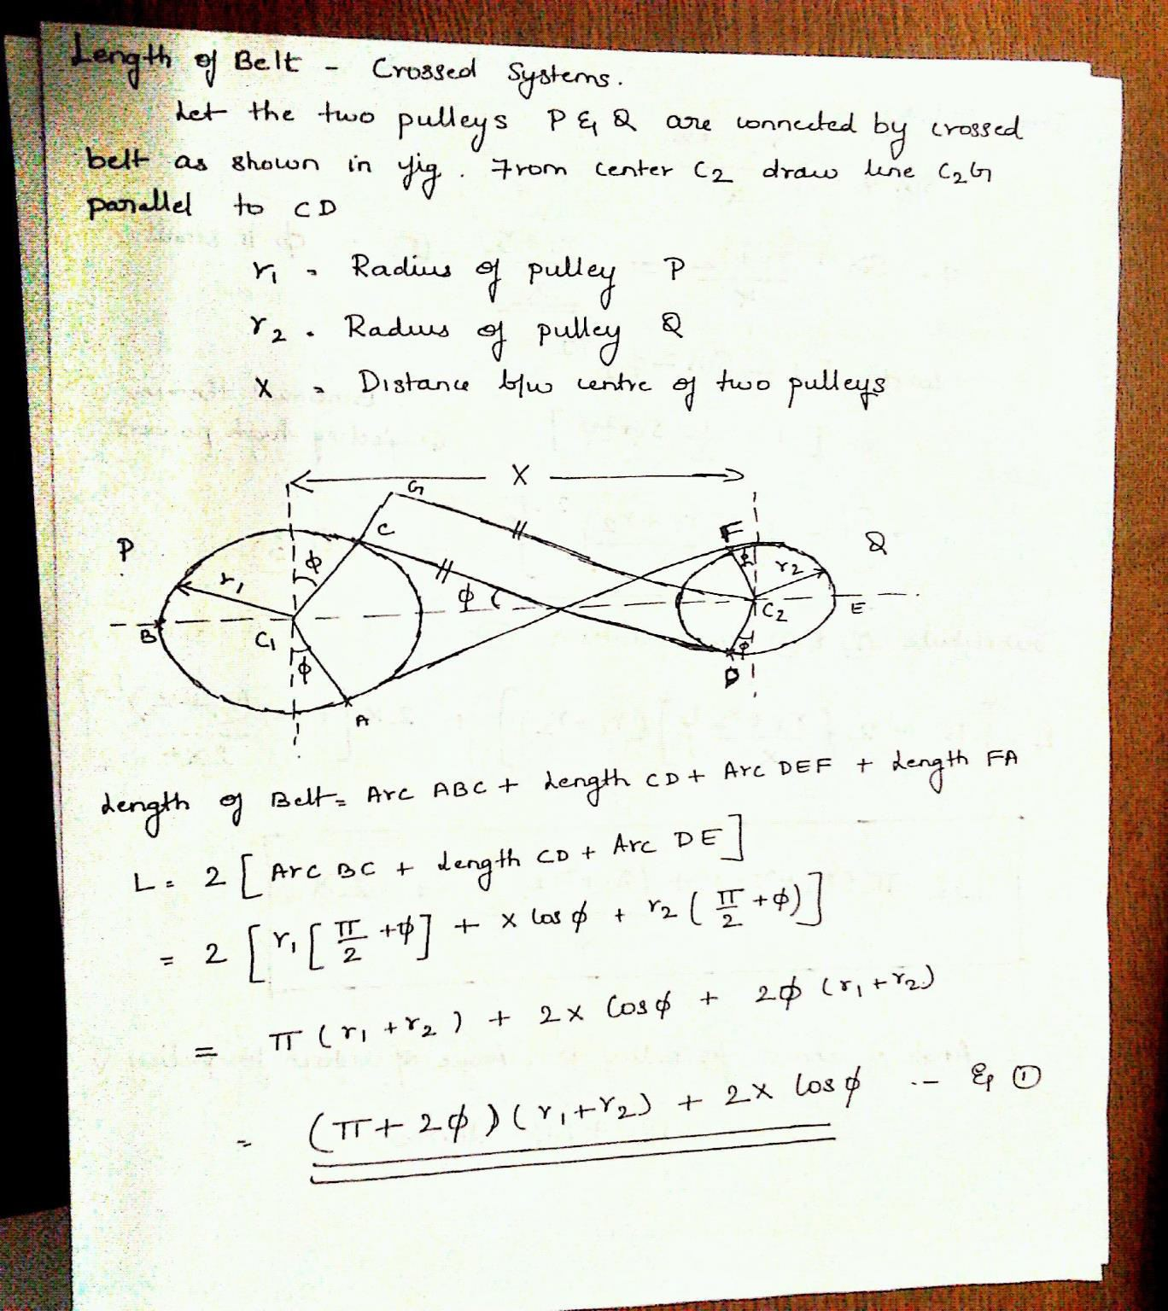

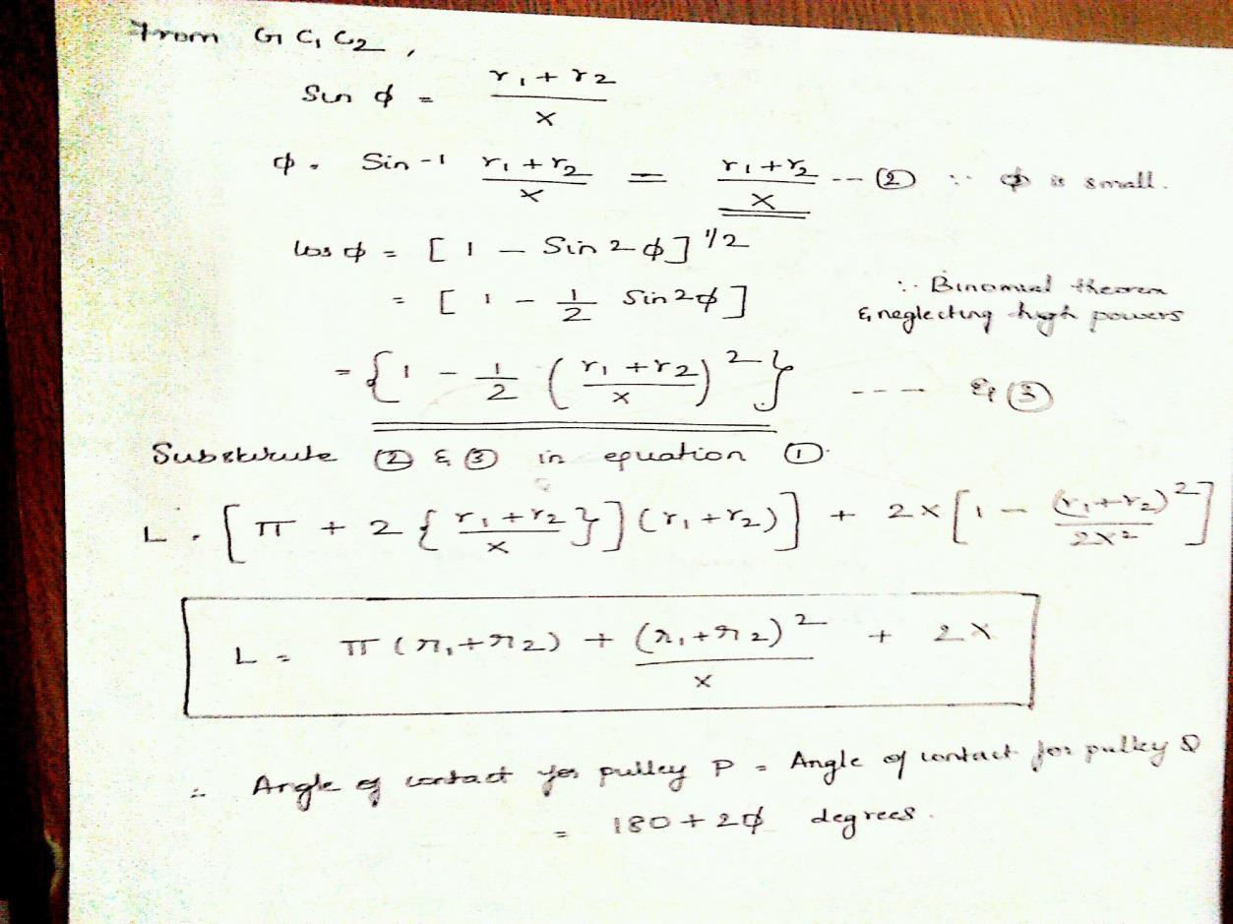

Slip in belt drives
In the belt drives force of friction is equal to difference between the tensions in tight side & slack side. When this condition exists there exists a firm frictional grip. But if the force of friction is lesser the tension differences of tensions, belt tends to slide over the pulley surface. This relative motion between the pulley & the belt is known as slip. Slip is always expressed in percentage of speed.

Creep in belt drives
In a belt drive portions of the belt are subjected to tight side tension & slack side tension. In the tight side the stresses in the belt increases thus causing stretching of the belt. In the slack side stress reduction takes place which results in belt contraction. This phenomenon of alternate stretching & contraction leads into increase in belt length and hence results in belt slip. This length increase causes relative motion b/w between pulley & belt surface known as creep.

SOLDERING, BRAZING & WELDING

INTRODUCTION

Some products cannot be manufactured as a single piece. The desired shape and size of such products can be obtained by joining two parts of same or different materials. These parts are manufactured individually and are joined together to obtain the desired product.
For example,
- Air craft and ship bodies,
- Welded machine frames,
- Furniture,
- Computers,
- Bridges
- Transmission or electric towers etc.,
Based on the type of joint produced joining processes can be classified as
- Temporary Joint.
- Permanent Joint.

If a product is in use for a long time and there is wear and tear, the parts need to be dismantled for maintenance, repair or replacement. A temporary joint can be easily dismantled separating the original parts without any damage to them.
In case it is a permanent joint, an attempt to separate the parts already joined will result in the damage of the parts. In a permanent joint, the joint is made such that it has properties similar to the base metal of the two parts. The joined parts become one piece. These parts cannot be separated into their original shape, size and surface finish.
Based on the process used for making the joint, the joining processes can be further classified as
- Soldering.
- Brazing.
- Welding.
- Mechanical Fasteners like bolts, nuts, rivets, screws etc.
- Adhesive bonding.

SOLDERING

Soldering is a method of joining thin similar or dissimilar metals by the application of heat and using a filler metal or alloy called solder below 450⁰C.
Solder: generally it is an alloy of lead and tin. It melts at low temperature. For strong joints a mixture of copper and zinc is used which has high melting point.

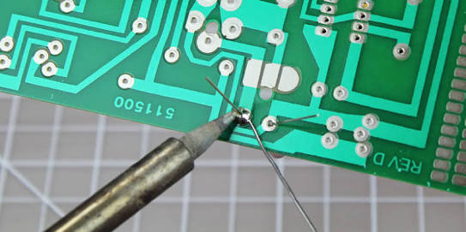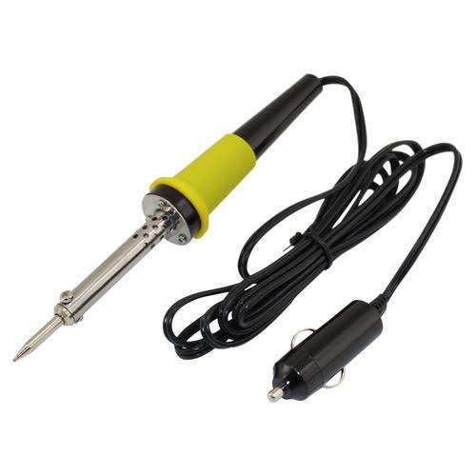

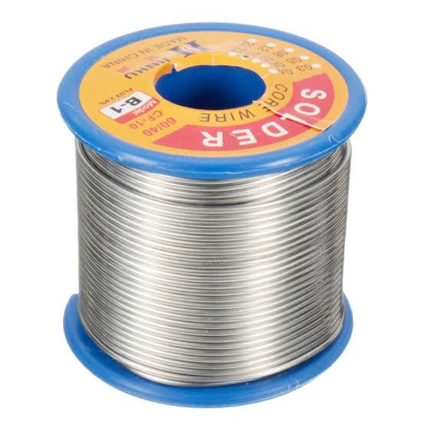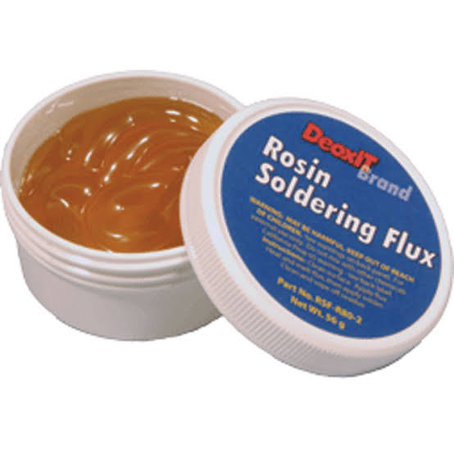
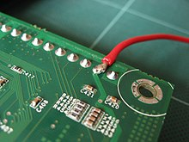

Classification of solder:
Soft solder:
- Generally it is composed of lead and tin.
- They are mixed in various proportions to solder different metals at different temperatures.
- The melting point for such solder lies between 150 to 300ºC.
- A suitable flux for the particular job is chosen.
- Soft solders are used to join the wires and sheet metal works of light jobs which are subjected to light loads and slight shocks.
- A plain soldering iron is used to heat the metal pieces during the process.
- Soldering using soft solder is known as soft soldering.
Method of Soldering
- Cleaning of joining surfaces:
Firstly, the joining surfaces are cleaned mechanically to make the surface free from dust, oil, scales, etc, and to ensure that the molten filler metal wets the surfaces
- Application of flux:
The joining surfaces are coated with flux (rosin or borax).This cleans the surfaces chemically and helps the solder in making bond
- Tinning of the surfaces to be soldered:
Tinning is a process in which the copper bit is heated and rubbed with a file to clean it properly. This is done to remove a thin film of oxide that forms on the copper bit which in turn does not allow the job to be heated and thus it becomes difficult to solder.
- Heating :
The soldering iron is then heated and the flowing molten metal fills the joint interface. Allow the soldered area to cool and then solidify thus making the joint.
- Final clean up
After completing the soldering (joints are formed), clean the joint with steel wool or solvent to remove left over flux.
Advantages of soldering

1) Solder joints are easy to repair
2) Solder joints are corrosion resistance.
3) Low cost and easy to use.
4) Low energy is required
5) Skilled operator is required.

Dis Advantages of soldering
1.Higher thickness material cannot be joined.
2.low strength joints.
3.Not suitable for higher temperature applications

BRAZING:
Brazing is a method of joining two similar or dissimilar metals by the application heat (suitable temperatures above 450º C) and using a special fusible alloy as filler metal having melting point (up to 900ºC) below that of the base metal.
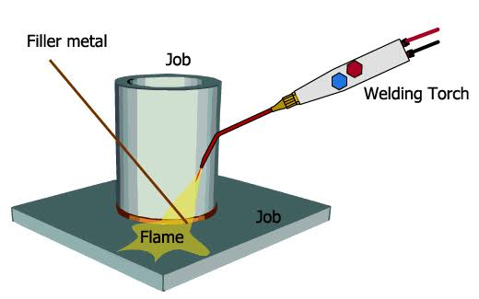

Method of brazing
- Firstly, the joining surfaces are cleaned mechanically to make the surface free from dust, oil, scales, etc, and to ensure that the molten filler metal wets the surfaces
- The joining surfaces are coated with flux (borax or mixture of borax and boric acid).This cleans the surfaces chemically and helps the brazing in making bond
- The joining surfaces and the filler material are heated by the oxy-acetylene welding torch to the temperatures above the melting temperature of the filler material. Thus formed filler molten metal flows by capillary action into the joint space and after cooling produces a strong joint.

Advantages of brazing:
- Joint strength is strong enough than soldering
- Virtually it is possible to join any dissimilar metals
- The bond line is very neat aesthetically

WELDING
Welding is a process of metallurgical joining two pieces of metals by the application of heat with or without the application of pressure and addition of filler metal.
Welding may be classified
- Pressure Welding: the parts of metal to be joined are heated to a plastic state and then forced together by external pressure.
- Forge welding
- Resistance welding
- Fusion welding process: the parts at the joint is heated to a molten state and allowed to solidify.
- Arc welding
- Gas welding
ELECTRIC ARC WELDING
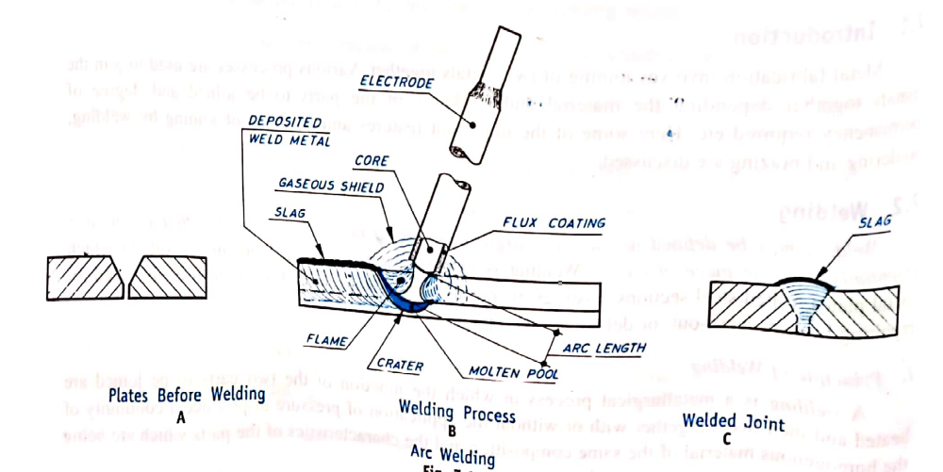

ELECTRIC ARC WELDING

Electric arc welding is a method of joining metals with heat produced by an electrical arc. In this process the heat necessary to melt the edges of the metal to be joined is obtained from an electric are struck between the electrode (filler rod) and the work, producing a temperature of 4000⁰C, in the welding zone. The heat of the arc melts the base metal or edges of the parts fusing them together. Filler metal, usually added melts and mixes with molten base metal to form the weld metal. The weld metal cools and solidifies to form the weld. In most cases, the composition of the filler material, known as welding rod, needed to provide extra metal to the weld, is same as that of the material being welded.

A typical arc welding setup is shown in Figure 2.

- An arc welding circuit consists of a power supply to furnish electric power.
- An electrode to conduct the electricity to the arc.
- Cables which connect the power supply to the electrode and workpiece to complete the welding circuit.
- The arc itself provides the heat for welding.
- The workpiece to welded is kept on a metallic table.
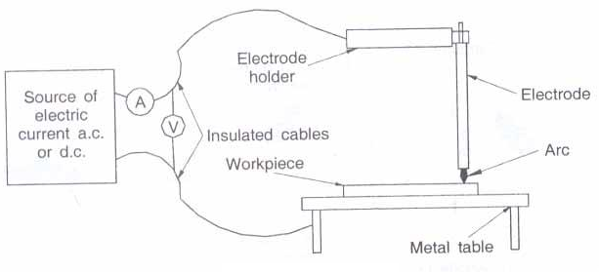
Figure 2: Arc Welding Setup

The arc must be shielded because; as it hardens the molten metal combines with oxygen and nitrogen to form impurities that weaken the weld. Shielding can be obtained by adding a paste, powder or fibrous flux to the arc. The electrodes are usually coated with a flux. This coating forms a gaseous cloud that shields the molten metal from the atmosphere. The coating also forms a protective slag. The slag floats on the molten pool and hardens as the weld cools. This keeps impurities out of the weld.

Advantages:
1. Portable
2. Low cost joining method
3. Excellent joint strength and weld quality
4. Can work on AC or DC
5. Higher corrosion resistance
Disadvantages:
1. Not suitable for welding thin metals.
2. Requires Continuous power supply.
3.Frequent stops /starts to change electrode
Applications
Arc welding is the most widely used for fabrication, repair work and maintenance.

GAS WELDING

Gas welding is a fusion welding process, in which a flame produced by the combustion of gases is employed to melt the metal. The molten metal is allowed to flow together thus forming a solid continuous joint upon cooling. By burning pure oxygen in combination with other gases, in special torches, a flame upto 3300⁰C can be attained. The gas is purchased in cylinder and connected through resulting valves and pressure gauges into flexible hoses attached to the nozzle. A typical arrangement is shown in Figure 4.
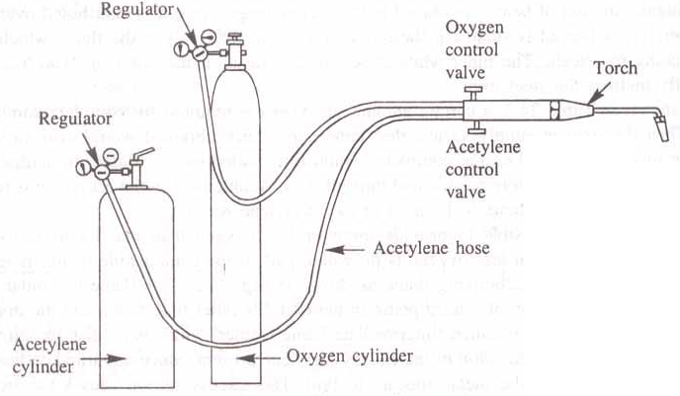
Figure 4: Gas Welding Equipment

The oxy-acetylene flame is used to pre heat the parts to be welded around the joint and also to melt the filler metal. A jet of oxy acetylene flame issuing from the nozzle of a burner is played on the junction of the two pieces to be welded. At the same time a filler rod is held in the zone of jet and its melt is deposited on the fused junction. A weld is obtained after the molten metal solidifies. The coating on the filler rod acts as a flux to keep the joint clean.

The filler metal or filler rod used must combine with the parts being joined. The melting point of the filler metal must be the same or lower than the melting point of the metal being joined.

The correct adjustment of the flame is very important for reliable works. When oxygen and acetylene are supplied to the torch in nearly equal volumes, a neutral flame is produced having a maximum temperature of 3200⁰C. This neutral flame is desired for most welding operations. Neutral flame has little effect on the base metal and sound welds are produced when compared to other flames. Figure 5 shows neutral flame.

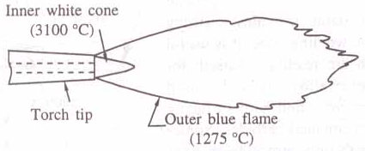
Figure 5: Neutral Flame

In a carbonizing flame or reducing flame excess of acetylene is present. The temperature of this flame is low. The excess unburnt carbon is absorbed in ferrous metals, making the weld hard and brittle. In between the outer blue flame and inner white cone, an intermediate flame feather exists, which is reddish in colour. The length of the flame feather is an indication of the excess acetylene present. Figure 6 shows a carbonizing flame. Carbonizing flame is used for welding high carbon steels and cast iron, alloy steel and for hard facing.

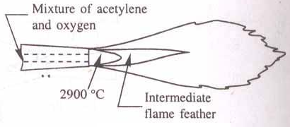
Figure 6: Carbonizing Flame

In an oxidizing flame excess of oxygen is present. The flame is similar to the neutral flame with the exception that the inner white cone is some what small, giving rise to higher tip temperatures. Excess of oxygen in the oxidizing flame causes the metal to burn or oxidize quickly. Oxidizing flame is useful for welding some nonferrous alloys such as copper and zinc base alloys. The Figure 7 shows the oxidizing flame.

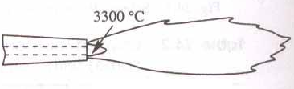
Figure 7: Oxidizing Flame

Advantages:
- The equipment is in expensive in complicated and it is easily portable.
- Useful for welding light metals such as automobile bodies and repair works.
- A large variety of material can be welded.
- Welds can be produced at reasonable cost.
- Compared to electric arc welding this provides greater flexibility with respect to heat impact and cooling rates.

Disadvantages:
- Gas welding equipment must always be handled carefully as in certain circumstances acetylene is explosive (when a flame is applied under pressure) as oxygen when used in an oily atmosphere (such as an olds dirty garage floor pit).
- A high temperature flame from a hand held torch is dangerous when handled carelessly.
- It is much slower than electric arc welding and does not concentrate the heat close to the weld. Thus, the heat treated area is larger, which causes more distortion.
- Highly skilled operators are required to produce a good weld.
- If electric arc welding is available gas welding is seldom used for work over 3.2mm thick.
- The process is not satisfactory for heavy section.

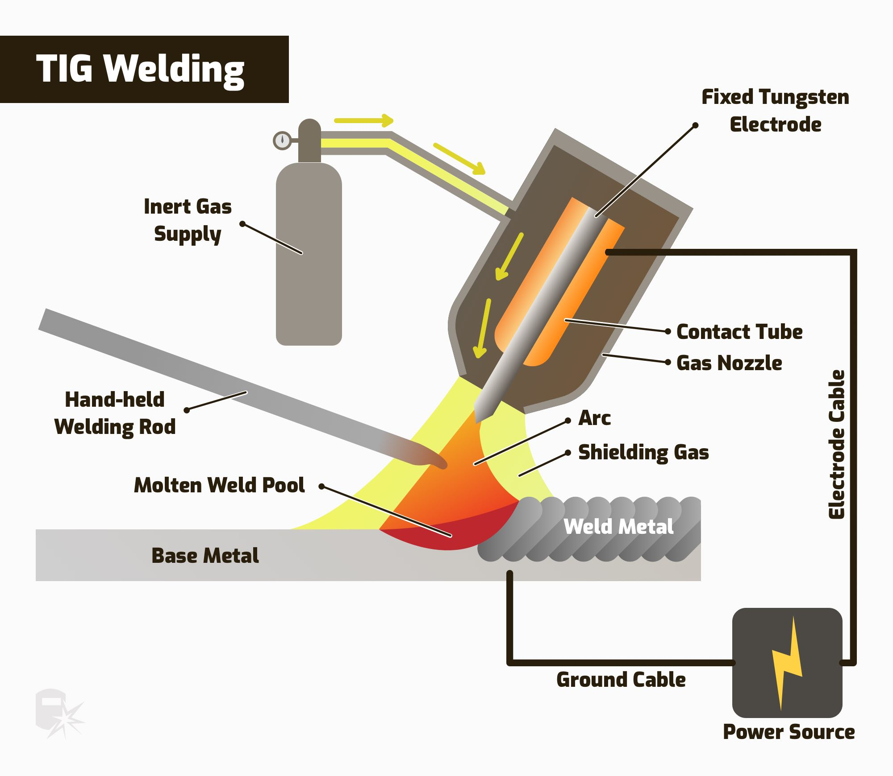

TIG stands for tungsten inert gas and is technically called gas tungsten arc welding (GTAW). The process uses a non-consumable tungsten electrode that delivers the current to the welding arc. An inert gas, typically argon, protects and cools the tungsten and weld puddle.

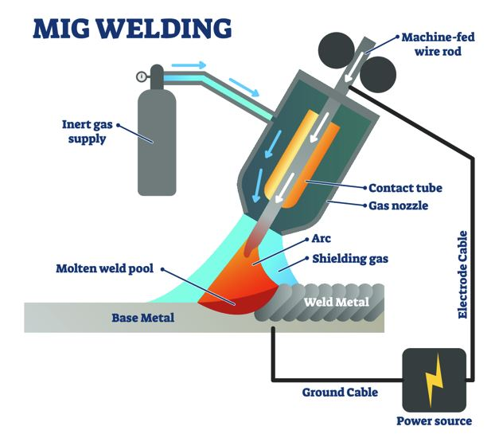

MIG welding uses a constant voltage power supply to create an electric arc that fuses the base metal with a filler wire that is continuously fed through the welding torch. At the same time, an inert shielding gas is also fed through the gun, to protect the weld pool from atmospheric contamination.

