ELEMENTS OF MECHANICAL ENGINEERING (BEMEM103/203)
MODULE-5
Insight into future mobility technology
Introduction to Mechatronics and Robotics
ELECTRIC VEHICLE

An electric vehicle (EV) is a vehicle that uses one or more electric motors for propulsion. It can be powered by a collector system, with electricity from extravehicular sources, or it can be powered autonomously by a battery (sometimes charged by solar panels, or by converting fuel to electricity using fuel cells or a generator). EVs include, but are not limited to, road and rail vehicles, surface and underwater vessels, electric aircraft and electric spacecraft.
EVs first came into existence in the mid-19th century, when electricity was among the preferred methods for motor vehicle propulsion, providing a level of comfort and ease of operation that could not be achieved by the gasoline cars of the time. Internal combustion engines were the dominant propulsion method for cars and trucks for about 100 years, but electric power remained commonplace in other vehicle types, such as trains and smaller vehicles of all types.
In the 21st century, EVs have seen resurgence due to technological developments, and an increased focus on renewable energy and the potential reduction of transportation's impact on climate change, air pollution, and other environmental issues.

Electric Vehicle Components

Basic Main Components of Electrical Vehicle
The basic main elements of electric cars installed in almost all types of electric cars are as follows:
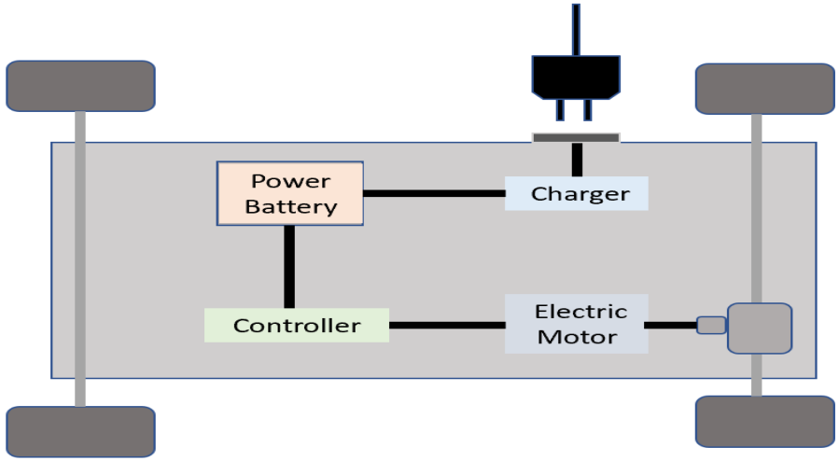
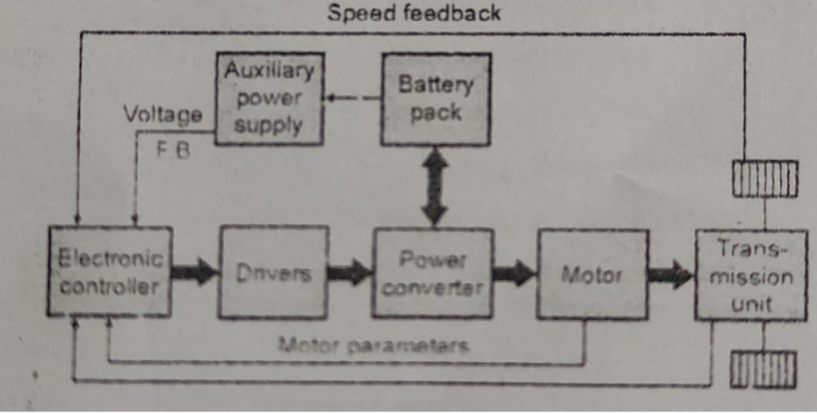
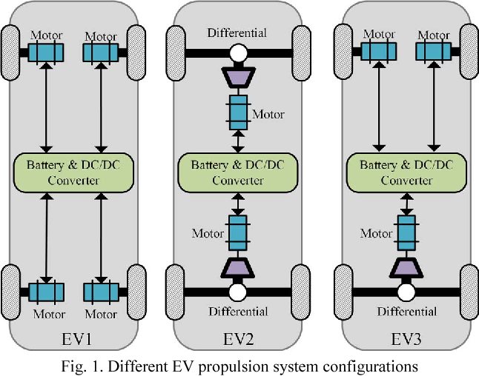
Traction Battery Pack (A)
The function of the battery in an electric car is as an electrical energy storage system in the form of direct-current electricity (DC). If it gets a signal from the controller, the battery will flow DC electrical energy to the inverter to then be used to drive the motor. The type of battery used is a rechargeable battery that is arranged in such a way as to form what is called a traction battery pack.
There are various types of electric car batteries. The most widely used is the type of lithium-ion batteries. Please read the article “Electric Car Batteries and Their Characteristics” to get a little idea about batteries for electric cars.

Power Inverter (B)
The inverter functions to change the direct current (DC) on the battery into an alternating current (AC) and then this alternating current is used by an electric motor. In addition, the inverter on an electric car also has a function to change the AC current when regenerative braking to DC current and then used to recharge the battery. The type of inverter used in some electric car models is the bi-directional inverter category.

Controller (C)
The main function of the controller is as a regulator of electrical energy from batteries and inverters that will be distributed to electric motors. While the controller itself gets the main input from the car pedal (which is set by the driver). This pedal setting will determine the frequency variation or voltage variation that will enter the motor, and at the same time determine the car’s speed.
In brief, this unit manages the flow of electrical energy delivered by the traction battery, controlling the speed of the electric traction motor and the torque it produces. This component will determine how electric car work.

Electric Traction Motor (D)
Because the controller provides electrical power from the traction battery, the electric traction motors will work turning the transmission and wheels. Some hybrid electric cars use a type of generator-motor that performs the functions of propulsion and regeneration. In general, the type of electric motor used is the BLDC (brushless DC) motor

Other Electric Car Components
Charger (E) is a battery charging device. Chargers get electricity from outside sources, such as the utility grid or solar power plants. AC electricity is converted into DC electricity and then stored in the battery. There are 2 types of electric car chargers:
- On-board charger: the charger is located and installed in the car
- Off-board charger: the charger is not located or not installed in the car.
Transmission (F): The transmission transfers mechanical power from the electric traction motor to drive the wheels.
DC/DC Converter (G): This one of electric car parts that to converts higher-voltage DC power from the traction battery pack to the lower-voltage DC power needed to run vehicle accessories and recharge the auxiliary battery.
Battery (H): In an electric drive vehicle, the auxiliary battery provides electricity to power vehicle accessories.
Thermal System – Cooling (I): This system maintains a proper operating temperature range of the engine, electric motor, power electronics, and other components.
Charge Port (J): The charge port allows the vehicle to connect to an external power supply in order to charge the traction battery pack.

Advantages of an Electric Vehicle

1. No Gas Required
Electric cars are entirely charged by the electricity you provide, meaning you don’t need to buy any gas ever again. Driving fuel-based cars can burn a hole in your pocket as prices of fuel have gone all-time high.

2. More Convenient
The electric vehicle is easy to recharge, and the best part is you will no longer need to run to the fuel station to recharge your car before hitting the road! Even a normal household socket could be used for charging an electric car.

3. Savings
These cars can be fuelled for very low prices, and many new cars will offer great incentives for you to get money back from the government for going green. Electric cars can also be a great way to save money in your own life.

4. No Emissions
The biggest advantage of an electric vehicle is its green credential. Electric cars are 100 percent eco-friendly as they run on electrically powered engines.

5. Cost-Effective
With more technological advancements, both cost and maintenance have gone down.
6. Low Maintenance
Electric cars run on electrically powered engines, and hence there is no need to lubricate the engines, anything related to the combustion engine

7. Reduced Noise Pollution
Electric cars put a curb on noise pollution as they are much quieter. Electric motors are capable of providing smooth drive with higher acceleration over longer distances.

8. Battery Life & Cost
Batteries are an integral part of an electric vehicle. Most electric vehicle batteries are lithium ones, and their costs are improving every year.
The full capacity of a lithium-ion battery cell should be good for 300 to 500 cycles. A good battery could last you up to ten years. With the improving technologies, the cost of these batteries is expected to come down even more.

9. Easy Driving
In the world of automobiles, electric cars have the simplest driving method. Commercial electric cars come with a transmission comprising of only one really long gear and also don’t suffer from the stalling problem as petrol cars do.
This effectively eliminates the need to add a clutch mechanism to prevent that from happening. Therefore, you can operate an electric car with just the accelerator pedal, brake pedal and steering wheel.

Disadvantages of an Electric Vehicle

1. Recharge Points
Electric fuelling stations are still in the development stages. Not a lot of places you go to on a daily basis will have electric fuelling stations for your vehicle, meaning that if you’re on a long trip or decide to visit family in a rural or suburban area and run out of charge, it may be harder to find a charging station. You may be stuck where you are.
However, until charging stations are more widespread, be sure to have a charging station maps where you live and where you frequently go so that you’ll be able to charge your new EV when you need to.

2. The Initial Investment is High
Presently EV price is little bit high. Though technology is advancing and the price to produce electric cars continues to drop

3. Short Driving Range and Speed
Electric cars are limited by range and speed. Most of these cars have a range of about 50-100 miles and need to be recharged again. You just can’t use them for long journeys as of now, although it is expected to improve in the future.

4. Longer Recharge Time
While it takes a couple of minutes to fuel your gasoline-powered car, an electric car takes about 4-6 hours and sometimes even a day to get fully charged.
Therefore, you need dedicated power stations as the time taken to recharge them is quite long. Thus, the time investment and necessary planning do put some people off.

5. Silence as a Disadvantage

Silence can be a bit disadvantage as people like to hear the noise if they are coming from behind them. An electric car is, however, silent and can lead to accidents in some cases.

6. Battery Replacement
Depending on the type and usage of battery, batteries of almost all electric cars are required to be changed every 3-10 years.

7. Not Suitable for Cities, Facing Shortage of Power
As electric cars need the power to charge up, the cities that already facing acute power shortages are not suitable for electric cars. The consumption of more power would hamper their daily power needs.

Hybrid Electric Vehicle (HEV)

Introduction
A Hybrid Electric Vehicle is a type of vehicle that uses a combination of an Internal Combustion (IC) engine and an electric propulsion system. The electric power train may enhance fuel efficiency, increase performance, or independently propel the vehicle on pure electric power, depending on the type of hybrid system.
In simple words, an HEV is a vehicle that comprises a conventional fuel engine and an electric power train, wherein the electric motor assists the engine to extract more performance, and better fuel economy, depending on the type of the system.

Working of Hybrid Vehicles
Unlike an electric vehicle, the working mechanism of an HEV is relatively simple to understand. The below points explain how an HEV works.
- Powering a hybrid electric vehicle is an IC engine and an electric motor.
- The electric motor utilizes the electrical energy stored in the battery pack.
- The battery pack gets charged via regenerative braking or through a generator that is run by the internal combustion engine.
- An HEV does not need to be plugged into a power source to charge the battery.
- The electric motor and IC engine work in conjunction to propel the vehicle.
- The additional power from the electric motor assists the engine, and it enhances the performance and improves the fuel economy.
- The battery pack can also power other electrical components such as lights.
- The electric power train also saves fuel via the engine start/stop technology, wherein the engine automatically shuts off when idle and starts automatically when the driver presses the throttle pedal.

Key components of a Hybrid Electric Vehicle

As mentioned before, an HEV combines a conventional engine and electric power train. Hence, you can find engine-related and electric power train components in an HEV. Below are the key components of a Hybrid Electric Vehicle.

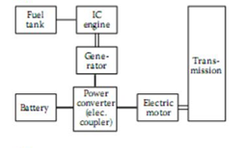
- Internal combustion engine: The primary power source of an HEV is a conventional engine. Hence, it is the main component responsible for propelling the vehicle. An HEV cannot run alone on an electric power train without an engine.
- Electric motor: The secondary power source of an HEV is the electric motor. It assists the engine during initial acceleration to improve performance and fuel economy. It runs on electrical energy stored in the battery pack. It can also charge the battery when the vehicle is braking or coasting via the regenerative braking system.
- Battery pack: A battery pack powers the electric motor. Basically, it acts as a fuel tank for the battery, wherein it stores the electrical energy via regenerative braking and the generator driven by the IC engine. The battery pack can also power auxiliary electrical components such as lights.
- Generator: It is an essential component found in the series hybrid vehicle. We will touch upon what series hybrid is in the upcoming sections. A generator draws power from the IC engine to power the electric motor and charge the battery pack. In simple words, a generator converts mechanical energy into electrical energy.
- Transmission: Typically, hybrid vehicles use conventional transmissions similar to petrol or diesel cars. It transmits the power produced by the IC engine to the drive shaft. The basic working principle of transmission remains the same, even in an HEV. It is one of the crucial components required to propel the vehicle.
- Fuel tank: Similar to a conventional car, hybrid electric vehicles also have a fuel tank to store the conventional fuel. With the electric power train involved in a hybrid car, the fuel consumption will be comparatively less than a vehicle purely relying on an IC engine.

Types of Hybrid Electric Vehicles
There are three types of HEVs based on power delivery and distribution. Below are more details on the same.
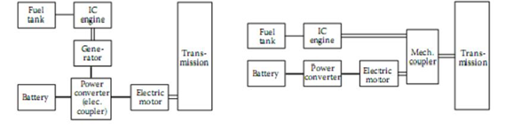

Series HEV Parallel HEV

1. Series hybrid
In a series hybrid system, the IC engine powers the electric generator, which drives the electric motor and charges the battery. In this setup, the engine does not directly power the wheels. Series hybrid is also called a range extender since the engine powers the electric motor and the battery pack.

2. Parallel hybrid

In this system, both the engine and electric motor work parallel to propel the vehicle. The engine and the electric motor deliver optimum power for the efficient functioning of the car. The battery pack gets charged via regenerative braking. If you wonder what regenerative braking is, here’s a brief explanation. Regenerative braking is a process of utilizing the kinetic energy produced while slowing the vehicle down to charge the battery pack.

Advantages of HEVs

Below are some of the advantages of Hybrid Electric Vehicles.
- They produce lower carbon emissions. Hence, HEVs are eco-friendly.
- With the electric motor assisting the IC engine, the fuel consumption reduces. Hence, HEVs deliver an improved fuel efficiency.
- HEVs consume less oil compared to their conventional counterparts.
- They require lower maintenance than conventional cars. Hence, the maintenance cost is less.

Disadvantages of HEVs
Here are some of the disadvantages of Hybrid Electric Vehicles.
- An HEV costs more than a conventional car. Hence, the upfront costs could be a problem if you are on a tight budget.
- The repair costs of the electric power train may run high as it is a very complex system.
- HEVs may produce less power than regular petrol or diesel cars. So, if you are a driving enthusiast, it may not suit your driving style.

Difference between Electric Vehicles and Hybrid Electric Vehicles
Below are the key differences between electric vehicles and HEVs.

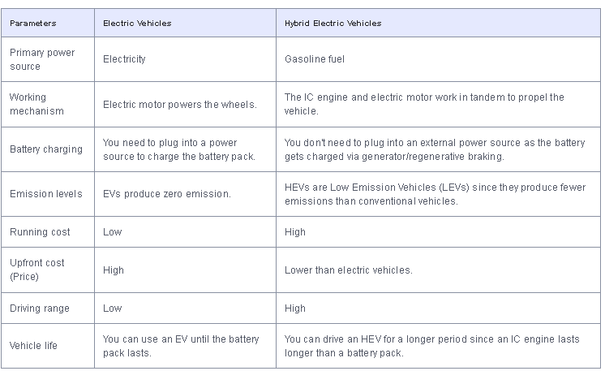

Mechatronics

A mechatronic system is composed of mechanical parts, electric devices, electronics components, sensors, hardware and it is operated and controlled under the supervisions and commands that are programmed through suitable software.

Open Loop System
A Control System which doesn’t have any feedback connected to it is called as Open Loop System. These types of systems don’t depend upon its output i.e., in open loop systems, output is not used as a control variable for the system and it has no effect on the input.
Open loop systems are one way signal flow systems. As these systems doesn’t contain any feedback i.e., the output is not fed back to the input, these are also known as Non-Feedback Systems.
The following figure shows a simple block diagram of an Open Loop System.

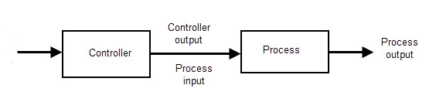
Ex. Electrical Clothes Drier
Input
Electric cloth drier operates depending on timer setting, irrespective of condition of cloths.

Traffic Control System
Most automated Traffic Control Systems are time-based open loop control systems i.e., each signal is allotted with a specific time slot during which it operates irrespective of the amount of traffic.

Washing Machine
The operations of soaking, washing, rinsing and drying are time based and do not depend on the cleanliness of the clothes or if the clothes are dry or not.

Electric Bulb
When electric current passes through an electric bulb, it produces light. When the mains supply is available, by switching ON the bulb, it glows. And this process does not depend up on the temperature of bulb or any other parameters.

Electric Hand Drier
The hand drier works on electric power supply and hands are kept in front of it; it will automatically dry our hands by blowing hot air, irrespective of how much our hand is dried.

Bread Toaster
The bread toaster runs based on the preset time period irrespective of the toasting of bread is completed or not.

Advantages of Open Loop Control System
The main advantages of the open loop control system are listed below:
- Open Loop Control Systems are very simple and easy to design.
- These are considerably cheaper than other types of control systems.
- Maintenance of an open loop control system is very simple.
- Generally, open loop systems are stable up to some extent.
- These types of systems are easy to construct and are convenient to use.

Disadvantages of Open Loop control System
The disadvantages of open loop system are:
- The bandwidth of open loop control system is less.
- The non-feedback system doesn’t facilitate the process of automation.
- Open loop systems are inaccurate in nature and also unreliable.
- If their output is affected by some external disturbances, there is no way to correct them automatically as these are non-feedback systems.
Closed Loop System
In closed loop control systems, output is fed back to the input. So, the control action is dependent on the desired output. The following figure shows the block diagram of negative feedback closed loop control system.
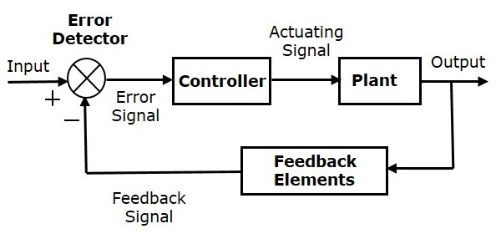
The error detector produces an error signal, which is the difference between the input and the feedback signal. This feedback signal is obtained from the block (feedback elements) by considering the output of the overall system as an input to this block. Instead of the direct input, the error signal is applied as an input to a controller.
So, the controller produces an actuating signal which controls the plant. In this combination, the output of the control system is adjusted automatically till we get the desired response. Hence, the closed loop control systems are also called the automatic control systems. Traffic lights control system having sensor at the input is an example of a closed loop control system.
Difference between Open-Loop Control System and Closed-Loop Control System:
Open loop control system | Closed loop Control system
It easier to build. | It is difficult to build.
It can perform better if the calibration is properly done. | It can perform better because of the feedback.
It is more stable. | It is comparatively less stable.
It does not consists of feedback mechanism. | Feedback mechanism is present.
It requires less maintenance. | Maintenance is difficult.
It can be easily installed and is economical. | Complicated installation is required and is expensive.
It is less reliable. | It is more reliable.

ROBOTICS
Robot: is a reprogrammable, multifunctional manipulator designed to move material, parts, tools or specialized devices through variable programmed motions of performance of a variety of tasks.
Robotics: is a field of technology that deals with the conception, design, construction, operation and application of robots.
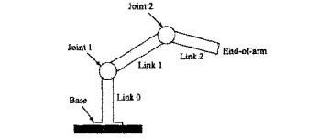
Basic terms related to Robot:
- Manipulator: is an-arm like mechanism, designed to manipulate or move materials, parts or tools without direct human contact.
- Joint: which integrates two or more links to provide controlled relative movement between input and output link
- Link: is a rigid member which connects the joints. They are input and output links, the movement of input link causes the motion of the output link.
- Degree of freedom (DOF): this describes the robot’s freedom of motion in three dimensional space.
- End Effectors: is the device at the end of the robot arm, shaped like a hand or as a special tool depending upon the application.
- Base: is the support for the robot arm.
Types of Robot joints:
- Rotational joint or R-joint:


This type of joint allows rotary relative motion, where the axis of the rotation is perpendicular to the axes of the input link and the output link.
- Linear joint or L-joint:

This type of joint allows translational sliding motion between the input and output links with the axes of the links parallel
- Orthogonal joints or O-joints:


This type of joint allows translational sliding motion between the input and output links with the axis of the output links perpendicular to the input link.
- Twisting joint or T-joints:


This type of joint allows rotary motion where the axis of rotation is parallel to the axes of the input and output links.
- Revolving joint or V-joint:
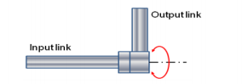

In this type of joint, the input link is axis is parallel to the rotational axis of the joint whereas the output link axis is perpendicular to the rotational axis of the joint.
Application of Robots
- Material / part handling: here Robots are used to
- Transfer materials from one location to another location.
- Pick and place: it is the most common and simple application, where objects are picked and placed from one location to another location.
- Palletizing: where the robot stacks (heaps/ loads) products or carton boxes on to a pallet at various positions on the pallet to the required height.
- Depalletizing: here robot picks the parts from already stacked pallet to another location.
- Stacking: here robots are used to stack parts upon one another.
- Insertion: here robots are used to insert the parts into the compartment or space provided in a carton.
- Machine loading / unloading:
- Machine loading: robot is used to load parts into the production machine.
- Machine unloading: robot is used to unload the finished parts that comes out from the into the production machine.
- Machine loading and unloading: in this operation, both loading the raw product into the production machine and unloading the finished parts from the production machine.
Examples:
- Die casting
- Forging
- Plastic injection moulding
- Sheet metal operation
- Heat treating
- Processing operation: here robots are used to carry put the processing operations by using suitable tool at its end-effectors.
- Spot welding:
- Arc welding:
- Spray painting
- Spray coating
- Grinding
- Drilling and other machining processes
- Plasma cutting
- Laser cutting etc.
- Assembly inspection:
- Assembly: the combination of two or more parts to form a new object is called an assembly. To do this assembly operation robot is used.
- Inspection: inspection means to separate poor quality products from the good ones to ensure the required quality.
Example: 1.To inspect weather oil filter is put in an engine or not.
2. To detect flaws in the finished product.
Advantages of Robots
- Robots can be substituted for humans to work in hazardous work environment.
Ex. Arc welding, powder coating, foundry etc.
- Robots can produce more quantity in a short span of time, accuracy and consistency than the humans.
- Robots can work at constant speed without any break
- Robots are capable of lifting heavy loads without getting tired.
- Robots can be reprogrammed to take up different task
- Accidents at the work place is avoided
- Robots produces lesser or no defective products
- Robots save more time
Disadvantages of robots
- Huge investment
- Since parts of robots are very precise, therefore there replacement is difficult and costly
- It requires highly skilled technical engineers and programmers to program and setup the robotic system
- Highly sophisticated level of artificial intelligence is only able to respond for any accident or any unexpected variance occurs.

