MODULE 5
EQUIPMENT SAFETY MEASURES
FUSE:
Q) What is fuse? Explain the working of fuse.
Fuse is a simplest protecting device which consists of small piece of metal, when current through it increases the metal melts and interrupt the circuit.
Working of fuse:
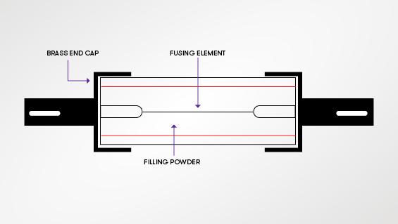
- Fuse is a simple protective device which is connected in series with the circuit. As shown in figure it consists of fusing element which is made up of conducting material like copper, through which current flows to the circuit.
- During normal condition the current flows through the fusing element is rated current but when fault occurs the magnitude of the current becomes more than the rated value hence fuse element melts and interrupt the circuit.
- Above figure shows a cartridge type of fuse which contains glass tube filled with filling power like quartz dust which absorbs the heat and acts as cooling medium.
Advantages of fuse:
- Fuse is a cheapest and simplest protective device;
- Maintenance is zero.
- Operation of fuse is very simple.
- No need of relay as in circuit breaker, because the sensing and interruption of fault is done by fuse only.
Disadvantages of fuse:
- After every operation the fusing element has to replace.
- Hence time consuming.
MCB (Miniature Circuit Breaker):
Q) With neat diagram explain the working of MCB.
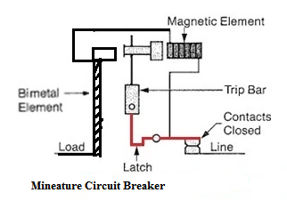
- A miniature circuit breaker is an electromechanical protective device which makes and breaks the contacts during normal and abnormal conditions and hence protects the circuit.
- As shown in figure MCB contains a bimetallic element, a latch and two contacts, one is fixed and another one is moving.
- When fault current flows through it the bimetallic element gets heated and deflects by bending. The deflection of the bimetallic strip releases the latch. The moving contact of the MCB opens and stops the flow of the fault current to the circuit. To restart the flow of the normal current the MCB must be turned on manually.
- During short circuit conditions, the current rises suddenly due to which the displacement of plunger with respect to solenoid takes place. The plunger hits the trip bar which causes automatic release of the latch and hence contacts of the MCB opens and interrupts the fault current.
Advantages of MCB:
- Very compact.
- Operation time is very less (less than 1milli second).
- No need of replacement of any element, hence time consuming.
- No need of any trip circuit.
- Noiseless operation, no smoke or flames.
Disadvantages of MCB:
- The cost of MCB is greater than fuse.
- Circuit is complicated compared to fuse.

MODULE 5
PERSONAL SAFETY MEASURES
ELECTRIC SHOCK:
A sudden agitation of the nervous system of a body due to the passage of an electric current is called electric shock.
Factors affecting the severity of the shock:
- Magnitude of the current through the body.
- Path of the current through the body.
- Time for which the current is passed through the body.
- Frequency of the current.
- Physical and psychological condition of the person.
Precautionary measures against electric shock:
- Insulation of the conductor must be proper and in good condition.
- Earthing should be always maintained in proper condition.
- Make the mains supply switch off and remove the fuse before starting work.
- Use rubber soled shoes while working.
- Use some wooden supper under the feet.
- Use rubber gloves while touching any terminals.
- Use line tester to check a live terminal carries any current or not.
- Always use insulated screw driver, pliers, line tester etc.
- Never touch two different terminals at the same time.
- The socket should be fixed at a height beyond the reach of the children.
EARTHING:

Earthing is defined as the connection of electrical machinery to the general mass of earth with a conducting material of very low resistance.
Necessity of earthing:
Let
V = Supply voltage in volts
I = current through the equipment in A
I_{body} = Current passing through the body of the person in A
R_{E} = Resistance of the earth in Ω
R_{body} = Resistance of the person’s body in Ω
R_{i} = Resistance of the insulation of the equipment in Ω
Case i) during normal condition: R_{i} = $∞$
I_{body} =$\frac{V}{Ri+Rbody+RE}$ = $\frac{V}{∞}$ = 0
ie; in normal condition the current passing through the person’s body is zero hence the person is safe.
Case ii) during fault condition: R_{i} = 0, R_{E} and R_{body} is very small.
I_{body} = $\frac{V}{0}$ = $∞$
ie; very high current flows through the person’s body and the person receives a fatal electric shock as shown in figure below
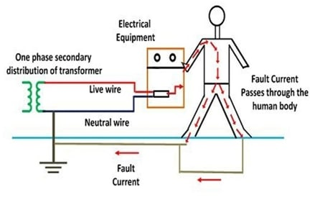
Case iii) during earthing the frame of equipment:
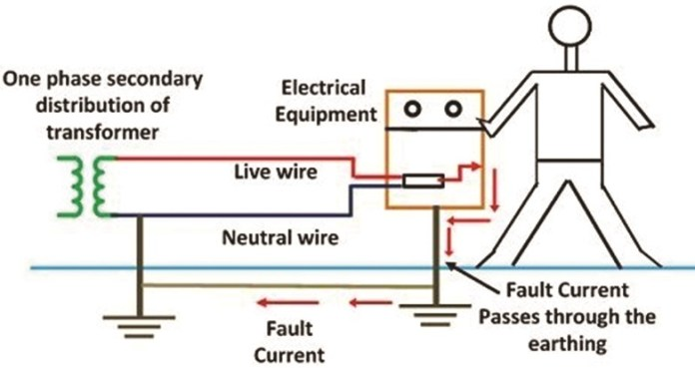

As shown in the figure above if the earthing is done to the equipment then the fault current flows to the earth hence person wont receive any shock.
Hence earthing is necessary to provide protection to the equipment and the operator.
TYPES OF EARTHING:
Pipe earthing:
In this method of earthing a G.I. pipe of 38mm diameter and 2 meter (7 feet) length is embeded vertically into the ground. This pipe acts as an earth electrode. The depth depends on the condition of the soil. The earth wires are fastened to the top section of the pipe above the ground level with nut and bolts. The pit area around the pipe is filled with salt and charcol mixture for improving the condition of the soil and earthing efficiency. Impregnating the coke with salt decreses the earth resistance. Generally alternate layers of salt and coke/ charcoal are used for pipe earthing.
According to indian standard, the pipe should be placed at a depth of 4.75m. in summer season, soil becomes dry. In such case water is poured through the funnel connected to G.I. main pipe through 19mm diameter pipe. This keeps the soil wet. The earth wires are connected to the G.I. pipe above the ground level and can be physically inspect from time to time. This is the important advantage of pipe earhing over plate earthing. The only disadvantage of pipe earthing is that the embeded pipe length has to be in cresed sufficiently in case the soil specific resistance is high. This increses the excavation work and hence incresed cost.
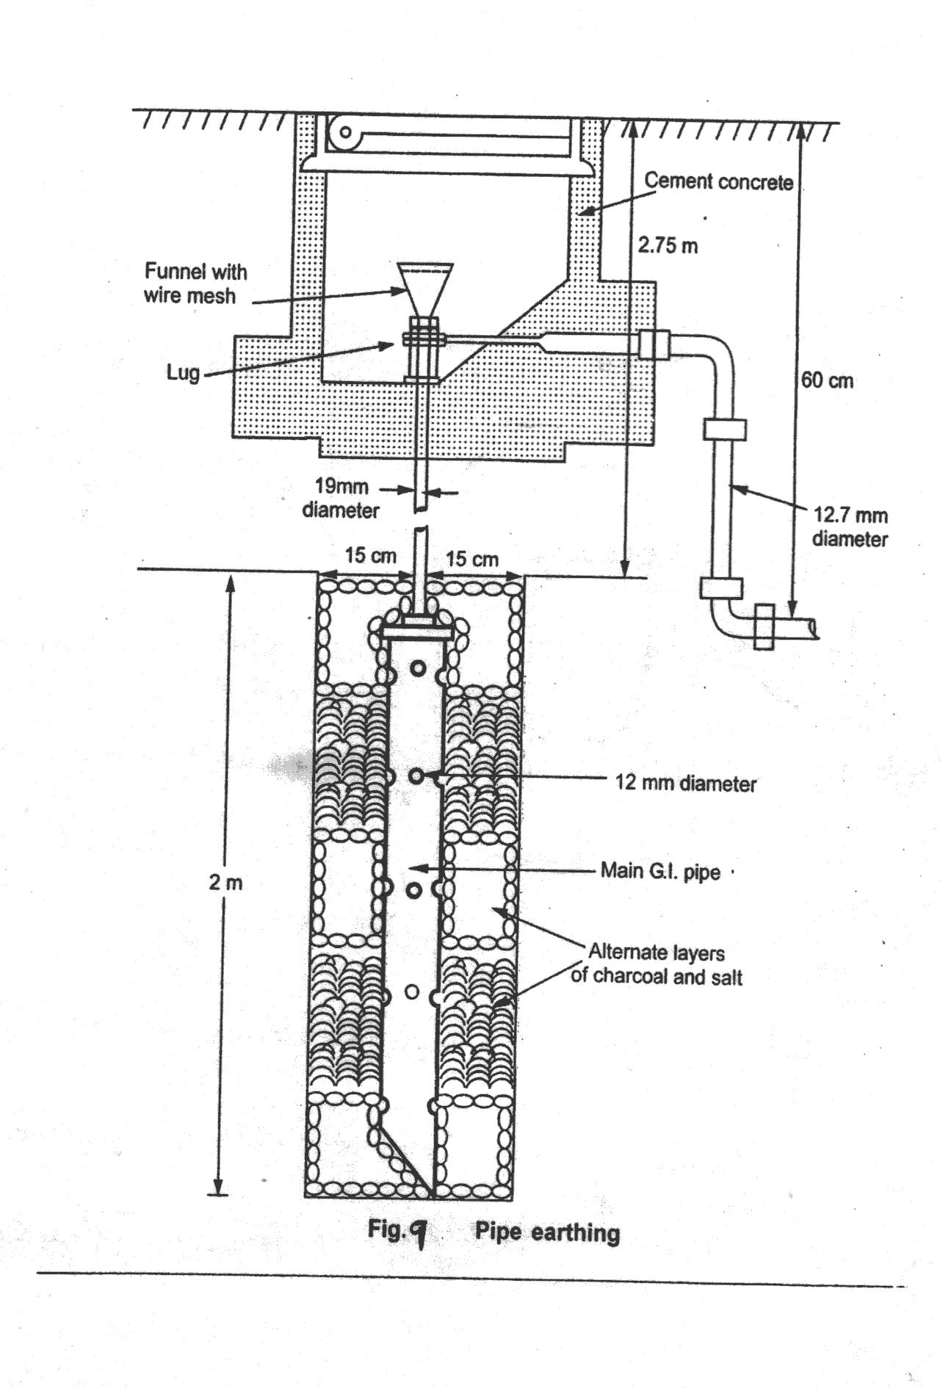
Plate earthing:
The earth connection is provided with the help of copper plate or galvanised iron (G.I.) plate. The copper plate size is 60 cm$×60 cm×3.18 mm$ while G.I. plate size is not less than 60 cm$×60 cm×6.3mm.$The plate is embedded 3 meters ( 10 feet) in to the ground. The plate is kept with its face vertical.
The plate is sarrounded by the alternate layer of cokeand salt for minimum thickness of about 15 cm. the earth wire is drawn through G.I. wire or G.I. strip of sufficient cross sectional area to carry the fault current safely. The earth wire is drawn through G.I. pipe of 19mm diameter, at about 60cm below the ground.
The G.I. pipe is fitted with a funnel on the top. In order to have an effective earthing salt water is poured through the funnel.
The only disadvantage of this method is that the discontinuity of the earth wire from the earthing plate below the earth can not be observed physically.

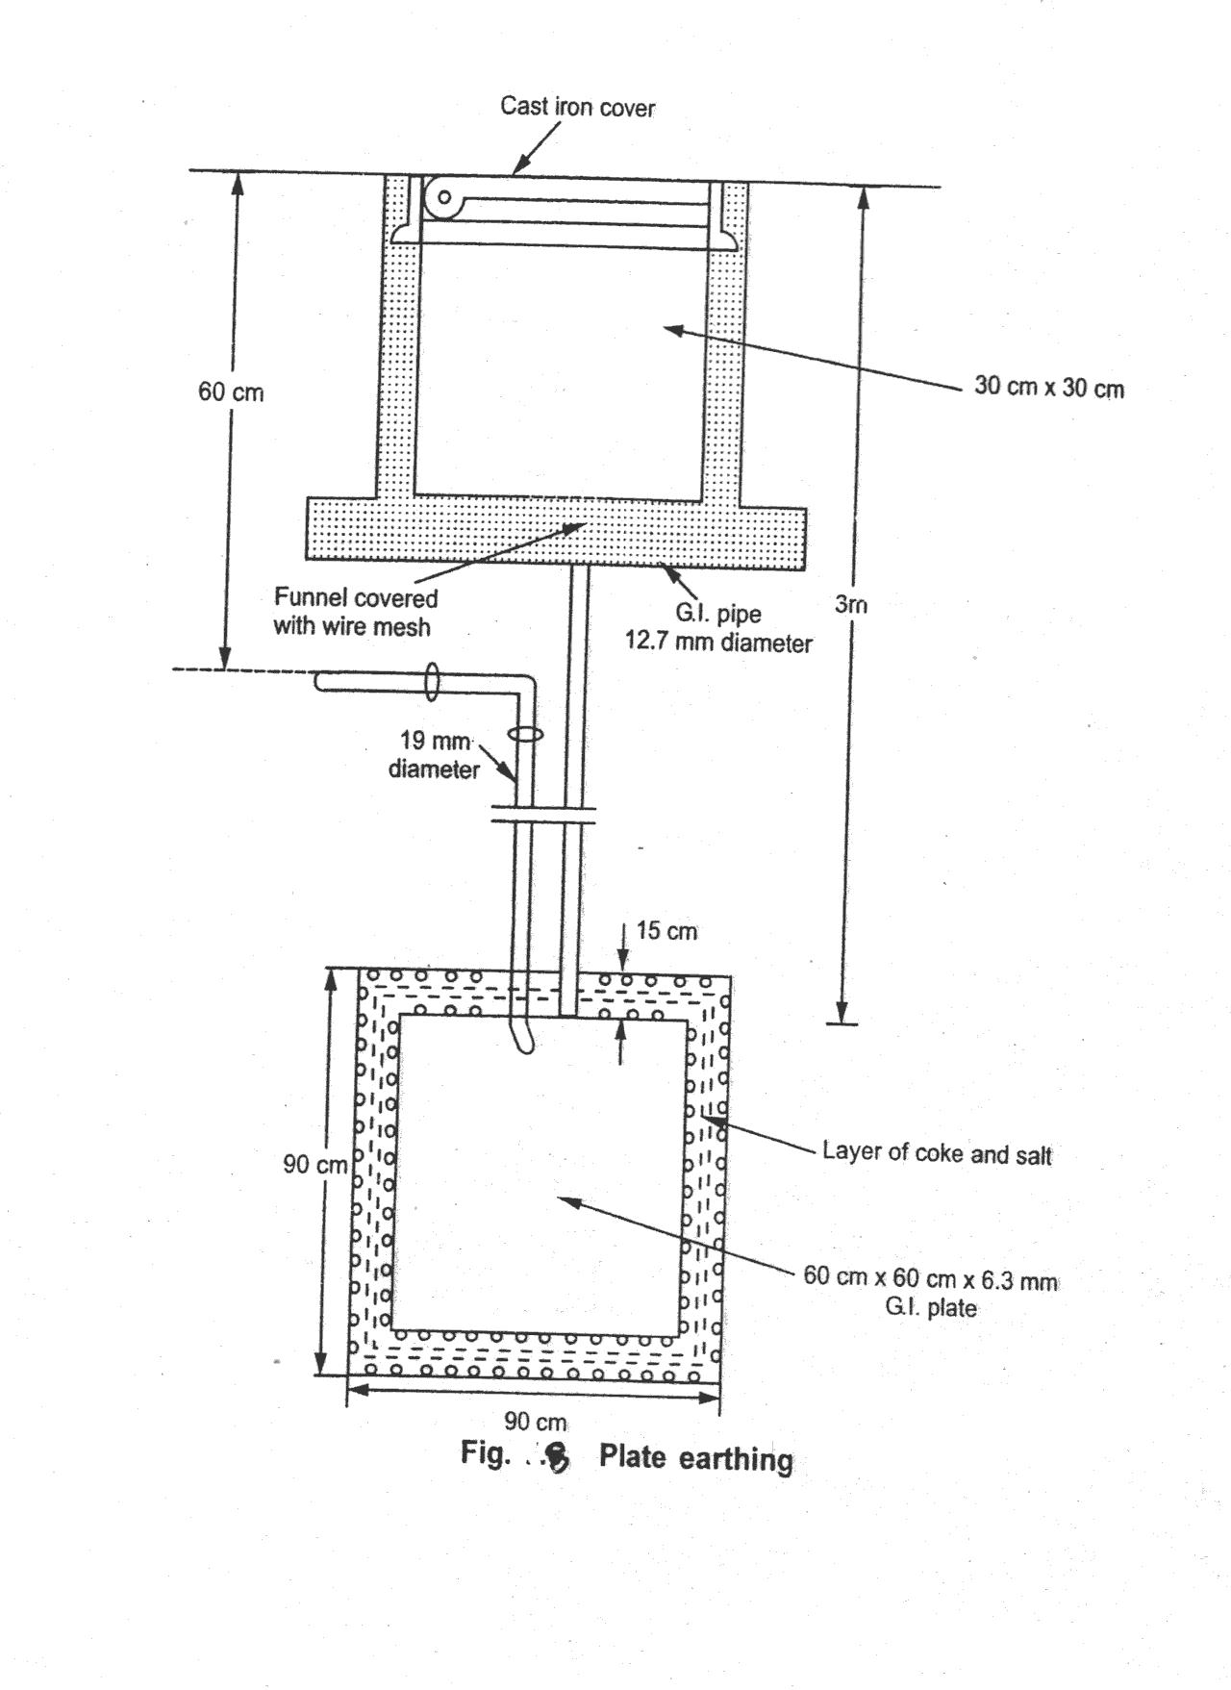

ELECTRICITY BILL
Power rating of household appliances including air conditioners, PCs, laptops, printers, etc
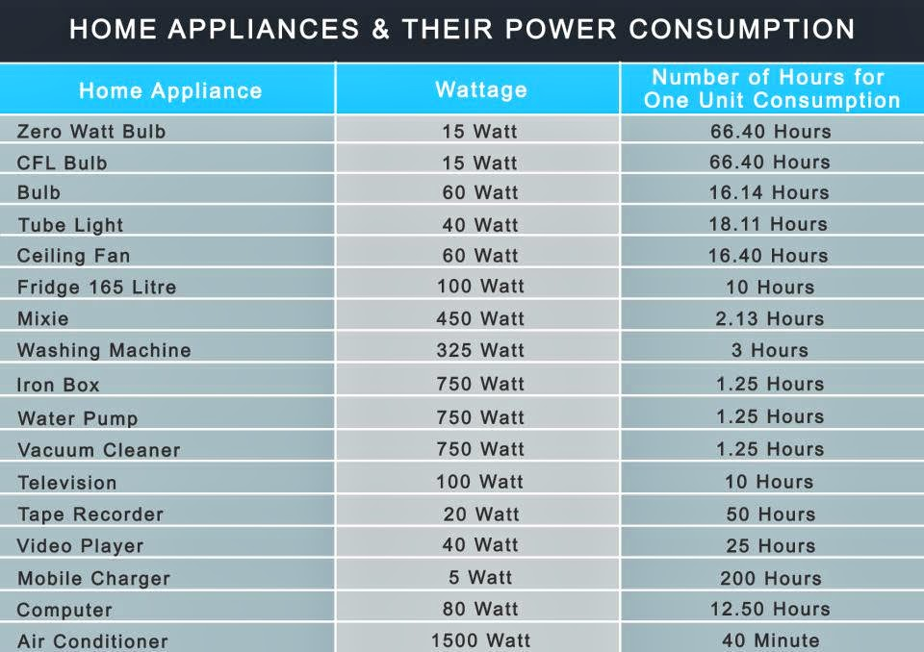
UNIT:
Definition of “unit” used for consumption of electrical energy: it’s a commercial name to the kWh consumption or generation of electrical energy, which means 1 kilo watts energy consumed or generated in one hour.
TARIFF:
The rate at which electrical energy is supplied to a consumer is known as tariff.
Characteristics of tariff:
A tariff must have following desirable characteristics:
- Proper return: the tariff should be such that the proper return from each consumer. This will enable the electric supply company to ensure continuous and reliable service to the consumers.
- Fairness: the tariff must be fair so that different types of consumers are satisfied with the rate of charge of electrical energy. Thus a big consumer should be charged at a lower rate than a small consumer.
- Simplicity: the tariff should be simple so that an ordinary consumer can easily understand it.
- Reasonable profit: the profit in the tariff should be reasonable. An electric supply company is public utility company and generally it’s a monopoly hence the profit to be restricted to 8% per annum.
- Attractive: the tariff should be attractive so that a large number of consumers are encouraged to use electrical energy.
TWO PART TARIFF:
In two part tariff the charges are divided in two parts on the basis of maximum demand of the consumer and the units consumed.
Total charges= (b$×$kW+c$×$kWh) Rs/-
Where b- charge per kW of maximum demand
And c- charge per kWh of energy consumed
- In two part tariff, the total charge to be made from the consumer is split into two components viz., fixed charges and running charges. The fixed charges depend upon the maximum demand of the consumer while the running charges depend upon the number of units consumed by the consumer.
- This type of tariff is suitable to industrial consumers who have appreciable maximum demand.
Advantages:
- It is easily understood by the consumers.
- It recovers the fixed charges which are dependent on the maximum demand of the consumer and independent of the units consumed.
Disadvantages:
- The consumer has to pay the fixed charges whether he has consumed or not.
- There is always error in assessing the maximum demand of the consumer.

-: NUMERICAL:-
1) A consumer has a maximum demand of 200kW at 40% load factor. If the tariff is 100Rs/- per kW of maximum demand plus 10 paise per kWh, find the overall cost per kWh.
Sol.: Units consumed/year = Maximum demand $×$ Load Factor $×$ Hours in a year
= 200$×$0.4$×$870
= 700800kWh
Annual charges = Annual Maximum Demand charges + Annual energy charges
= (100$×$200 + 0.1$×$700800)
= 90080 Rs/-
Overall cost/kWh = $\frac{Annual charges}{Units consumed/year}$ = $\frac{90080}{700800}$ = 12.85 paise

DOMESTIC WIRING SYSTEM
Types of wiring:
Casing and capping:
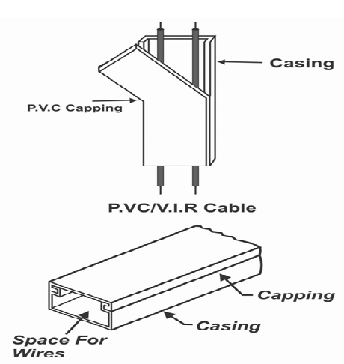
One of the oldest and most commonly seen wiring in use today is casing capping wiring. PVC-insulated wires are encased in plastic casings and protected with a cap in this approach to electrical wiring. The casing capping wiring is generally recommended for low-voltage wiring in homes, offices, and devices, as well as for wire distribution and protection.
The casing is typically a rectangular strip with a grey or white channel and cap. It comes in sizes of 1.5 inches in width and 0.8 inches in thickness, with a standard “case and cap” length of 39.4 inches. The system has a 20-year lifespan and performs admirably in homes and offices.
PVC casing and capping is a fantastic product that has many uses in wiring installations. They offer insulation and electrical safety and support the distribution load of the wires in accordance with their capacity. PVC has the highest level of chemical resistance available, making it the most durable material on the market. It also aids in shielding the cables and wires from damage.

Casing capping wiring: Types
There are four varieties of casing capping wiring:

Press and fit
The most common type of casing capping wiring is press and fit, which has one component on the bottom surface and another on top. The installation procedure is fairly simple. The bottom portion is first fastened to the walls. The wiring is then fed downward, and the cover is pressed against the base.

Sliding and fit
Deeper-lying casings that are challenging to press and fit the capping are more typical. PVC is a particularly difficult material to press; sliding makes it much easier to install.

Trunked fit
Trunked fit is a practical wiring system that is frequently used in street light installations as an added layer on subsurface voltage wires.

Grilled fit
For telephone cable management, a typical casing and capping wiring system type that offers lots of customization is called grilled fit.
Casing capping wiring: Advantages
- All of the wires are kept together by the manufactured product’s internal locking system, which also holds them all inside the casing, assisting you in developing the desired aesthetics.
- There are many different sizes and fits for casings and caps.
- PVC casings and caps are simple to install in any environment, including the office or the home.
- It is inexpensive.
- PVC is also completely enclosed, which safeguards us against unintentional electric shocks and is rust-free—great for monsoons.
- Avoid letting the tangled cables get in the way of your renovation or rewiring project.
- Guaranteed toughness because un-plasticized PVC retains its shape even after prolonged use.
Casing capping wiring: Disadvantages
- Since this wiring system contains plastic, there is a chance of a serious fire from short circuits.
- This wiring system is not appropriate for use in industries with acidic environments.
- Finding any wire-related fault is challenging.

Two way and three way control of lamp
Two way control of lamp:
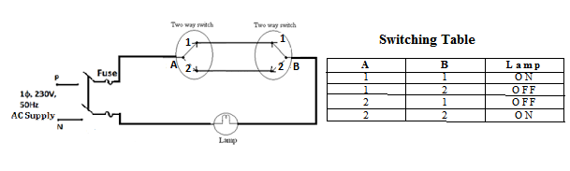
Explanation: from the switching table it is clear that if both the switches (A&B) are at position 1 or 2 means on or off then the lamp will glow. And if both the switches are at different position the lamp will remain off.
Three way control of lamp:

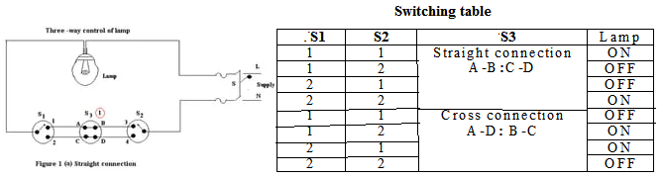
Explanation: from the switching table it is clear that there are two connections of intermediate switch. When switch S3 is connected straight then the lamp will glow only if the two way switches S1&S2 are at same position, otherwise the lamp remains off.
When the switch S3 is cross connected then the lamp will glow if the switches S1&S2 are at different positions, otherwise the lamp remains off.

