Program 1:

Aim : Develop a program to solve simple computational problems using arithmetic expressions and use of each operator leading to simulation of a commercial calculator. (No built-in math function)

Theory

An arithmetic operator performs mathematical operations such as addition, subtraction, multiplication, division etc on numerical values.
Operator | Meaning of Operator
+ | addition or unary plus
- | subtraction or unary minus
* | multiplication
/ | division
% | remainder after division (modulo division)

Algorithm:

Step 1: start
Step 2: read a and b variables
Step 3: display the options
Step 4: read input choice
Step 5: choice is 1 then goto step 6, or choice is 2 then goto step 7, or choice is 3 then goto step
8, or choice is 4 then goto step 9, or choice is other then these num goto step 10
Step 6: addition of two numbers
Step 7: subtraction of two numbers
Step 8: multiplication of two numbers
Step 9: division of two numbers.
Step 10: invalid choice
Step 11: print result
Step 12: stop

Flow Chart:
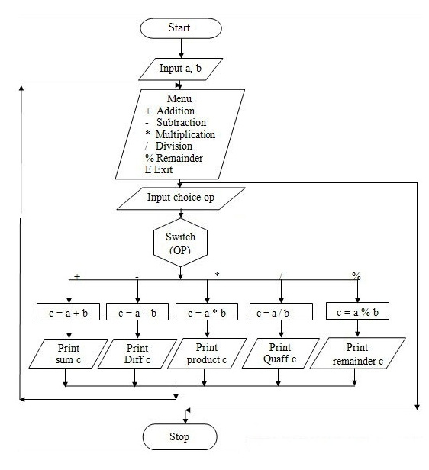

Program:

#include<stdio.h>
main()
{
int a,b;
int op;

clrscr();
printf(" 1.Addition\n 2.Subtraction\n 3.Multiplication\n 4.Division\n 5.Remainder\n");
printf("Enter the values of a & b: ");
scanf("%d %d",&a,&b);
printf("Enter your Choice : ");
scanf("%d",&op);
switch(op)
{
case 1 :
printf("Sum of %d and %d is : %d",a,b,a+b);
break;
case 2 :
printf("Difference of %d and %d is : %d",a,b,a-b);
break;
case 3 :
printf("Multiplication of %d and %d is : %d",a,b,a*b);
break;
case 4 :
printf("Division of Two Numbers is %d : ",a/b);
break;
case 5:
printf("Remainder of %d and %d is : %d",a,b,a%b);
break;
default :
printf(" Enter Your Correct Choice.");
break;
}

}

Program 2

Aim: Develop a program to compute the roots of a quadratic equation by accepting the coefficients. Print appropriate messages.

Theory : The if else in C is an extension of the if statement which not only allows the program to execute one block of code if a condition is true, but also a different block if the condition is false. This enables making decisions with two possible outcomes.
Syntax of if-else
if (condition) {
// Code to execute if condition is true
}
else {
// Code to execute if condition is false
}

Algorithm:

Step1 :[read the values of A,B and C]
Read A,B,C

Step2: [check for the co-efficients]
If A=0 and B=0 and C=0
Then roots are non-determinant

Step 3: [compute the value of Disc]
Disc=B*B-4*A*C;

Step 4: [Depending on the value of disc different roots are obtained]
If Disc is lesser than 0 go to Step 5
If Disc is equals to 0 go to step 6
If Disc is greater than 0 go to step 7

Step 5:Print the imaginary roots
Realp=-B/2*A;
Imagp =sqrt(Disc)/2*A;
Root1=realp+imagep;
Root2=realp-imagep;

Step 6:roots are real and equal
Root1=-B/2*A;
Root2=root1 ;

Step 7:roots are real and distinct
Root1=-B+sqrt(Disc)/2*A;
Root2=-B-sqrt(Disc)/2*A;

Step 8:stop

Flowchart
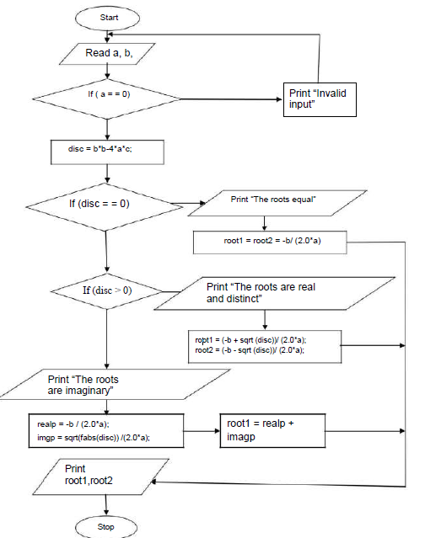

PROGRAM
#include<stdio.h>
#include<conio.h>
#include<math.h>
void main()
{
float a,b,c,disc;
float root1,root2,realp,imagp;
clrscr();
printf("enter values of a,b,c\n");
scanf("%f%f%f",&a,&b,&c);
if(a==0 && b==0 && c==0)
{
printf("roots cannot be determined\n");
exit(0);
}
else
{
disc=b*b-4*a*c;
if(disc>0)
{
root1=(-b+sqrt(disc))/(2*a);
root2=(-b-sqrt(disc))/(2*a);
printf("roots are real and distinct\n");
printf("root1=%f\n",root1);
printf("root2=%f\n",root2);
}
else if(disc==0)
{
root1=-b/(2*a);
root2=root1;
printf("roots are real and equal\n");
printf("root1=%f\n",root1);
printf("root2=%f\n",root2);
}
else if(disc<0)
{
realp=-b/(2*a);
imagp=sqrt(abs(disc)/(2*a));
printf("roots are complex\n");
printf("root1=%f+i%f\n",realp,imagp);
printf("root2=%f-i%f\n",realp,imagp);
}
}
getch();
}

Program 3 :

3. An electricity board charges the following rates for the use of electricity: for the first 200 units 80 paisa per unit: for the next 100 units 90 paisa per unit: beyond 300 units Rs 1 per unit. All users are charged a minimum of Rs. 100 as meter charge. If the total amount is more than Rs 400, then an additional surcharge of 15% of total amount is charged. Write a program to read the name
of the user, number of units consumed and print out the charges.
ALGORITHM:
Step 1: start
Step 2: read customer number
Step 3: read customer name
Step 4: read unit consumed
Step 5: unit is less then 200,charge 0.80 per unit
Step 6: if unit is greater then 200 and less then 300, charge 0.90 per unit
Step 7: unit is greater then 400 charge 1.00 per unit,
Step 8: calculate amount by unit* charge
Step 9: if the amount is greater then 400, then an additional surcharge of 15% of total amount is
charge toatal-amount=amt+surcharge.
Step 10: the toatal_amount is less then 100 then,charge a minimum of rs 100 as meter charge
Step 11: print customer number,name,unit_consumed_amount,surcharge,totalAMOUNT
Step 12:stop

Start

Read IDNo,
Name, Unit

If Unit<200

Charge=0.80

No
If Unit<200
Yes No
Total Amt=100
If T.Amt<100

Total Amt=Amt+Surcharge
Surcharge+amt*15/100.0
If Amt>400

Charge=1.00
Amt=unit*charge
Charge=0.90

Yes

Yes

No
Stop

Print, IDNo, Name,
Unit Consume, Amt,
Surcharge, Totao-Amt

Program:
#include<stdio.h>
#include<string.h>
#include<conio.h>
void main()
{
int cust_no, unit_con;
float charge,surcharge=0, amt,total_amt;
char nm[25];
clrscr();
printf("enter the customer IDNO :\t");
scanf("%d",&cust_no);
printf("\nenter the customer Name :\t");
scanf("%s",nm);
printf("\nenter the unit consumed by customer :\t");
scanf("%d",&unit_con);
if (unit_con <200 )
charge = 0.80;
else if (unit_con>=200 && unit_con<300)
charge = 0.90;
else
charge = 1.00;
amt = unit_con*charge;
if (amt>400)
surcharge = amt*15/100.0;
total_amt = amt+surcharge;
if (total_amt < 100)
total_amt =100;
clrscr();
printf("\t\t\tElectricity Bill\n\n");
printf("Customer IDNO :\t%5d",cust_no);
printf("\nCustomer Name :\t%s",nm);
printf("\nunit Consumed :\t%5d",unit_con);
printf("\nAmount Charges @Rs. %4.2f per unit :\t%8.2f",charge,amt);
printf("\nSurchage Amount :\t%8.2f",surcharge);
printf("\nNet Amount Paid By the Customer :\t%8.2f",total_amt);
getch();
}

Program 4 : Implement Binary search on Integers/Names.

Algorithm:
Step 1:[read the value of N]
Read N

Step 2:[Enter the elements in ascending order]
For i=0 to N-1 is to be read from the key board

Step 3:[Enter the one element for searching that could be a key element]

Step 4:intialy set low=0 and high=N

Step 5:[Find out the middle value]
Mid=(low+hogh)/2;

Step 6:check key value is lesser than middle value go to step 7
Check key value is greater than middle value go to step 8

Step 7: high=mid-1
Step 8 low =mid+1;

Step 9: if key value and mid value are same than go to step 10 if not go to step 11

Step 10: successful search

Step 11: not searched the key element

Step 12: stop

FLOWCHART

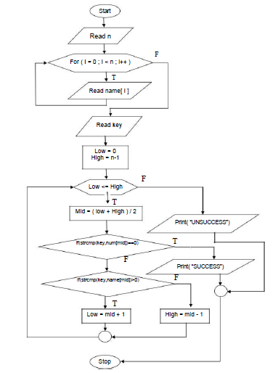
PROGRAM:

#include<stdio.h>
#include<conio.h>
#include<string.h>

void main()
{
char name[50][50],key[50];
int n,i,low,high,mid,found=0;
printf("How many names to Read:\n");
scanf("%d",&n);
printf("Enter the Names in ascending order:\n");
for(i=0;i<n;i++)
{
scanf("%s",name[i]);
}
printf("\nType the name to be searched:");
scanf("%s",key);
low=0;
high=n-1;
while(low<=high && !found)
{
mid=(low+high)/2;
if(strcmp(name[mid],key)==0)
found=1;
else if(strcmp(name[mid],key)<0)
low=mid+1;
else
high=mid-1;
}

if(found==1)
printf("\nSearch successful and Name found in the list at position:%d",mid+1);
else
printf("Name not found and search Unsuccessful....!");
getch();
}

Program 5 : Implement Matrix multiplication and validate the rules of multiplication.

ALGORITHM:

Step 1:start

Step 2:[Read the order of both matrices M,N,P,Q]

Step 3: check for i=0 to M and j=0 to N for the matrix A,read A[i][j]

Step 4:Check for i=0to P and j=0 to Q for matrix B read B[i][j]

Step 5:if(N=P) then only multiplication is possible then go to step 6 otherwise go
to step 7

Step 6: intialy set matrix C[i][j] as 0
For k=0 to n
C[i][j]=C[i][j]+A[i][k]*B[i][k] go to step 8

Step 7:multiplication is not possible

Step 8:prints the multiplication of two matrix

Step 9:stop

FLOWCHART:

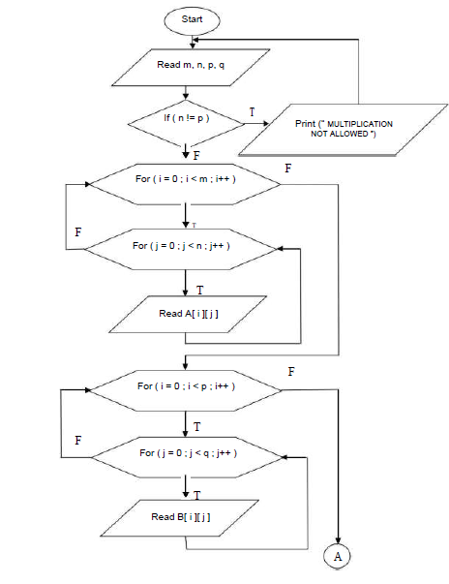
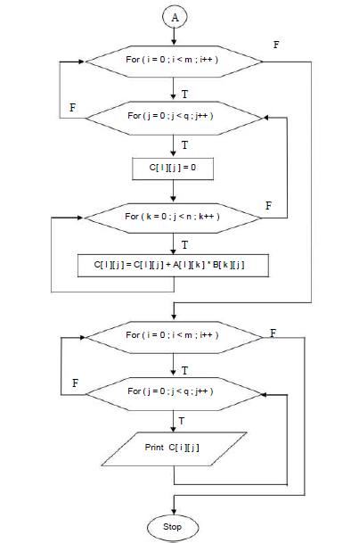

PROGRAM:

#include<stdio.h>
#include<conio.h>
main()
{
int a[20][20],b[20][20],c[20][20];
int m,n,p,q,i,j,k;
clrscr();
printf("enter rows and columns of matrix a\n");
scanf("%d%d",&m,&n);
printf("enter rows and columns of matrix b\n");
scanf("%d%d",&p,&q);
if(n!=p)
{
printf("matrix multiplication not possible\n");
return 0;
}
printf("enter elements of matrix a\n");
for(i=0;i<m;i++)
{
for(j=0;j<n;j++)
{
scanf("%d",&a[i][j]);
}
}
printf("enter elements of matrix b\n");
for(i=0;i<p;i++)
{
for(j=0;j<q;j++)
{
scanf("%d",&b[i][j]);
}
}
for(i=0;i<p;i++)
{
for(j=0;j<q;j++)
{
c[i][j]=0;
for(k=0;k<n;k++)
{
c[i][j]=c[i][j]+a[i][k]*b[k][j];
}
}
}
printf("product of two matrices is\n");
for(i=0;i<m;i++)
{
for(j=0;j<q;j++)
{
printf("%d\n",c[i][j]);
}
}
getch();
}

Program 6 : Compute Sin(x)/Cos(x) using Taylor series approximation. Compare your result with the built- in Library function. Print both the results with appropriate inferences.

ALGORITHM:

Step 1: [Start]
Step 2: [Read the value of x in
degrees] Read x
Step 3: [Initialization & Radians
conversion] Temp=x
x=x*(3.142/180.0)
Term=x
Sinx=term
n=1
Step 4: [compute sin value]]
Repeat While (term>FLT_EPSILON)
Fact =2*n*(2*n+1)
Term=term*x*x/fact Sinx
sinx+term= n+1n

Step 5: [Output]
Print sin(x) without using library function Print sin(x) with using library function
Step 6: [Stop]

FLOWCHART:
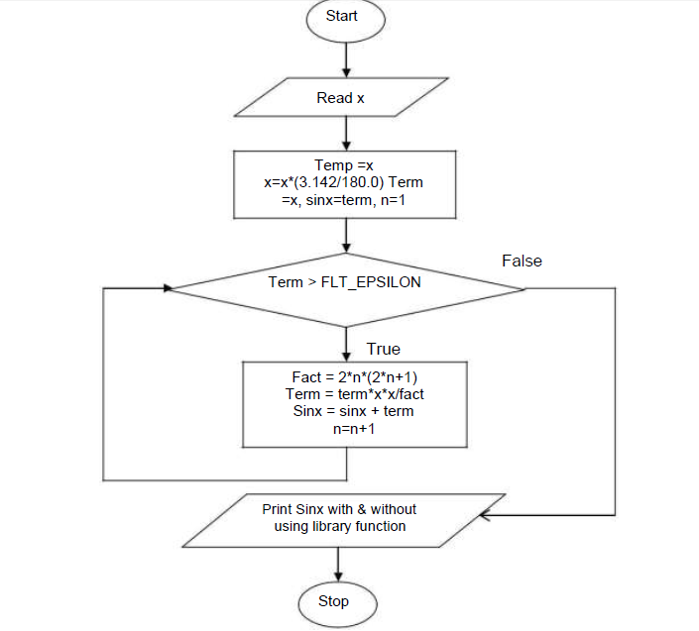
PROGRAM:

#include<stdio.h>
#include<conio.h>
#include<math.h>
void main()
{
int x,n,i;
float rad, res, sum=0;

clrscr();

printf("Enter degree\n");
scanf("%d",&x);

printf("Enter number of terms\n");
scanf("%d",&n);

rad=x*3.14/180;
for(i=1;i<=n;i+=2)
{
if ((i-1)%4==0)
sum=sum+pow(rad,i)/fact(i);
else
sum=sum-pow(rad,i)/fact(i);
}
printf("Calculate sin(%d) = %f", x,sum);
printf("Library sin (%d) = %f",x,sin(rad));

getch();
}
int fact(int m)
{
int i,f=1;
for(i=1;i<=m;i++)
{
f=f*i;
}
return 1;
}

Program 7:

Sort the given set of N numbers using Bubble sort.
ALGORITHM:
Step 1:[read the value of N]
Read N

Step 2:[Read N elements in to the array]
For i=0 to N,for j=0 to n-i-1

Step 3:check for bubble sort technique
A[j]>a[j+1]
Go to step 4 other wise repeat step 3

Step 4:temp=A[j];
A[j]=A[j+1]
A[j+1]=temp(SWAPPING OF ELEMENTS)

Step 5:Print the sorted array

Step 6:stop

FLOWCHART:

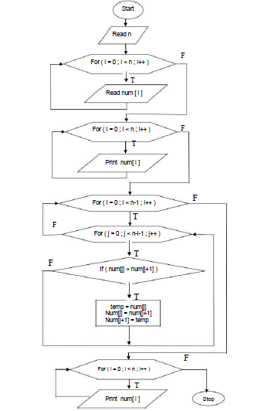
PROGRAM:
#include<stdio.h>
#include<conio.h>
void main()
{
int a[20],n,i,j,temp;
clrscr();
printf("enter no. of elements\n");
scanf("%d",&n);
printf("enter array elements\n");
for(i=0;i<n;i++)
{
scanf("%d",&a[i]);
}

for(i=0;i<(n-1);i++)
{
for(j=0;j<(n-i-1);j++)
{
if(a[j]>a[j+1])
{
temp=a[j];
a[j]=a[j+1];
a[j+1]=temp;
}
}
}
printf("sorted array is\n");
for(i=0;i<n;i++)
{
printf("%d\n",a[i]);
}
getch();
}

Program 8

Write functions to implement string operations such as compare, concatenate, string length. Convince the parameter passing techniques.

Algorithm:
Step1: start
Step 2: read two strings
Step 3: calculate the string length using strlen()
Step 4: compare the string using strcmp()
Step 5: concatenate the strings using strcat()
Step 6: print the stringlength
Step 7: print strings are equal or not equal
Step 8: print concatenated sting
Step 9: stop

FLOWCHART:

PROGRAM:
#include<stdio.h>
#include<conio.h>
#include<string.h>
void stringlength(char a[100],char b[100]);
void concatenate(char a[100],char b[100]);
void stringcompare(char a[100],char b[100]);
void main()
{
char p[100],q[100],ch[100];
int len1,len2;
clrscr();
printf("Enter the first string:\n");
gets(p);
printf("Enter the second string:\n");
gets(q);
stringlength(p,q);
stringcompare(p,q);
concatenate(p,q);
getch();
}

void stringlength(char a[100], char b[100])
{
int len1,len2;
len1=strlen(a);
len2=strlen(b);
printf("First string length is :%d \nSecond string lenght is: %d",len1,len2);
}
void concatenate(char a[100], char b[100])
{
printf("The concatenated String is :%s ", strcat(a,b));
}

void stringcompare(char a[100], char b[100])
{
if(strcmp(a,b)==0)

printf("\nSTRINGS ARE EQUAL\n");

else

printf("\nSTRINGS ARE NOT EQUAL\n");
}
Program 9: Implement structures to read, write and compute average- marks and the students scoring above and below the average marks for a class of N students..

Algorithm:

Program:

#include<stdio.h>
struct stud
{
int rollno, s1, s2, tot ;
char name[10] ;
float avg ;
} s[10] ;
float compute( struct stud S[], int n )
{
int i;
float sum=0 ;
for ( i = 0 ; i < n ; i++ )
{
sum = sum + S[i].avg ;
}
return (sum/n);
}
void display( struct stud s )
{
printf("%d \t %s \t\t %d \t %d \t %d \t %.2f \n", s.rollno,s.name,s.s1,s.s2,s.tot,s.avg);
}
void main()
{
int i, n ;
float mean;
clrscr();
printf("Enter the number of students : ") ;
scanf("%d", &n) ;
for(i = 0 ; i < n ; i++)
{
printf("\nEnter the roll number : ") ;
scanf("%d", &s[i].rollno) ;
printf("\nEnter the name : ") ;
scanf("%s", s[i].name) ;
printf("\nEnter the marks in 2 subjects : ") ;
scanf("%d %d", &s[i].s1, &s[i].s2) ;
s[i].tot = s[i].s1 + s[i].s2 ;
s[i].avg = s[i].tot / 2.0 ;
}
mean = compute( s,n);
printf("\nBelow Average Students\n");
printf("\nRoll No. Name \t\tSub1\t Sub2\t Total\t Average\n\n") ;
for(i = 0 ; i < n ; i++)
{
if( s[i].avg < mean )
display(s[i]);
}
printf("\nAbove Average Students\n");
printf("\nRoll No. Name \t\tSub1\t Sub2\t Total\t Average\n\n") ;
for(i = 0 ; i < n ; i++)
{
if( s[i].avg >= mean )
display(s[i]);
}
getch();

}

10. Develop a program using pointers to compute the sum, mean and standard deviation of all elements stored in an array of n real numbers.

Algorithm:

Step 1: [Start]
Step 2: [Input the elements]
Read n, a[i]

Step 3: [Initialize] sum=0,
sumstd=0

Step 4: [Compute sum, mean, standard
deviation] Ptr=a
For i = 0 thru n in steps of 1
Sum=sum+*ptr
Ptr++
Mean=sum/n
Ptr=a
For i 0 thru n in steps of 1
Sumstd=sumstd+pow((*ptr-mean),2)
Ptr++
std=sqrt(sumstd/n)

Step 5: [Output]
Print sum, mean, standard deviation

Step 6: [Stop]

Flowchart:

Program:

#include<stdio.h>
#include<math.h>
Void main ()
{
float a[20], sum1 = 0, sum2 = 0, mean, var, dev;
int i, n;
clrscr();
printf ("enter no of ele\n");
scanf ("%d", &n);
printf ("enter array ele\n");
for (i = 0; i < n; i++)
{
scanf ("%f", a + i);
sum1 = sum1 + * (a + i);
}
mean = sum1 / n;
for (i = 0; i < n; i++)
{
sum2 = sum2 + pow ((*(a + i) - mean), 2);
}
var = sum2 / n;
dev = sqrt (var);
printf ("sum is%f\n", sum1);
printf ("mean is%f\n", mean);
printf ("variance is%f\n", var);
printf ("devn is%f\n", dev);
getch();
}

