GURU NANAK DEV ENGINEERING COLLGE, BIDAR
Staff Profile
Name of faculty | SHILPA KODGE | 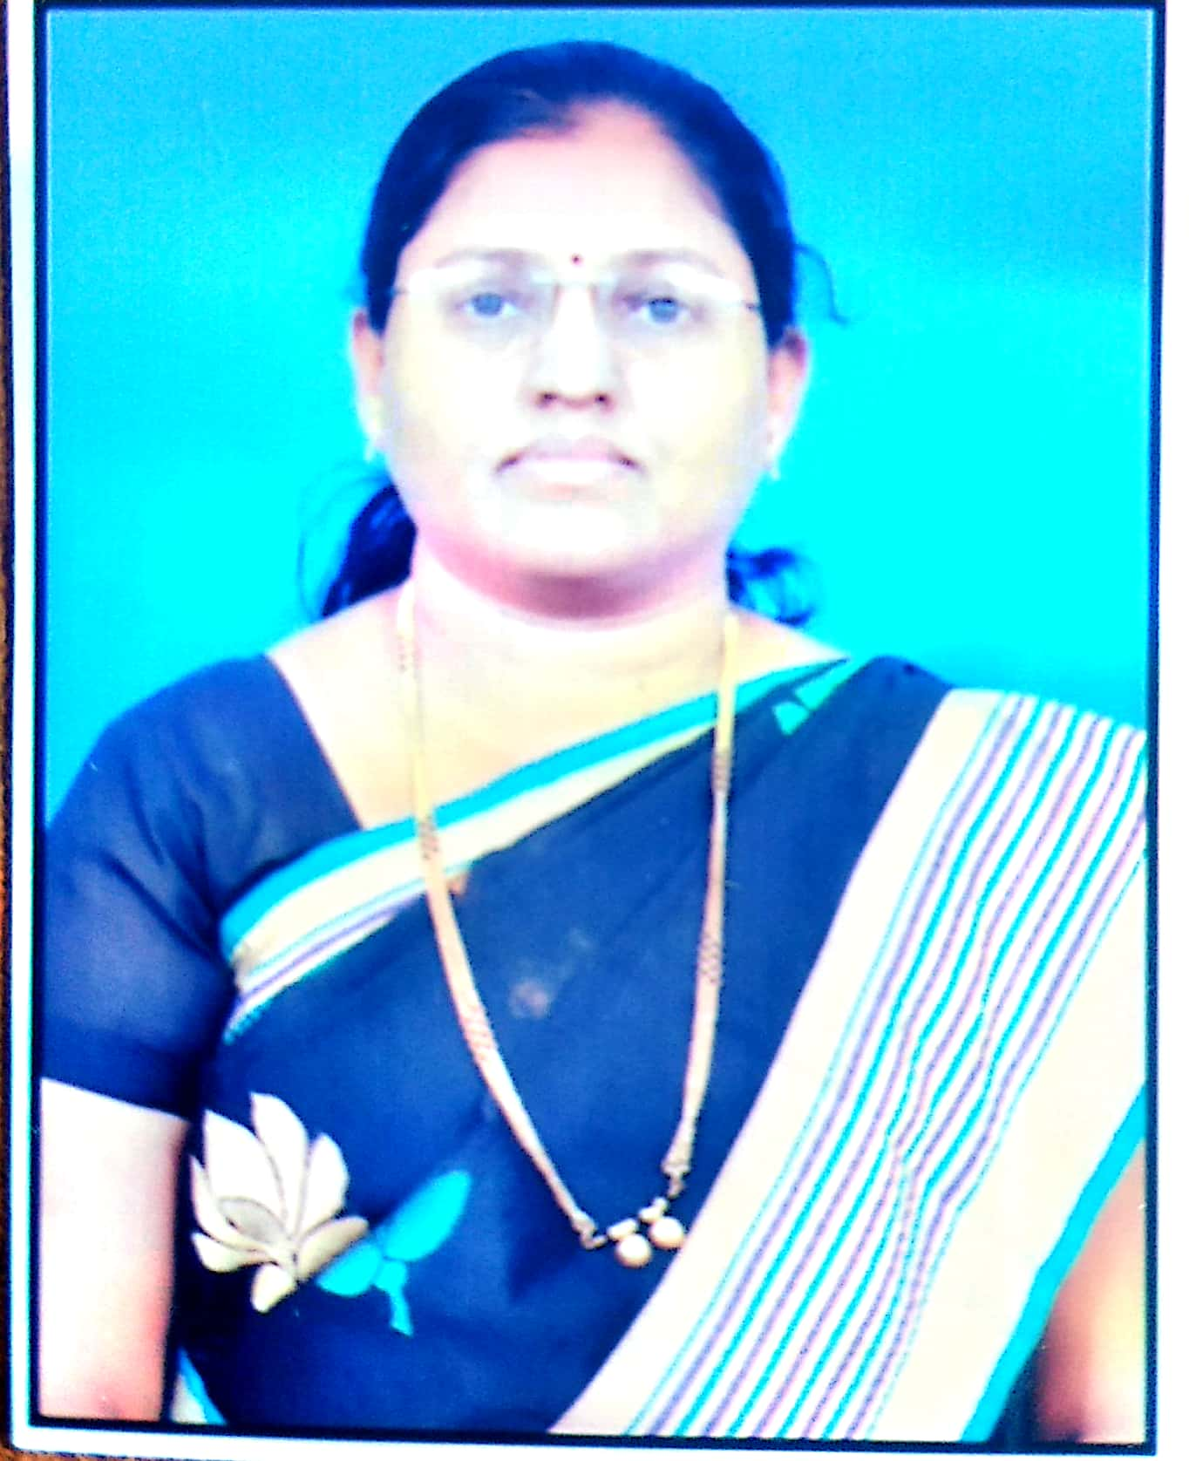  Recent passport size Photo
Designation | Assoc. Professor
Husband’s name | Anil Kodge
Date of Birth | 27-09-1978
Blood Group | A^{+ve}
Nationality | INDIAN
Aadhar Number | 2050 6298 6481
PAN number | BWRPK9191E
College ID Number | 3GNCHE0003727
Mobile number | 9480114132
Email Id: | shilpakodge78@gmail.com

Present Address :  c/o Shashikumar Patil  Mailoor cross, Patil’s Mansion,  Near Sunsoft Technology,  Beside Yuvaranga press, Bidar  State:Karnataka Pin Code:585403 | Permanent Address  Shilpa Kodge  H.No: 3-1-17 Hiremath Galli,  Bhalki  State: Karnataka Pin Code:585328

Details of Qualification
Examination passed | Specialization/  Branch | Name of university | Year of degree award | %age | Division/Class
Under Graduation | B.Sc. (CBZ) | Dr. BAMU, Aurangabad | 1999 | 73.54 | First Division
Post Graduation | M.Sc. ( Organic) | SRT, Nanded University | 2001 | 62.00 | First Division
Ph. D
Other qualification
(if any)

Continuous education: Additional information
Course/Degree under Persuasion | Date of Registration | University | Guide name | Present Status | Remarks
Ph.D | April 2014 | VSK University Bellary | Dr. K.H. Shivprasad | Synthesis work completed | Published 4 papers till date

Teaching and research experience
Teaching Experience (yrs) | Industry Experience (yrs) | Total Experience (yrs)
12.5 | -- | 12.5
Research experience (yrs) | --

Professional experience details (Chronological order)
Sl No | Post | Name and address of Organisation | Period |  | No. of Years
Sl No | Post | Name and address of Organisation | From | To | No. of Years
1 | Asst. Professor | GND. Engg College Bidar | 2006 | Till date | 12

Important Appointment/Post held at College level/University level/Industry
Sl No | Post | Name of University/college | Period |  | No. of Years
Sl No | Post | Name of University/college | From | To | No. of Years
-- | -- | -- | -- | -- | --

Details of Papers presented/published
Sl No | National/  International | Conference / Journal name | Title: MICROWAVE ASSISTED SYNTHESIS, CHARACTERIZATION AND ANTIMICROBIAL SCREENING OF DRUG BASED SCHIFF BASE SILVER COMPLEXES
1 | International | International Journal of Pharma and Bio Sciences | Volume No:8(1)
1 | International | International Journal of Pharma and Bio Sciences | Page No: 183 - 188
1 | International | International Journal of Pharma and Bio Sciences | UGC Approval: No
1 | International | International Journal of Pharma and Bio Sciences | ISSN No: 0975-6299
2 | International | International Journal on Emerging Technologies (Special Issue on ICRIET-2016) | Title: Microwave Aided Synthesis and Biological Screening of Drug Based  Schiff Base Complexes of Silver
2 | International |  | Volume No: 7(2)
2 | International |  | Page No: 143 - 147
2 | International |  | UGC Approval: No
2 | International |  | ISSN No: 0975-8364
3 | International | INTERNATIONAL JOURNAL OF SCIENTIFIC RESEARCH | Title: Green Synthesis, Characterisation and Biological Evaluation of Schiff base of Drug and its Silver Complex
3 | International | INTERNATIONAL JOURNAL OF SCIENTIFIC RESEARCH | Volume No: 6
3 | International | INTERNATIONAL JOURNAL OF SCIENTIFIC RESEARCH | Page No: 437 - 439
3 | International | INTERNATIONAL JOURNAL OF SCIENTIFIC RESEARCH | UGC Approval: No
3 | International | INTERNATIONAL JOURNAL OF SCIENTIFIC RESEARCH | ISSN No: 2277 - 8179
4 | International | IAETSD JOURNAL FOR ADVANCED RESEARCH IN APPLIED SCIENCES | Title: Microwave Synthesis, Characterization and Study of Biological  Activities of Cefixime Schiff base Silver Complexes
4 | International | IAETSD JOURNAL FOR ADVANCED RESEARCH IN APPLIED SCIENCES | Volume No: 5
4 | International | IAETSD JOURNAL FOR ADVANCED RESEARCH IN APPLIED SCIENCES | Page No: 330 - 336
4 | International | IAETSD JOURNAL FOR ADVANCED RESEARCH IN APPLIED SCIENCES | UGC Approval: No
4 | International | IAETSD JOURNAL FOR ADVANCED RESEARCH IN APPLIED SCIENCES | ISSN No: 2394-8442

Details of Technical Books Published
Sl. No | Title of Book | Publication | Edition | Name of Author/s
-- | -- | -- | -- | --

I hereby declare that the above information prescribed is true to the best of my knowledge.

Date: Signature of staff

